**EMERALD ROYAL INTERNATIONAL SCHOOL**

**MPAPE, ABUJA.**

**LESSON PLAN AND NOTE FOR WEEK 2 ENDING 19/01/2024**

**Term: Second**

**Week: 2**

**Date: 15/01/2024**

**Class: Nursery 2**

**Subject: Nature studies**

**Topic : Living and non living things**

**Sub– topic: Things that living things can do and things that non living things can not do.**

**Period: 3rd**

**Time: 09:30 –10:10 am**

**Duration: 40 minutes**

**Number in class: 13**

**Average age: 5 years**

**Sex: Mixed**

**Specific objectives: By the end of the lesson,the pupils should be able to:**

1. **Mention the things that living thing can do.**

**2. List out things that non living things can not do.**

**Rationale: For pupils to know more about living and non living things.**

**Previous knowledge: Pupils have learn the meaning of living and non living things in previous term**

**Instructional materials: Table,chairs and a short video clip of animals moving around in search for food.**

**Reference materials: Basic science and technology for nursery schools book 3 by OPEMIPO DADA.**

**LESSON DEVELOPMENT**

|  |  |  |  |
| --- | --- | --- | --- |
| **Stages/ steps** | **Teacher’s activities** | **Pupils’ activities** | **Learning point** |
| **Introduction** | **Teacher introduces the lesson by reviewing the previous lesson on table manners.** | **Pupils listen attentively to the teacher.** | **To arouse pupils interest.** |
| **Presentation step 1** | **Teacher presents the lesson by mentioning the the things that living things can do to pupils and ask them to repeat after him or her.** | **Pupils pay attention to the teacher and repeat after her.** | **For proper understanding.** |
| **Step 2** | **Teacher guides pupils to list the things that non living things can not do.** | **Pupils list out things that non living things can not do.** | **For better understanding.** |
| **Board summary** | **Teacher writes the whole note of lesson on the board for pupils to copy into their books. That is:**  **THINGS THAT LIVING THINGS CAN DO**  **1: living things can eat.**  **2: living things can grow.**  **3: living things can breathe.**  **4: living things can reproduce.**  **5: living things can move from one places to another.**  **6: living things have senses.**  **THINGS THAT NON LIVING THINGS CAN NOT DO**  **1:non living things can not eat.**  **2: non living things can not grow.**  **3: non living things can not reproduce.**  **4: non living things can not move from one place to another.**  **5: non living things can not breathe.**  **6 :non living things do not have senses.** | **Pupils copy the note into their exercise books.** | **For onward study.** |
| **Evaluation** | **Teacher evaluates the lesson by asking pupils the following questions:**  **1: What are those things that living things can do?**  **2: Mention the things that non living things can not do.** | **Pupils answer the questions ask by the teacher** | **To assess pupils level of understanding.** |
| **Conclusion** | **Teacher concludes the lesson by marking pupils books.** | **Pupils submit their books for marking.** | **For endorsement.** |
| **Assignment**  **(Home work)** | **1:Mention 5 things that animals can do.**  **2: outline 5 things that stone can not do.** | **Pupils do their assignment at home.** | **To encourage learning at home.** |

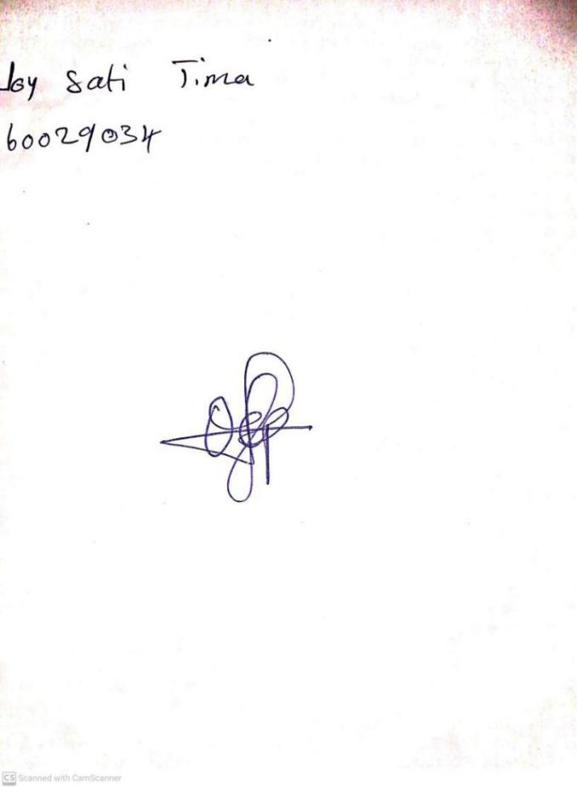

**12th February, 2024**

**Perpetual Ojoma Ocheja**

**Stream Head Nursery**