**EMERALD ROYAL INTERNATIONAL SCHOOL**

**MPAPE, ABUJA.**

**LESSON PLAN AND NOTE FOR WEEK 2 PERIOD 1 ENDING 12/05/2023**

TERM: THIRD

WEEK: 2ND

DATE: 08/05/2023

CLASS: NURSERY 2

SUBJECT: LETTER WORK

TOPIC: VOWEL DIGRAPHS 1

SUB-TOPIC: MEANING OF VOWEL DIGRAPHS

PERIOD: 1ST PERIOD

TIME: 09: 30 - 10:10am

DURATION: 40 MINUTES.

NUMBER IN CLASS: 17

AVERAGE AGE: 5 YEARS.

SEX: MIXED.

SPECIFIC OBJECTIVES: BY THE END OF THE LESSON,THE PUPILS SHOULD BE

ABLE TO:

1. DEFINE VOWEL DIGRAPHS.

2. MENTION WORDS WITH VOWEL DIGRAPHS “EE”

RATIONALE: FOR PUPILS TO KNOW THE MEANING OF VOWEL

DIGRAPHS

PREVIOU KNOWLEDGE: PUPILS HAVE LEARNT ABOUT CONSONANT DIGRAPHS

IN PREVIOUS LESSON.

REFERENCE MATERIALS: GOOGLE.COM .

**LESSON DEVELOPMENT**

|  |  |  |  |
| --- | --- | --- | --- |
| STAGES/STEPS | TEACHER’S ACTIVITIES | PUPILS’ ACTIVITIES | LEARNING POINTS |
| INTRODUCTION | Teacher reviews the previous lesson on consonant digraphs to pupils. | Pupil listen attentively to the teacher. | To prepare pupils minds for the lesson ahead. |
| PRESENTATION  STEP 1 | Teacher defines vowel digraphs to pupils and asks them to repeat after her. | Pupils listen attentively to the teacher and repeat after her. | For proper understanding . |
| STEP 2 | Teacher writes the words with vowel digraphs “ee” on the board, spell and pronounce and also asks pupils to repeat after her. | Pupils pay attention to the teacher and repeat after her. | For better understanding of the lesson. |
| BOARD SUMMARY | Teacher writes the whole not of lesson on the board for pupils to copy.ie,  VOWEL DIGRAPH  Vowel digraphs are two vowels that, when placed together, generate one sound.  Example: vowel digraph “ee”  “ee” as in feet  “ee” as in meet  “ee” as in see  “ee” as in bee  “ee” as in tree  “ee” as in leek  “ee” as in week  “ee” as in cheek  “ee” as in feed  “ee”as in weed etc. | Pupils copy the note into their exercise books. | For onward study. |
| EVALUATION | Teacher evaluates the lesson by spelling and pronouncing the words on the board and then asks pupils to repeat after her and also asks them to read one after another. | Pupils listen to the teacher and read the note on the board one after another. | To assess pupils reading skills. |
| CONCLUTION | Teacher concludes the lesson by marking pupils books. | Pupils submit their books for marking. | For endorsement. |
| ASSIGNMENT | Answer the following questions:   1. Define vowel digraphs 2. Mention 10 words with vowel “ea” | Pupils do their assignment at home. | To encourage learning at home. |

**LESSON PLAN AND NOTE FOR WEEK 2 PERIOD 2 ENDING 12/05/2023**

TERM: THIRD

WEEK: 2ND

DATE: 08/05/2023

CLASS: NURSERY 2

SUBJECT: LETTER WORK

TOPIC: VOWEL DIGRAPHS 1

SUB-TOPIC: WORDS WITH VOWEL DIGRAPHS “EA”

PERIOD: 2ND PERIOD

TIME: 08: 50 - 09:30am

DURATION: 40 MINUTES.

NUMBER IN CLASS: 17

AVERAGE AGE: 5 YEARS.

SEX: MIXED.

SPECIFIC OBJECTIVES: BY THE END OF THE LESSON,THE PUPILS SHOULD BE

ABLE TO:

1. MENTION WORDS WITH VOWEL DIGRAPHS “EA”

2. SPELL AND PRONOUNCE WORDS WITH VOWEL

DIGRAPHS "EA"

RATIONALE: FOR PUPILS TO KNOW WORDS WITH VOWEL DIGRAPHS

DIGRAPHS "EA"

PREVIOU KNOWLEDGE: PUPILS HAVE LEARNT MEANING OF VOWEL DIGRAPHS IN PREVIOUS LESSON.

REFERENCE MATERIALS: GOOGLE.COM .

**LESSON DEVELOPMENT**

|  |  |  |  |
| --- | --- | --- | --- |
| STAGES/STEPS | TEACHER’S ACTIVITIES | PUPILS’ ACTIVITIES | LEARNING POINTS |
| INTRODUCTION | Teacher reviews the previous lesson on vowel digraphs to pupils. | Pupil listen attentively to the teacher. | To prepare pupils minds for the lesson ahead. |
| PRESENTATION  STEP 1 | Teacher mentions words with vowel digraphs “ea” to pupils and asks them to repeat after her. | Pupils listen attentively to the teacher and repeat after her. | For proper understanding . |
| STEP 2 | Teacher writes the words with vowel digraph “ea” on the board, spell and pronounce and also asks pupils to repeat after her. | Pupils pay attention to the teacher and repeat after her. | For better understanding of the lesson. |
| BOARD SUMMARY | Teacher writes the whole not of lesson on the board for pupils to copy.ie,  VOWEL DIGRAPH “EA”  “ea” as in steak  “ea” as in break  “ea” as in great  “ea” as in bear  “ea” as in tear  “ea” as in wear  “ea” as in pear  “ea” as in swear etc | Pupils copy the note into their exercise books. | For onward study. |
| EVALUATION | Teacher evaluates the lesson by spelling and pronouncing the words on the board and then asks pupils to repeat after her and also asks them to read one after another. | Pupils listen to the teacher and read the note on the board one after another. | To assess pupils reading skills. |
| CONCLUTION | Teacher concludes the lesson by marking pupils books. | Pupils submit their books for marking. | For endorsement. |
| ASSIGNMENT | Make 10 words with vowel “oo” | Pupils do their assignment at home. | To encourage learning at home. |

**LESSON PLAN AND NOTE FOR WEEK 2 PERIOD 3 ENDING 12/05/2023**

TERM: THIRD

WEEK: 2ND

DATE: 08/05/2023

CLASS: NURSERY 2

SUBJECT: LETTER WORK

TOPIC: VOWEL DIGRAPHS 1

SUB-TOPIC: WORDS WITH VOWEL DIGRAPHS “OO”

PERIOD: 3RD PERIOD

TIME: 09: 30 -10:10am

DURATION: 40 MINUTES.

NUMBER IN CLASS: 17

AVERAGE AGE: 5 YEARS.

SEX: MIXED.

SPECIFIC OBJECTIVES: BY THE END OF THE LESSON,THE PUPILS SHOULD BE

ABLE TO:

1. MENTION WORDS WITH VOWEL DIGRAPHS “OO”

2. SPELL AND PRONOUNCE WORDS WITH VOWEL

DIGRAPHS "OO"

RATIONALE: FOR PUPILS TO KNOW WORDS WITH VOWEL DIGRAPHS

"OO"

PREVIOU KNOWLEDGE: PUPILS HAVE LEARNT VOWEL DIGRAPHS “EA” IN PREVIOUS LESSON.

REFERENCE MATERIALS: GOOGLE.COM .

**LESSON DEVELOPMENT**

|  |  |  |  |
| --- | --- | --- | --- |
| STAGES/STEPS | TEACHER’S ACTIVITIES | PUPILS’ ACTIVITIES | LEARNING POINTS |
| INTRODUCTION | Teacher reviews the previous lesson on vowel digraphs “ea” to pupils. | Pupil listen attentively to the teacher. | To prepare pupils minds for the lesson ahead. |
| PRESENTATION  STEP 1 | Teacher mentions words with vowel digraphs “oo” to pupils and asks them to repeat after her. | Pupils listen attentively to the teacher and repeat after her. | For proper understanding . |
| STEP 2 | Teacher writes the words with vowel digraph “oo” on the board, spell and pronounce and also asks pupils to repeat after her. | Pupils pay attention to the teacher and repeat after her. | For better understanding of the lesson. |
| BOARD SUMMARY | Teacher writes the whole not of lesson on the board for pupils to copy.ie,  VOWEL DIGRAPH “OO”  “oo” as in moon  “oo” as in food  “oo” as in good  “oo” as in foot  “oo” as in book  “oo” as in room  “oo” as in hook  “oo” as in look etc | Pupils copy the note into their exercise books. | For onward study. |
| EVALUATION | Teacher evaluates the lesson by spelling and pronouncing the words on the board and then asks pupils to repeat after her and also asks them to read one after another. | Pupils listen to the teacher and read the note on the board one after another. | To assess pupils reading skills. |
| CONCLUTION | Teacher concludes the lesson by marking pupils books. | Pupils submit their books for marking. | For endorsement. |
| ASSIGNMENT | Make 10 words each with the following:   1. “ee” 2. “ea” 3. “oo” | Pupils do their assignment at home. | To encourage learning at home. |

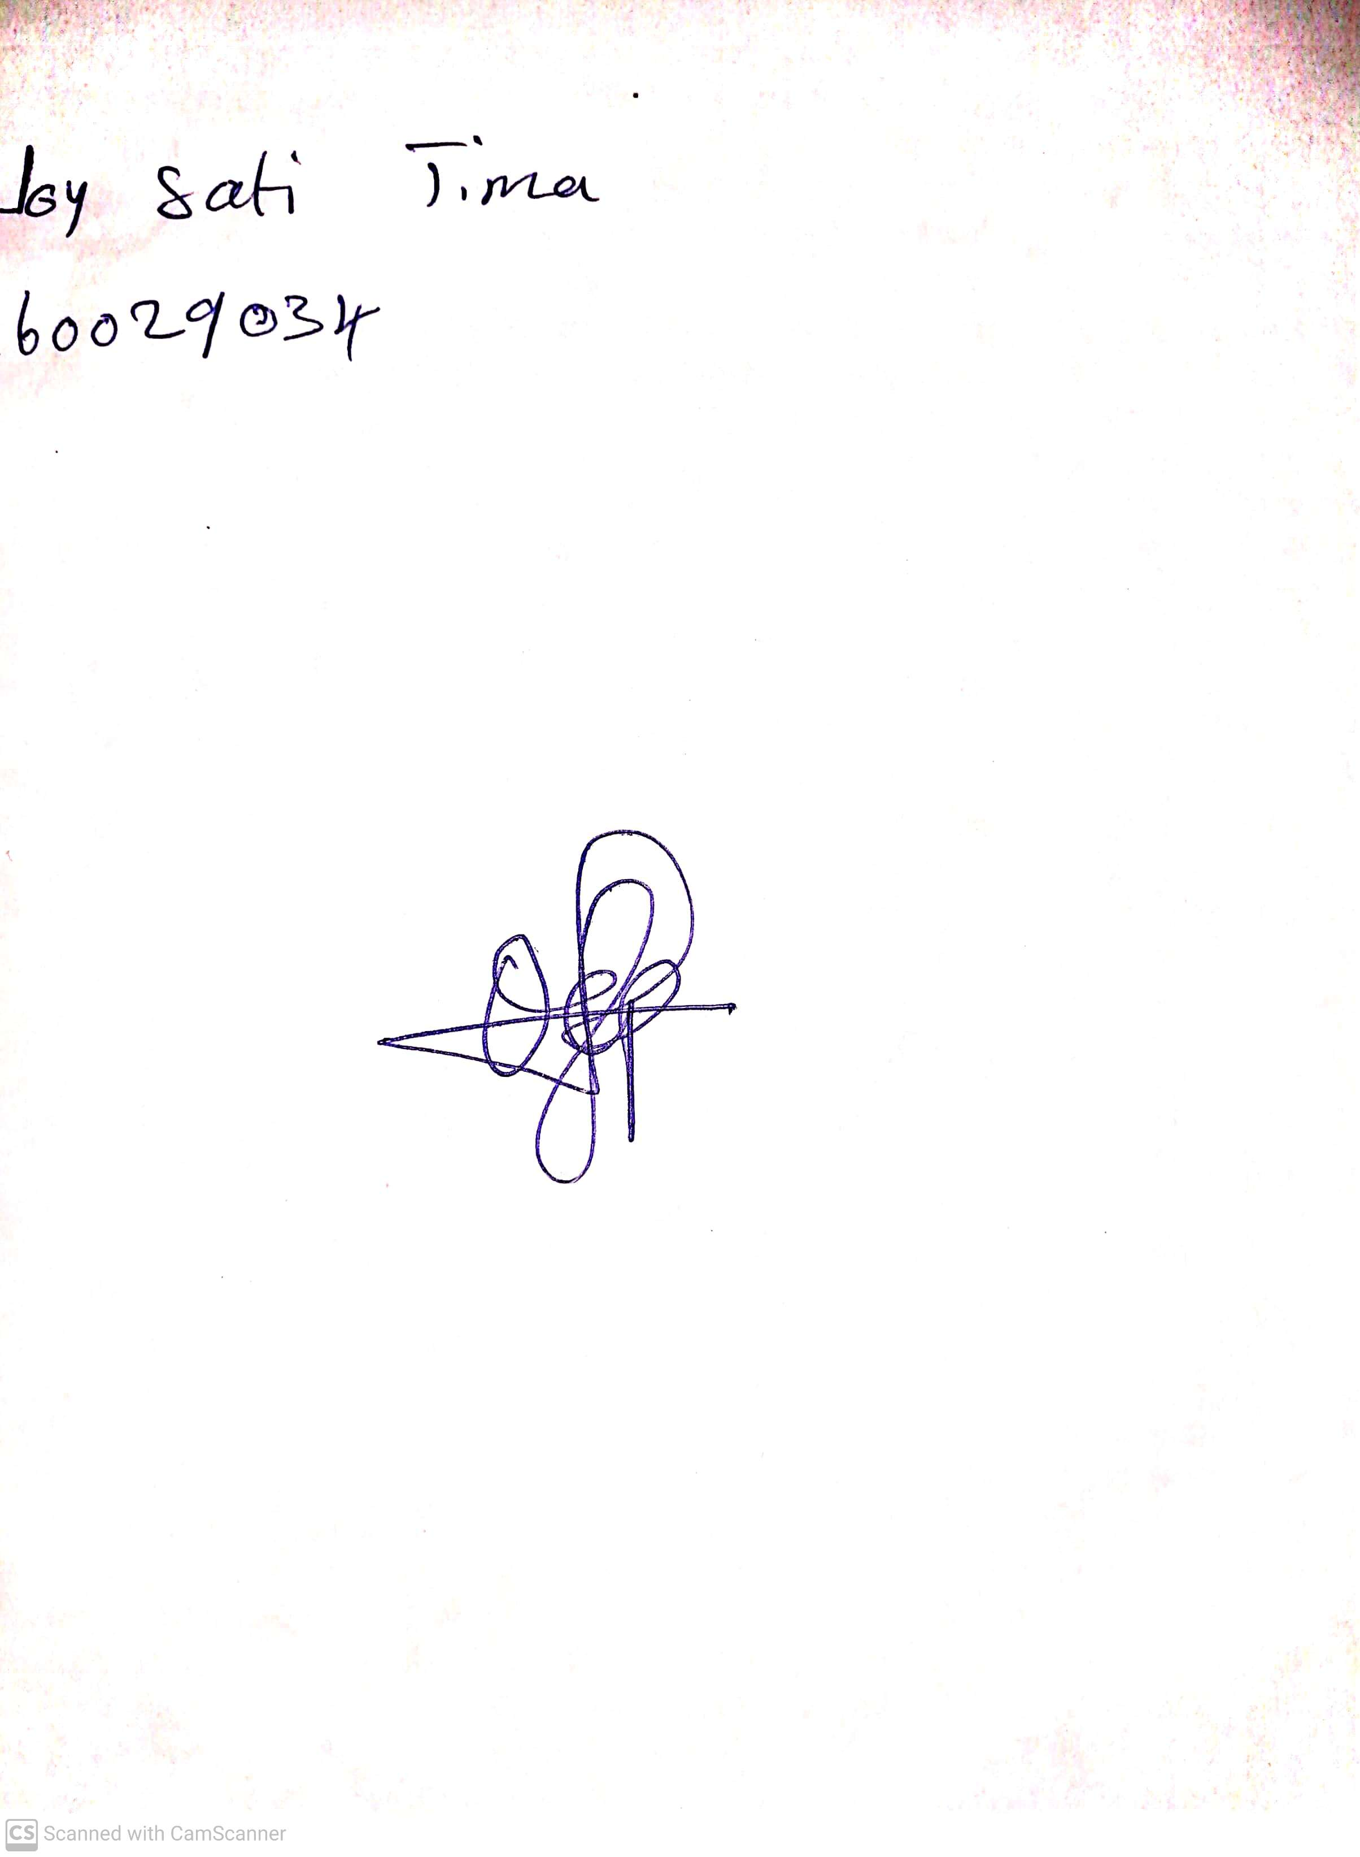

14th May, 2023

Perpetual Ojoma

Stream Head Nursery