**EMERALD ROYAL INTERNATIONAL SCHOOL**

**MPAPE, ABUJA.**

**LESSON PLAN AND NOTE FOR WEEK 2 PERIOD 1 ENDING 22/09/2023**

TERM: FIRST

WEEK: 2ND

DATE: 18/09/2023

CLASS: NURSERY 2

SUBJECT: LETTER WORK

TOPIC: THREE LETTER WORDS ENDING IN "AT", "AD", "AN"

"AG", "AM" AND "AP" .

SUB-TOPIC: THREE LETTER WORDS ENDING IN " AT" , AND "

" AD".

PERIOD: 1ST

TIME: O8:50-09:30.

DURATION: 40 MINUTES.

NUMBER IN CLASS: 17

AVERAGE AGE: 5 YEARS.

SEX: MIXED.

SPECIFIC OBJECTIVES: BY THE END OF THE LESSON,THE PUPILS SHOULD BE

ABLE TO:

1. IDENTIFY THREE LETTER WORDS ENDING IN "AT"

AND " AD".

2. SPELL AND PRONOUNCE THREE LETTER WORDS

ENDING IN "AT" AND "AD".

RATIONALE: FOR PUPILS TO BE ABLE TO SPELL AND PRONOUNCE

THERE LETTER WORDS ENDING IN "AT" AND "AD".

PREVIOU KNOWLEDGE: PUPILS HAVE LEARNT TWO LETTER WORDS IN PREVIOUS LESSON.

INSTRUCTIONAL MATERIALS: MAT, HAT, AND PICTURE OF A SAD FACE.

REFERENCE MATERIALS: MASTERING ENGLISH BOOK 2 BY J. M OMOGBAI

**LESSON DEVELOPMENT**

|  |  |  |  |
| --- | --- | --- | --- |
| STAGES/STEPS | TEACHER’S ACTIVITIES | PUPILS’ ACTIVITIES | LEARNING POINTS |
| INTRODUCTION | Teacher introduces the lesson by asking pupils to recite two Letter words.. | Pupil listen to the teacher and recite two letter words. | To arouse pupils interest for the lesson ahead. |
| PRESENTATION  STEP 1 | Teacher presents the lesson by writes three letter words ending in " at" and "ad" on the board, identify and then asks pupils to repeat after her. | Pupils pay attention and repeat after the teacher. | For proper understanding of the lesson . |
| STEP 2 | Teacher spells and pronounce the three letter words ending in "at" and "ad" on the board and also asks pupils to repeat after her. | Pupils spelled the three letter words on the board after the teacher. | For better understanding of the lesson. |
| BOARD SUMMARY | Teacher summarizes the lesson by writing the whole note of lesson on the board for pupils to copy into their books.that is,  THREE LETTER WORDS ENDING IN "AT" AND "AD" ARE:  "at" as in;   1. Cat 2. Fat 3. Pat 4. Sat 5. Hat 6. Rat 7. Bat 8. Mat etc.   "ad" as in;   1. Lad 2. Bad 3. Sad 4. Dad 5. Mad 6. Had 7. Pad etc. | Pupils copy the note into their exercise books. | For onward study. |
| EVALUATION | Teacher asks pupils to go to the board one after the other and read. | Pupils read the note on the board one after another. | To assess pupils level of understanding of the lesson so far. |
| CONCLUSION | Teacher marks pupils books. | Pupils submit their books for marking. | For endorsement. |
| ASSIGNMENT | Assignment on page 23 in Mastering English text book. | Pupils do their assignment at home. | To encourage learning at home. |

**LESSON PLAN AND NOTE FOR WEEK 2 PERIOD 2 ENDING 22/09/2023**

TERM: FIRST

WEEK: 2ND

DATE: 19/09/2023

CLASS: NURSERY 2

SUBJECT: LETTER WORK

TOPIC: THREE LETTER WORDS ENDING IN "AT " ,"AD","AN",

"AG", " AM" AND "AP".

SUB-TOPIC: THREE LETTER WORDS ENDING IN" AN" AND "AG".

PERIOD: 2ND

TIME: O8:50-09:30.

DURATION: 40 MINUTES.

NUMBER IN CLASS: 17

AVERAGE AGE: 5 YEARS.

SEX: MIXED.

SPECIFIC OBJECTIVES: BY THE END OF THE LESSON,THE PUPILS SHOULD BE

ABLE TO:

1. IDENTIFY THREE LETTER WORDS ENDING IN" AN"

AND "AG".

2. SPELL AND PRONOUNCE THREE LETTER WORDS

ENDING IN " AN" AND "AG".

RATIONALE: FOR PUPILS TO BE ABLE TO READ WORDS THAT ENDS

WITH " AN" AND "AG".

PREVIOU KNOWLEDGE: PUPILS HAVE LEARNT THREE LETTER WORDS ENDING IN " AT" AND "AD" IN PREVIOUS LESS0N.

INSTRUCTIONAL MATERIALS: TAG, FAN, BAG AND RAG.

REFERENCE MATERIALS: MASTERING ENGLISH 2 BY J. M OMOGBAI.

**LESSON DEVELOPMENT**

|  |  |  |  |
| --- | --- | --- | --- |
| STAGES/STEPS | TEACHER’S ACTIVITIES | PUPILS’ ACTIVITIES | LEARNING POINTS |
| INTRODUCTION | Teacher introduces the lesson by reviewing the previous lesson. | Pupil listen attentively to the teacher. | To arouse pupils interest for the lesson ahead. |
| PRESENTATION  STEP 1 | Teacher presents the lesson by writing three Letter words ending in "an" and "ag" on the board, identify and then asks pupils to repeat after. | Pupils listen and repeat after the teacher. | For proper understanding of the lesson . |
| STEP 2 | Teacher spells and pronounce the three letter words ending in "an" and "ag" on the board and also asks pupils to repeat after her. | Pupils pay attention and repeat after the teacher. | For better understanding of the lesson. |
| BOARD SUMMARY | Teacher summarizes the lesson by writing the whole note of lesson on the board for pupils to copy into their books.that is;  THREE LETTER WORDS ENDING IN "AN" AND "AG" ARE:  "an" as in;   1. Can 2. Fan 3. Ran 4. Pan 5. Man 6. Ban etc.   "ag" as in;   1. Rag 2. Bag 3. Tag 4. Wag 5. Sag 6. Nag etc. | Pupils copy the note into their exercise books. | For onward study. |
| EVALUATION | Teacher asks Pupils to read the three Letter words ending in "an" and "ag" on the board one after the other. | Pupils read the note on the board one after another. | To assess pupils understanding of the lesson. |
| CONCLUSION | Teacher marks pupils books. | Pupils submit their books for marking. | For endorsement. |
| ASSIGNMENT | Assignment on page 25 in Mastering English. | Pupils do their assignment at home. | To encourage learning at home. |

**LESSON PLAN AND NOTE FOR WEEK 2 PERIOD 3 ENDING 22/09/2023**

TERM: FIRST

WEEK: 2ND

DATE: 22/09/2023

CLASS: NURSERY 2

SUBJECT: LETTER WORK

TOPIC: THREE LETTER WORDS ENDING IN "AT", " AD",

"AN", " AG", "AM", AND " AP".

SUB-TOPIC: THREE LETTER WORDS ENDING IN "AM" AND "AP".

PERIOD: 3RD

TIME: 08:10- 08:50am

DURATION: 40 MINUTES.

NUMBER IN CLASS: 17

AVERAGE AGE: 5 YEARS.

SEX: MIXED.

SPECIFIC OBJECTIVES: BY THE END OF THE LESSON,THE PUPILS SHOULD

BE ABLE TO:

1. IDENTIFY THREE LETTER WORDS ENDING IN "AM"

AND "AP".

2. SPELL AND PRONOUNCE THREE LETTER WORDS

ENDING IN "AM" AND "AP".

RATIONALE: FOR PUPILS TO KNOW HOW TO PRONOUNCE WORDS

THAT ENDS WITH " AM" AND "AP".

PREVIOU KNOWLEDGE: PUPILS HAVE LEARNT ABOUT THREE LETTER WORDS ENDING IN "AN" AND "AG" IN PREVIOUS LESS0N.

INSTRUCTIONAL MATERIALS: CAP AND YAM.

REFERENCE MATERIALS: MASTERING ENGLISH BOOK 2 BY J.M OMOGBAI.

**LESSON DEVELOPMENT**

|  |  |  |  |
| --- | --- | --- | --- |
| STAGES/STEPS | TEACHER’S ACTIVITIES | PUPILS’ ACTIVITIES | LEARNING POINTS |
| INTRODUCTION | Teacher introduces the lesson by reviewing the previous lesson. | Pupils pay attention to the teacher. | To arouse pupils interest for the lesson ahead. |
| PRESENTATION  STEP 1 | Teacher presents the lesson by writing three letter words ending in "am" and "ap" on the board, identify and then asks pupils to repeat after her. | Pupils listen to the teacher and repeat after her. | For proper understanding of the lesson . |
| STEP 2 | Teacher guides pupils to spell and pronounce the words ending in "am" and "ap" on the board. | Pupils spell and pronounced the words on the board. | For better understanding of the lesson. |
| BOARD SUMMARY | Teacher summarizes the lesson by preparing pupils books for them to copy the note on the board.ie,  Three Letter words ending in " am" and "ap" are:  "am" as in;   1. Ram 2. Yam 3. Dam 4. Sam 5. Pam 6. Fam 7. Lam 8. Cam etc.   "ap" as in;   1. Map 2. Pap 3. Tap 4. Cap 5. Lap 6. Gap 7. Nap etc. | Pupils copy the note into their exercise books. | For onward study. |
| EVALUATION | Teacher evaluates the lesson by asking pupils to all stand and spell and pronounce three Letter words ending in "am" and "ap" on the board all together. | Pupils all stand and spelled and pronounced the words on the board. | To create platform for slow learners. |
| CONCLUSION | Teacher concludes the lesson by marking pupils books. | Pupils submit their books for marking. | For endorsement. |
| ASSIGNMENT | Fill in the missing letters and pronounce.   1. M ___ t 2. B ___g 3. B ___ t 4. R ___ g 5. M ___ d 6. M ___ p 7. D ___ d 8. L ___ p 9. R ___ M 10. R ___ t | Pupils do their assignment at home. | To encourage learning at home. |

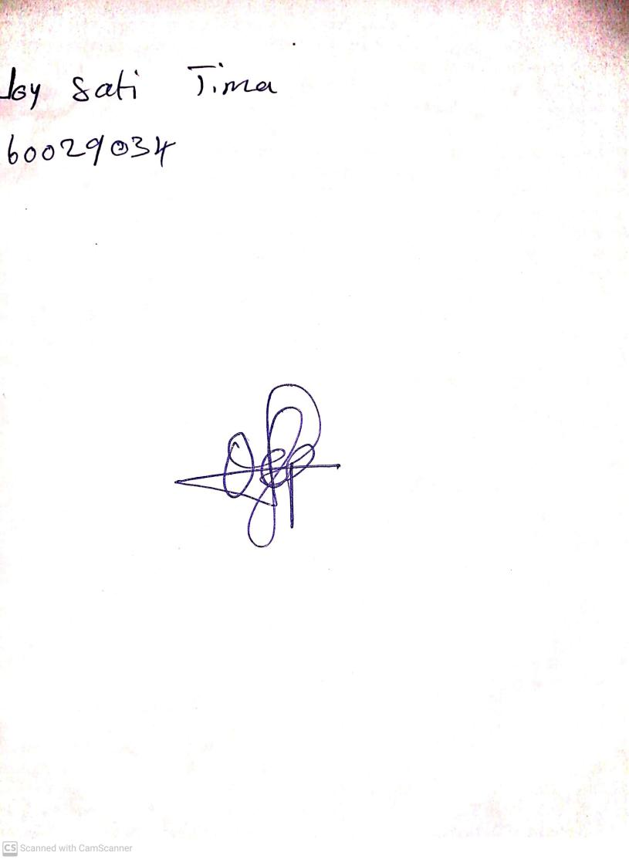

18th September, 2023

Perpetual Ojoma Ocheja

Stream Head Nursery