**EMERALD ROYAL INTERNATIONAL SCHOOL, MPAPE ABUJA**

**LESSON PLAN AND NOTE FOR WEEK 6 ENDING FRIDAY, 20TH OCTOBER, 2023**

**TERM:** FIRST TERM

**WEEK:** WEEK 6

**SUBJECT:** SOCIAL STUDIES

**TOPIC:** CULTURE AND SOCIAL VALUES

**SUB-TOPIC:** VALUES THAT SHOWS GOOD MORALS IN OUR SOCIETY

**DATE:** TUESDAY, 17TH ANDWEDNESDAY, 18TH OCTOBER, 2023

**TIME:** 11:50 – 12:30PM AND 01:20 – 02:00PM

**DURATION:** 40 MINUTES

**PERIOD:** 6TH AND 8TH

**CLASS:** NURSERY 3

**NUMBER IN CLASS:** ELEVEN

**AVERAGE AGE:** FIVE

**SEX:** MIXED

**LEARNING OBJECTIVES:** By the end of the lesson, the pupils should be able to:

1. Explain the meaning of morals.
2. State the examples of good morals values.

**RATIONALE:** for pupils to learn the meaning and examples of good moral values in the society.

**PREVIOUS KNOWLEGDE:** pupils learnt the aspects of culture. **INSTRUCTIONAL MATERIALS:**

1. Charts.
2. Textbook

**REFERENCE MATERIALS:**

1. Social Studies for primary schools book 1 by Olufemi J. Olugasa, Olusola H. Bamidele, Felix K. Alonge, Julius O. Onwuka

**LESSON DEVELOPMENT**

|  |  |  |  |
| --- | --- | --- | --- |
| **STAGES/STEPS** | **TEACHER’S ACTIVITIES** | **PUPILS’ ACTIVITIES** | **LEARNING POINTS** |
| **INTRODUCTION** | Review previous knowledge | Respond to the teacher | To arouse the pupils’ interest. |
| **PRESENTATION**  **STEP 1** | Teaches and explain the meaning of moral values.  **Meaning of moral**  Morals are a guide to behaviour in the society. The morals of a society explains whether human behaviour is right or wrong. | Listen attentively and learn. | Meaning of moral values. |
| **STEP 2** | List and explain the examples of good moral values.  **Examples of good moral values**   1. Greeting 2. Respect 3. Loyalty 4. Kindness 5. Tolerance | Listen attentively and learn. | Examples of good moral values. |
| **SUMMARY** | Summarises the lesson by emphasising on the main concept and writes note on the board | Listen and copy their notes | For onward study |
| **EVALUATION** | Asks pupils to:   1. Define morals. 2. List the examples of good moral values. | Respond to the teacher’s question. | To test the pupils understanding on the lesson. |
| **CONCLUSION** | Summarizes, corrects and mark pupils’ notebooks | Submit their notebooks for marking. | Clarifying the concept. |
| **HOME WORK** | 1. List five (5) examples of good moral values. | Cope and return with task. | Extending lesson home. |

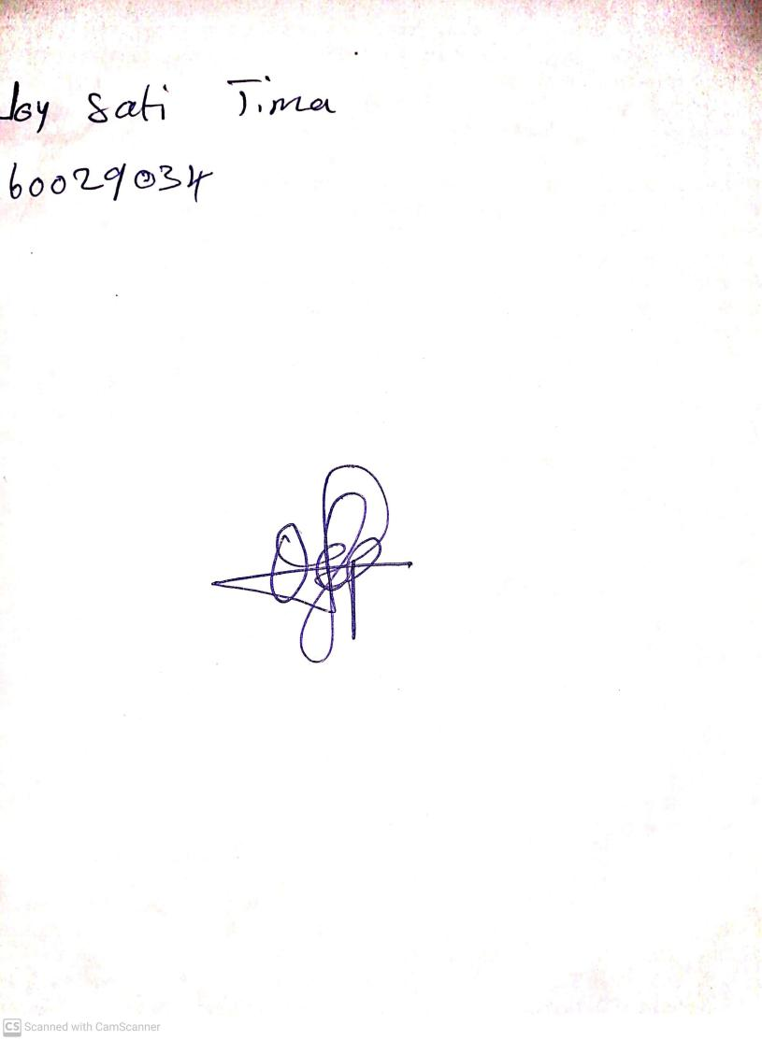

13TH October, 2023

Perpetual Ojoma Ocheja

Stream Head Nursery