EMERALD ROYAL INTERNATIONAL SCHOOL MPAPE, ABUJA

LESSON PLAN AND NOTE FOR WEEK 4 PERIOD 1 ENDING 06/10/2023

TERM: FIRST

WEEK: 4TH

DATE: 02/10/2023

CLASS: NURSERY 2

SUBJECT: NUMBER WORK

TOPIC: TIME MEASUREMENT OCLOCK AND HALF PAST.

SUB-TOPIC: TELLING THE TIME IN O CLOCK.

PERIOD: 1ST

TIME: 08: 50-09: 30 am

DURATION: 40 MINUTES

NUMBER IN CLASS: 16

AVERAGE AGE: 4

SEX: MIXED

SPECIFIC OBJECTIVES: BY THE END OF THE LESSON, THE PUPILS SHOULD BE ABLE

TO:

1.IDENTIFY A CLOCK

2.EXPLAIN THE LONGER HAND AND THE SHORTER HAND

ON A CLOCK.

1. TELL THE TIME ON CLOCK FACES.

RATIONALE: FOR PUPILS TO BE ABLE TO KNOW HOW TO TELL TIME.

PREVIOUS KNOWLEDGE: PUPILS HAVE BEEN WEARING WRIST WATCH TO SCHOOL.

INSTRUCTIONAL MATERIALS: A CLOCK.

REFERENCE MATERIALS: MY CHOICE OF MATHEMATICS STAGE 3 BY TOP STAR.

LESSON DEVELOPMENT

|  |  |  |  |
| --- | --- | --- | --- |
| STAGES/STEPS | TEACHER’S ACTIVITIES | PUPILS’ ACTIVITIES | LEARNING POINT |
| INTODUCTION | Teacher introduces the lesson by reviewing the previous lesson. | Pupils listen attentively to the teacher. | To arouse pupils interest for the lesson ahead. |
| PRESENTATION STEP 1 | Teacher draws a clock on the board, identify to pupils and then asks them to repeat after her. | Pupils pay attention to the teacher and repeat after her. | For proper understanding. |
| STEP 2 | Teacher explains the longer hand and the shorter hand in the clock to pupils and also asks them to repeat after her. | Pupils listen very attentively to the teacher and repeat after her. | For better understanding of the lesson. |
| STEP 3 | Teacher also draws different clock faces on the board and then guides pupils to tell the time on the clock faces. | Pupils pay attention to the board and tell the time. | To create plat form for slow learners. |
| BOARD SUMMARY | Teacher summarizes the lesson by writing the whole note of lesson on the board for pupils to copy into their books. As;  TELLING THE TIME  Time tells us when things are done.  Telling the time in o clock  The hands of a clock move to show what time it is.   1. The longer hand is called the minutes hand. It moves round about the face of the clock to read minutes. 2. The shorter hand is called the hour hand.   It moves round about the face of the clock to read hours.  Examples:   1. When the longer hand is on 12, and the shorter hand is on 3, we say the time is 3, o'clock. 2. When the longer hand is on 12, and the shorter hand is on 7, we say the time is 7 o'clock. 3. When the longer hand is on 12, and the shorter hand is on 10, we say the time is 10 o'clock etc. | Pupils copy the note on the board into their exercise books. | For onward study. |
| EVALUATION | Teacher evaluates the lesson by asking the following questions:   1. Time tells us when things are done .   True or false.   1. The longer hand in a clock is called --------- 2. The shorter hand in the clock is called ------- 3. When the longer hand is on 12, and the shorter hand is on 4, we say the time is ------ 4. When the longer hand is on 12, and the shorter hand is on 12, we say the time is ------ | Pupils answer the questions asked by the teacher. | To asses pupils level of understanding of the lesson. |
| CONCLUSION | Teacher concludes the lesson by marking pupils books. | Pupils submit their books for marking. | For endorsement. |
| ASSIGNMENT | 1. Say the time in each clock face on page 74. 2. Draw the shorter hand in each clock to indicate the time shown under each clock on page 75. 3. Draw the shorter hand in each clock to indicate the time shown under each clock.on page 76. | Pupils do their assignment at home. | To encourage learning at home. |

EMERALD ROYAL INTERNATIONAL SCHOOL MPAPE, ABUJA

LESSON PLAN AND NOTE FOR WEEK 4 PERIOD 2 ENDING 06/10/2023

TERM: FIRST

WEEK: 4TH

DATE: 03/10/2023

CLASS: NURSERY 2

SUBJECT: NUMBER WORK

TOPIC: TIME MEASUREMENT

SUB-TOPIC: TELLING THE TIME IN QUARTER PAST

PERIOD: 2ND

TIME: 08: 50-09: 30 am

DURATION: 40 MINUTES

NUMBER IN CLASS: 16

AVERAGE AGE: 4

SEX: MIXED

SPECIFIC OBJECTIVES: BY THE END OF THE LESSON, THE PUPILS SHOULD BE ABLE

TO:

1.EXPLAIN THE TIME WHEN IS QUARTER PAST.

2.SAY THE TIME ON THE CLOCK FACE.

RATIONALE: FOR PUPILS TO BE ABLE TO TELL TIME WHEN IS QUARTER PAST.

PREVIOUS KNOWLEDGE: PUPILS HAVE LEARNT ABOUT HANDS IN THE CLOCK IN PREVIOUS LESSON.

INSTRUCTIONAL MATERIALS: A CLOCK.

REFERENCE MATERIALS: MY CHOICE OF MATHEMATICS STAGE 3 BY TOP STAR.

LESSON DEVELOPMENT

|  |  |  |  |
| --- | --- | --- | --- |
| STAGES/STEPS | TEACHER’S ACTIVITIES | PUPILS’ ACTIVITIES | LEARNING POINT |
| INTODUCTION | Teacher introduces the lesson by reviewing the previous lesson. | Pupils listen attentively to the teacher. | To arouse pupils interest for the lesson ahead. |
| PRESENTATION STEP 1 | Teacher explains how to tell time when is quarter past to pupils and then asks them to repeat after her. | Pupils pay attention to the teacher and repeat after her. | For proper understanding. |
| STEP 2 | Teacher draws some clock faces on the board, and then guides pupils to say the time as shown on the clock. | Pupils listen very attentively to the teacher and say the time. | For better understanding of the lesson. |
| BOARD SUMMARY | Teacher summarizes the lesson by writing the whole note of lesson on the board for pupils to copy into their books. That is;  Telling the time in quarter past  Whenever the longer hand is on 3, the time will read quarter past the number the number where the shorter hand is leaving.  Examples:   1. When the longer hand is on 3, and the shorter hand is leaving 5, we say the time is quarter past 5. 2. When the longer hand is on 3, and the shorter hand is leaving 12, we say the time is quarter past 12. 3. When the longer hand is on 3, and the shorter hand is leaving 9, we say the time is quarter past 9 etc.. | Pupils copy the note on the board into their exercise books. | For onward study. |
| EVALUATION | Teacher evaluates the lesson by drawing some clocks on the board showing quarter past, after which asks the pupils question relating to what she draws. | Pupils answer the questions asked by the teacher. | To asses pupils level of understanding of the lesson. |
| CONCLUSION | Teacher concludes the lesson by marking pupils books. | Pupils submit their books for marking. | For endorsement. |
| ASSIGNMENT | Tell the time in each picture on page 78. | Pupils do their assignment at home. | To encourage learning at home. |

EMERALD ROYAL INTERNATIONAL SCHOOL MPAPE, ABUJA

LESSON PLAN AND NOTE FOR WEEK 4 PERIOD 3 ENDING 06/10/2023

TERM: FIRST

WEEK: 4TH

DATE: 06/10/2023

CLASS: NURSERY 2

SUBJECT: NUMBER WORK

TOPIC: TIME MEASUREMENT.

SUB-TOPIC: TELLING THE TIME IN QUARTER TO .

PERIOD: 1ST

TIME: 08: 10-08:50 am

DURATION: 40 MINUTES

NUMBER IN CLASS: 16

AVERAGE AGE: 4

SEX: MIXED

SPECIFIC OBJECTIVES: BY THE END OF THE LESSON, THE PUPILS SHOULD BE ABLE

TO:

1.EXPLAIN THE TIME WHEN IS QUARTER TO

2. SAY THE TIME ON THE CLOCK FACE

RATIONALE: FOR PUPILS TO BE ABLE TO TELL THE TIMEWHEN IS QUARTER TO.

PREVIOUS KNOWLEDGE: PUPILS HAVE LEARNT ABOUT TIME WHEN IS QUARTER PAST IN PREVIOUS LESSON.

INSTRUCTIONAL MATERIALS: A WALL CLOCK

REFERENCE MATERIALS: TOP STAR MY CHOICE OF MATHEMATICS STAGE 3 BY TOP STAR PUBLISHING LTD.

LESSON DEVELOPMENT

|  |  |  |  |
| --- | --- | --- | --- |
| STAGES/STEPS | TEACHER’S ACTIVITIES | PUPILS’ ACTIVITIES | LEARNING POINT |
| INTODUCTION | Teacher introduces the lesson by reviewing the previous lesson. | Pupils listen attentively to the teacher. | To arouse pupils interest for the lesson ahead. |
| PRESENTATION STEP 1 | Teacher explains the time when is quarter to, to pupils and then asks them to repeat after her. | Pupils pay attention to the teacher and repeat after her. | For proper understanding. |
| STEP 2 | Teacher draws a clock on the board showing quarter to, and then say the time to pupils and also asks them to repeat after her. | Pupils listen very attentively to the teacher and repeat after her. | For better understanding of the lesson. |
| BOARD SUMMARY | Teacher summarizes the lesson by writing the whole note of lesson on the board for pupils to copy into their books. That is;  TIME MEASUREMENT  Telling the time when in quarter to  When the longer hand is on 9,the time will read quarter to the number where the shorter hand is going.  Example   1. When the longer hand is in 9, and the shorter hand is going to 2, we say the time is quarter to 2. 2. When the longer hand is in 9, and the shorter hand is going to 4, we say the time is quarter to 4 etc. | Pupils copy the note on the board into their exercise books. | For onward study. |
| EVALUATION | Teacher evaluates the lesson by drawing some clocks on the board showing quarter to, after which she asks the pupils questions relating to what she draws. | Pupils answer the questions asked by the teacher. | To asses pupils level of understanding of the lesson. |
| CONCLUSION | Teacher concludes the lesson by marking pupils books. | Pupils submit their books for marking. | For endorsement. |
| ASSIGNMENT | Assigment page 80 | Pupils do their assignment at home. | To encourage learning at home. |

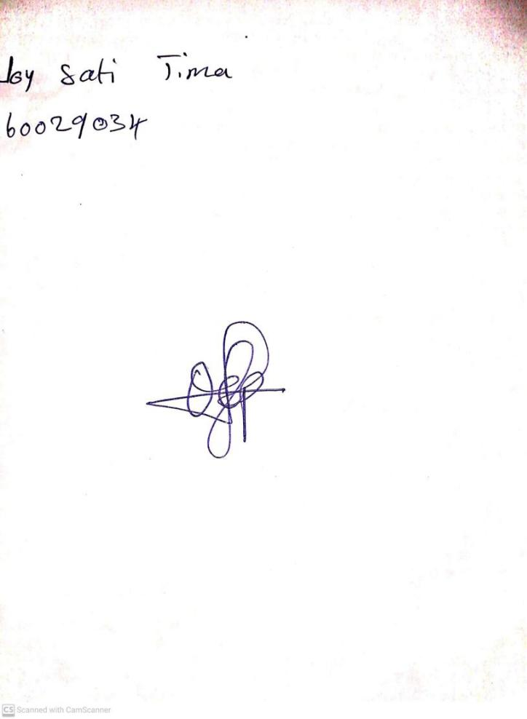

29TH September, 2023

Perpetual Ojoma Ocheja

Stream Head Nursery