**LESSON PLAN AND NOTE 1 FOR WEEK 7 ENDING 23/2/2024**

**Term 2nd term**

**Week 7th week**

**Date 20th February,2024**

**Class Nursery One**

**Subject Number Work**

**Topic Counting numbers 1-100**

**Sub-topic Counting numbers 90-95**

**Period 2nd period**

**Time 9:05 am**

**Duration 35 minutes**

**No in class 15**

**Average Age 3 years**

**Sex Mixed**

**Specific Objectives: By the end of the lesson ,the pupils should be able to:**

1. **Count numbers 90-95**
2. **Identify numbers 90-95**
3. **Write numbers 90-95**

**Rationale: To make sure the pupils know how to Count, identify and write numbers 90-95**

**Previous Knowledge: The pupils have colour and match numbers 85-90**

**Instructional Resources: Chart, board, marker, etc.**

**Reference Materia The new mastering mathematics by Henry Z. Idogun.**

**LESSON PRESENTATION**

|  |  |  |  |
| --- | --- | --- | --- |
| **Steps** | **Teacher’s Activities** | **Pupils’ Activities** | **Learning Points** |
| **Introduction** | **The teacher introduces the topic (counting numbers 1-100) by rhyming.** | **The pupils together with the teacher rhyme the numbers 1-100.** | **To arouse the pupils’ interest.** |
| **Step 1** | **The teacher assists the pupils to count numbers 90-95.**  **90 91 92**  **93 94 95** | **The pupils count the numbers 90-95 with their teacher.** | **For proper understanding** |
| **Step 2** | **The teacher leads the pupils to identify numbers 90, 91, 92, 93, 94, 95.** | **The pupils identify numbers 90, 91, 92 93, 94, 95.** | **For better understanding** |
| **Step 3** | **The teacher guides the pupils to write numbers 90-95 inside their notebooks.** | **The pupils write numbers 90-95 as the teacher guides them** | **For further understanding** |
| **Summary** | **The teacher summarizes the lesson by counting numbers 90-95.** | **The pupils have master and count numbers 90-95.** | **For onward study.** |
| **Evaluation** | **Question:**  **Count numbers: 90-95 fluently.** | **The pupils answer the question correctly.** | **To ascertain the pupils’ understanding.** |
| **Conclusion** | **The teacher summarizes, reacts and corrects the pupils.** | **The pupils gives answers to the teacher's question.** | **To consolidate the lesson.** |
| **Assignment** | **Write the following numbers below**   |  |  | | --- | --- | | **90** | **91** | |  |  | | **92** | **93** | |  |  | | **94** | **95** | |  |  | | **The pupils copy and do their homework at home.** | **To encourage learning while at home.** |

**LESSON PLAN AND NOTE 2 FOR WEEK 7 ENDING 23/2/2024**

**Term 2nd term**

**Week 7th week**

**Date 21st February,2024**

**Class Nursery One**

**Subject Number Work**

**Topic Counting numbers 1-100**

**Sub-topic Counting numbers 95-100.**

**Period 2nd period**

**Time 9:32 am**

**Duration 35 minutes**

**No in class 15**

**Average Age 3 years**

**Sex Mixed**

**Specific Objectives: By the end of the lesson ,the pupils should be able to:**

1. **Count numbers 95-100**
2. **Identify numbers 95-100**
3. **Write numbers 95-100**

**Rationale: To make sure the pupils know how to Count, identify and write numbers 95-100**

**Previous Knowledge: The pupils have count, identify & write numbers 95-100.**

**Instructional Resources: Chart, board, marker, etc.**

**Reference Material: The new mastering mathematics by Henry Z. Idogun**

**LESSON PRESENTATION**

|  |  |  |  |
| --- | --- | --- | --- |
| **Steps** | **Teacher’s Activities** | **Pupils’ Activities** | **Learning Points** |
| **Introduction** | **The teacher introduces the topic (counting numbers 1-100) by rhyming.** | **The pupils together with the teacher rhyme the numbers 1-100** | **To arouse the pupils’ interest.** |
| **Step 1** | **The teacher assists the pupils to count numbers 95-100.**  **95 96 97**  **98 99 100** | **The pupils count the numbers 95-100 with their teacher.** | **For proper understanding.** |
| **Step 2** | **The teacher leads the pupils to identify numbers 95, 96, 97, 98, 99, 100.** | **The pupils identify numbers 95, 96, 97 98, 99, 100.** | **For better understanding.** |
| **Step 3** | **The teacher guides the pupils to write numbers 95-100 inside their notebooks.** | **The pupils write numbers 95-100 as the teacher guides them** | **For further understanding.** |
| **Summary** | **The teacher summarizes the lesson by counting numbers 95-100.** | **The pupils have master and count numbers 95-100.** | **For onward study.** |
| **Evaluation** | **Question:**  **Count numbers: 95-100 fluently.** | **The pupils answer the question correctly** | **To ascertain the pupils’ understanding.** |
| **Conclusion** | **The teacher summarizes, reacts and corrects the pupil.** | **The pupils gives answers to the teacher's question.** | **To consolidate the lesson.** |
| **Assignment** | **Write the following numbers below**   |  |  | | --- | --- | | **95** | **96** | |  |  | | **97** | **98** | |  |  | | **99** | **100** | |  |  | | **The pupils copy and do their homework at home.** | **To encourage learning while at home.** |

**LESSON PLAN AND NOTE 3 FOR WEEK 7 ENDING 23/2/2024**

**Term 2nd term**

**Week 7th  week**

**Date 23rd February,2024**

**Class Nursery One**

**Subject Number Work**

**Topic Counting numbers 1-100**

**Sub-topic Colouring and matching numbers 90-100**

**Period 2nd period**

**Time 9:50 am**

**Duration 35 minutes**

**No in class 15**

**Average Age 3 years**

**Sex Mixed**

**Specific Objectives: By the end of the lesson ,the pupils should be able to:**

1. **Colour numbers 90-95**
2. **Match numbers 95-100**

**Rationale: To make sure the pupils colour & match numbers 90-100**

**Previous Knowledge: The pupils have count, identify & write numbers 95-100**

**Instructional Resources: Crayons, exercise books, pencils.**

**Reference Material: Exercise books, the new mastering mathematics by Henry Z. Idogun**

**LESSON PRESENTATION**

|  |  |  |  |
| --- | --- | --- | --- |
| **Steps** | **Teacher’s Activities** | **Pupils’ Activities** | **Learning Points** |
| **Introduction** | **The teacher introduces the topic (counting numbers 1-100) by rhyming.** | **The pupils together with the teacher rhyme the numbers 1-100** | **To arouse the pupils’ interest.** |
| **Step 1** | **The teacher draws numbers 90-95 inside their notebooks for the pupils to identify and colour** | **The pupils participate to identify and colour numbers 90-95.** | **For proper understanding.** |
| **Step 2** | **The teacher write down numbers 95-100 for the pupils to match inside their notebooks.**  **95 99**  **96 100**  **97 98**  **98 95**  **99 96**  **100 97** | **The pupils match the numbers 95-100.**  **95 99**  **96 100**  **97 98**  **98 95**  **99 96**  **100 97** | **For better understanding.** |
| **Summary** | **The teacher summarizes the lesson by counting numbers 95-100.** | **The pupils have master and count numbers 95-100.** | **For onward study.** |
| **Evaluation** | **Question:**  **Count numbers: 90-100** | **The pupils answer the question correctly.** | **To ascertain the pupils’ understanding.** |
| **Conclusion** | **The teacher summarizes, reacts and corrects the pupils.** | **The pupils gives answers to the teacher's question** | **To consolidate the lesson.** |
| **Assignment** | **Match the following numbers**  **90 96**  **95 99**  **98 90**  **96 95**  **93 100**  **100 97**    **97 93** | **The pupils copy and do their homework at home.** | **To encourage learning while at home.** |

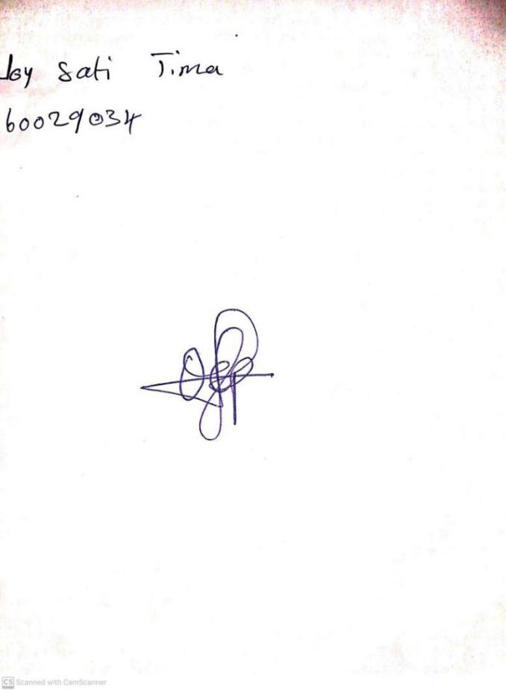

16TH February, 2024

Perpetual Ojoma Ocheja

Stream Head Nursery

**N.B THE EVALUATION SHOULD TALLY WITH THE LEARNING OBJECTIVES**

|  |  |
| --- | --- |
| **Evaluation** | **Question:**  **Count numbers: 90-100** |

**Specific Objectives: By the end of the lesson ,the pupils should be able to:**

1. **Colour numbers 90-95**
2. **Match numbers 95-100**

KINDLY DO SAME FOR THE NOTES