**EMERALD ROYAL INTERNATIONAL SCHOOL**

**MPAPE, ABUJA.**

**LESSON PLAN AND NOTE FOR WEEK 5 ENDING 13/10/2023**

TERM: FIRST

WEEK: 5TH

DATE: 09/10/2023

CLASS: NURSERY 2

SUBJECT: SOCIAL NORMS

TOPIC: RESPONSIBILITIES .

SUB-TOPIC: MY RESPONSIBILITIES AT HOME

PERIOD: 2ND PERIOD AFTER LONG BREAK

TIME: 11: 20- 12: 00PM

DURATION: 40 MINUTES.

NUMBER IN CLASS: 14

AVERAGE AGE: 5 YEARS.

SEX: MIXED.

SPECIFIC OBJECTIVES: BY THE END OF THE LESSON,THE PUPILS SHOULD BE ABLE TO:

1. EXPLAIN THE MEANING OF RESPONSIBILITIES
2. STATE THE RESPONSIBILITIES AT HOME

RATIONALE: FOR PUPILS TO KNOW THEIR RESPONSIBILITIES AT HOME

PREVIOU KNOWLEDGE: PUPILS HAVE BEEN HELPING THEIR MUMMY AT HOME.

INSTRUCTIONAL MATERIALS: A SHORT VIDEO CLIP OF CHILDREN HELPING THEIR MUMMY AT HOME.

REFERENCE MATERIALS: GOOGLE.COM

**LESSON DEVELOPMENT**

|  |  |  |  |
| --- | --- | --- | --- |
| STAGES/STEPS | TEACHER’S ACTIVITIES | PUPILS’ ACTIVITIES | LEARNING POINTS |
| INTRODUCTION | Teacher introduces the lesson by reviewing the previous lesson. | Pupils pay attention to the teacher. | To arouse pupils interest for the lesson ahead. |
| PRESENTATION  STEP 1 | Teacher explains the meaning of responsibilities to pupils and then asks them to repeat after her. | Pupils listen attentively to the teacher and repeat after her. | For proper understanding . |
| STEP 2 | Teacher mentions the responsibilities of children at home to pupils and also asks them to repeat after her. | Pupils pay attention to the teacher and repeat after her. | For better understanding of the lesson. |
| BOARD SUMMARY | Teacher summarizes the lesson by writing the whole note of lesson on the board for pupils to copy into their books. That is;  MY RESPONSIBILITIES  Responsibility is something that you have a duty to do,and that you are expected to do. Or  Responsibility means being dependable, making good choices, and taking accountability for your actions. Or  Responsibility means you do the things you are supposed to do and accept the results of your action.  Responsibilities at home are:   1. Washing/folding/putting away laundry. 2. Making beds 3. Cleaning the kitchen. 4. Putting away dishes. 5. Wiping down table 6. Sweeping floors 7. Pick up messes 8. Take care of pets 9. Maintain a neat bedroom 10. Take part in a family cleaning day. etc | Pupils copy the note into their exercise books. | For onward study. |
| EVALUATION | Teacher evaluates the lesson by asking the following questions;   1. Define responsibility? 2. Mention your duties or responsibilities at home. | Pupils answer the questions asked by the teacher. | To assess pupils level of understanding. |
| CONCLUSION | Teacher concludes the lesson by marking pupils books. | Pupils submit their books for marking. | For endorsement. |
| ASSIGNMENT | 1. Mention 5 responsibilities in school 2. State 5 responsibilities in the society. | Pupils do their assignment at home. | To encourage learning at home. |

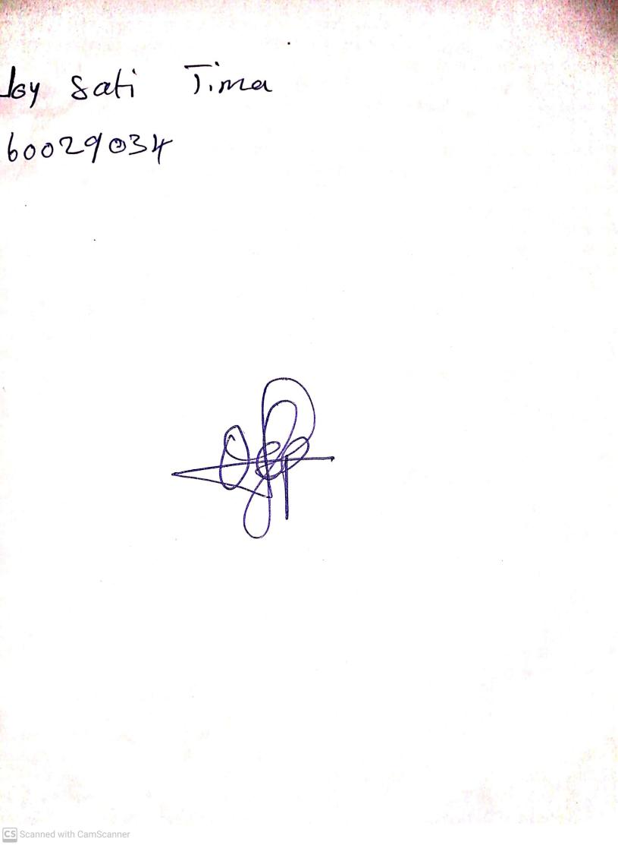

18th September, 2023

Perpetual Ojoma Ocheja

Stream Head Nursery