**EMERALD ROYAL INTERNATIONAL SCHOOL MPAPE, ABUJA**

**LESSON PLAN AND NOTE FOR WEEK 7 PERIOD 1 ENDING 25/10/2023**

**TERM: FIRST**

**WEEK: 7TH**

**DATE: 21/10/2024**

**CLASS: NURSERY 2**

**SUBJECT: NUMBER WORK**

**TOPIC: SHAPES**

**SUB-TOPIC: MEANING OF SHAPES AND EXAMPLES.**

**PERIOD: 2ND**

**TIME: 08: 50-09: 30 am**

**DURATION: 40 MINUTES**

**NUMBER IN CLASS: 16**

**AVERAGE AGE: 4**

**SEX: MIXED**

**SPECIFIC OBJECTIVES: BY THE END OF THE LESSON, THE PUPILS SHOULD BE ABLE**

**TO:**

1. **IDENTIFY OBJECTS AROUND US.**
2. **SAY THE SHAPES OF THE OBJECTS.**

**RATIONALE: FOR PUPILS TO BE ABLE TO KNOW SHAPES AROUND THEM.**

**PREVIOUS KNOWLEDGE: PUPILS ARE USED TO OBJECTS AROUND THEM.**

**INSTRUCTIONAL MATERIALS: CLOCK, MATCHES BOX, WHITE BOARD, CUBE OF SUGAR AND DICE.**

**REFERENCE MATERIALS: MY CHOICE OF MATHEMATICS STAGE 3 BY TOP STAR.**

**LESSON DEVELOPMENT**

|  |  |  |  |
| --- | --- | --- | --- |
| **STAGES/STEPS** | **TEACHER’S ACTIVITIES** | **PUPILS’ ACTIVITIES** | **LEARNING POINT** |
| **INTODUCTION** | **Teacher introduces the lesson by reviewing the previous lesson.** | **Pupils listen attentively to the teacher.** | **To arouse pupils interest for the lesson ahead.** |
| **PRESENTATION STEP 1** | **Teacher use cube of sugar, dice, matches box, tin, ball, and whiteboard to explain the shape identify to pupils and then asks them to repeat after her.** | **Pupils pay attention to the teacher and repeat after her.** | **For proper understanding.** |
| **STEP 2** | **Teacher says the shape of the objects mentioned above to pupils and also asks them to repeat after her.** | **Pupils pay attention to the board and tell the time.** | **To create plat form for slow learners.** |
| **BOARD SUMMARY** | **Teacher summarizes the lesson by writing the whole note of lesson on the board for pupils to copy into their books. That is;**  **SHAPES**  **Every object around us has shape.**  **The different shapes are :**   1. **Rectangle** 2. **Triangle** 3. **Square** 4. **Circle** 5. **Oval** 6. **Cylinder etc.** | **Pupils copy the note on the board into their exercise books.** | **For onward study.** |
| **EVALUATION** | **Teacher evaluates the lesson by asking the following questions:**  **What is the shape of the following ?**   1. **Cube of sugar** 2. **Dice** 3. **Matches box** 4. **Tin** 5. **Ball** 6. **Whiteboard** | **Pupils answer the questions asked by the teacher.** | **To asses pupils level of understanding of the lesson.** |
| **CONCLUSION** | **Teacher concludes the lesson by marking pupils books.** | **Pupils submit their books for marking.** | **For endorsement.** |
| **ASSIGNMENT** | **ACTIVITY 1 page 110 , AND ACTIVITY 2 page 111.** | **Pupils do their assignment at home.** | **To encourage learning at home.** |

**LESSON PLAN AND NOTE FOR WEEK 7 PERIOD 2 ENDING 25/10/2024**

**TERM: FIRST**

**WEEK: 7TH**

**DATE: 22/10/2024**

**CLASS: NURSERY 2**

**SUBJECT: NUMBER WORK**

**TOPIC: SHAPE**

**SUB-TOPIC: CIRCLE AND TRIANGLE**

**PERIOD: 2ND**

**TIME: 08: 50-09: 30 am**

**DURATION: 40 MINUTES**

**NUMBER IN CLASS: 16**

**AVERAGE AGE: 4**

**SEX: MIXED**

**SPECIFIC OBJECTIVES: BY THE END OF THE LESSON, THE PUPILS SHOULD BE ABLE**

**TO:**

**1.IDENTIFY SHAPE OF CIRCLE AND TRIANGLE**

**2. EXPLAIN THE SIDES AND CORNERS OF CIRCLE AND THAT**

**OF A TRIANGLE.**

**RATIONALE: FOR PUPILS TO KNOW MORE ABOUT CIRCLE AND TRIANGLE.**

**PREVIOUS KNOWLEDGE: PUPILS HAVE LEARNT ABOUT MEANING OF SHAPES AN EXAMPLES OF SHAPES IN PREVIOUS LESSON.**

**INSTRUCTIONAL MATERIALS: A CLOCK AND A FUNNEL.**

**REFERENCE MATERIALS: MY CHOICE OF MATHEMATICS STAGE 3 BY TOP STAR.**

**LESSON DEVELOPMENT**

|  |  |  |  |
| --- | --- | --- | --- |
| **STAGES/STEPS** | **TEACHER’S ACTIVITIES** | **PUPILS’ ACTIVITIES** | **LEARNING POINT** |
| **INTODUCTION** | **Teacher introduces the lesson by reviewing the previous lesson.** | **Pupils listen attentively to the teacher.** | **To arouse pupils interest for the lesson ahead.** |
| **PRESENTATION STEP 1** | **Teacher draws a circle and a triangle shape on the board for pupils to identify.** | **Pupils pay attention to the teacher and identify the shapes on the board.** | **For proper understanding.** |
| **STEP 2** | **Teacher explains the sides and corners of a circle and triangle to the pupils and then asks them to repeat after her.** | **Pupils listen very attentively to the teacher and repeat after her.** | **For better understanding of the lesson.** |
| **BOARD SUMMARY** | **Teacher summarizes the lesson by writing the whole note of lesson on the board for pupils to copy into their books. That is;**  **Sides and corners of a circle and triangle**   1. **A circle is round in shape it has no sides.** 2. **A triangle has three (3) equal sides and three (3 ) corners.** | **Pupils copy the note on the board into their exercise books.** | **For onward study.** |
| **EVALUATION** | **Teacher evaluates the lesson by asking the following questions;**   1. **What is a circle?** 2. **How may sides and corners does a triangle has?** | **Pupils answer the questions asked by the teacher.** | **To asses pupils level of understanding of the lesson.** |
| **CONCLUSION** | **Teacher concludes the lesson by marking pupils books.** | **Pupils submit their books for marking.** | **For endorsement.** |
| **ASSIGNMENT** | **Assignment on page 112, activity 3.** | **Pupils do their assignment at home.** | **To encourage learning at home.** |

**LESSON PLAN AND NOTE FOR WEEK 7 PERIOD 3 ENDING 25/10/2024**

**TERM: FIRST**

**WEEK: 7TH**

**DATE: 25/10/2024**

**CLASS: NURSERY 2**

**SUBJECT: NUMBER WORK**

**TOPIC: SHAPES.**

**SUB-TOPIC: SQUARE AND RECTANGLE .**

**PERIOD: 1ST**

**TIME: 08: 10-08:50 am**

**DURATION: 40 MINUTES**

**NUMBER IN CLASS: 16**

**AVERAGE AGE: 4**

**SEX: MIXED**

**SPECIFIC OBJECTIVES: BY THE END OF THE LESSON, THE PUPILS SHOULD BE ABLE**

**TO:**

1. **IDENTIFY THE SHAPE OF A SQUARE AND RECTANGLE**
2. **EXPLAIN THE SIDES AND CONNERS OF A SQUARE AND**

**RECTANGLE.**

**RATIONALE: FOR PUPILS TO KNOW HOW TO IDENTIFY VARIOUS SHAPES.**

**PREVIOUS KNOWLEDGE: PUPILS HAVE LEARNT ABOUT THE SHAPE OF A CIRCLE AND TRIANGLE IN PREVIOUS LESSON.**

**INSTRUCTIONAL MATERIALS: A DICE AND A MATCHES BOX.**

**REFERENCE MATERIALS: TOP STAR MY CHOICE OF MATHEMATICS STAGE 3 BY TOP STAR PUBLISHING LTD.**

**LESSON DEVELOPMENT**

|  |  |  |  |
| --- | --- | --- | --- |
| **STAGES/STEPS** | **TEACHER’S ACTIVITIES** | **PUPILS’ ACTIVITIES** | **LEARNING POINT** |
| **INTODUCTION** | **Teacher introduces the lesson by reviewing the previous lesson.** | **Pupils listen attentively to the teacher.** | **To arouse pupils interest for the lesson ahead.** |
| **PRESENTATION STEP 1** | **Teacher draws the shape of a rectangle and square on the board for pupils to identify.** | **Pupils pay attention to the teacher and identify the shapes on the board.** | **For proper understanding.** |
| **STEP 2** | **Teacher explains the sides and corners of a rectangle and square to pupils and also asks them to repeat after her.** | **Pupils listen very attentively to the teacher and repeat after her.** | **For better understanding of the lesson.** |
| **BOARD SUMMARY** | **Teacher summarizes the lesson by writing the whole note of lesson on the board for pupils to copy into their books. That is;**  **Rectangle and square**   1. **A rectangle has four (4) sides. Not all the sides are equal,**   **Opposite sides are equal and parallel.**  **A rectangle also has four (4) corners.**   1. **A square has four (4) sides. All sides are equal and four (4) corners.** | **Pupils copy the note on the board into their exercise books.** | **For onward study.** |
| **EVALUATION** | **Teacher evaluates the lesson by asking pupils to explain the following shapes;**   1. **Rectangle** 2. **square** | **Pupils answer the questions asked by the teacher.** | **To asses pupils level of understanding of the lesson.** |
| **CONCLUSION** | **Teacher concludes the lesson by marking pupils books.** | **Pupils submit their books for marking.** | **For endorsement.** |
| **ASSIGNMENT** | **Assignment page 113 activity 4.** | **Pupils do their assignment at home.** | **To encourage learning at home.** |

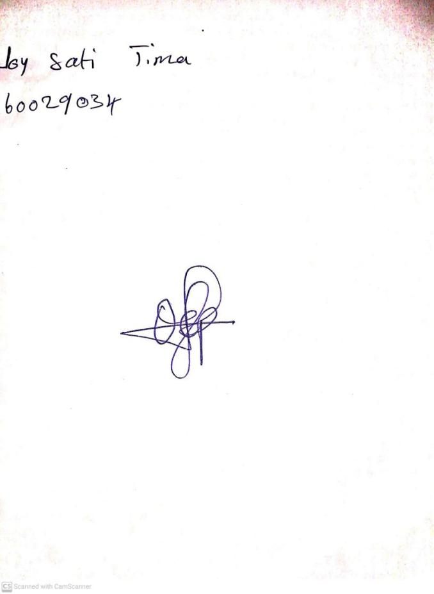

**11th October, 2024**

**Perpetual Ojoma Ocheja**

**Stream Head Nursery**