LESSON PLAN AND NOTE FOR WEEK 2 ENDING 22/09/2023

TERM: 1st

WEEK: 2nd

DATE: 18/09/2023

CLASS: Nursery 2

SUBJECT: Nature studies

TOPIC: First aid

SUB—TOPIC: Items in first aid kit and their uses.

PERIOD: 4th

TIME: 10:40—11:20am

DURATION: 40 minutes

NUMBER IN CLASS: 14

AVERAGE AGE: 5 years

SEX: Mixed

LEARNING OBJECTIVES: By the end of the lesson, the pupils should be able to:

1. Mention first aid items.

2. State the uses of the first aid items.

RATIONALE: For pupils to know more about first aid and it's items and uses.

PREVIOUS KNOWLEDGE: Pupils have learnt about the meaning of first aid and first aid kit in

Previous lesson.

INSTRUCTIONAL MATERIALS: Razor blade, scissors, and bandage.

REFERENCE MATERIALS: Basic science and technology for Nursery schools book 3 by OPEMIPO DADA.

LESSON DEVELOPMENT

|  |  |  |  |
| --- | --- | --- | --- |
| Steps | Teacher's activities | Pupils' activities | Learning point |
| Introduction | Teacher introduces the lesson by reviewing the previous lesson. | Pupils pay attention to the teacher. | To prepare pupils minds for the lesson ahead. |
| Presentation step 1 | Teacher mentions the first aid items to pupils and then asks them to repeat after her. | Pupils listen to the teacher and repeat after her. | To improve pupils listening and speaking ability. |
| Step 2 | Teacher States the uses of the first aid items to pupils and also asks them to repeat after her. | Pupils pay attention to the teacher and repeat her. | To enhance pupils participation in the class. |
| Board summary | Teacher writes the whole note of lesson on the board for pupils to copy into their books. That is;  First aid items:  Items in first aid kit are:   1. Cotton wool 2. Scissors 3. Plaster 4. Razor blade 5. Bandage 6. Tea spoon 7. G.V 8. Disposable sterile gloves. 9. Safety pins 10. Mentholated spirit 11. Eye wash 12. Iodine 13. Antiseptic 14. Tweezer 15. Insect bite cream 16. Eye patch 17. Pain reliever etc.   Uses of first aid items:  1.Cotton wool is used for cleaning blood.  2. Plaster is use to stick treatment to the wound.  3. Bandage is use to tie dislocation .  4. Eye wash is used for washing the eyes.  5. Iodine is used for cleaning wounds to keep germs away.  6. Safety pin is used for holding the ends of a bandage.  7. Scissors is used for cutting plaster and bandage.  8. Plaster is used for covering wounds to keep germs away.  9. Gloves are used for protecting the hands.  10. Eye patch is used to cover an injured eye.  11. Antiseptic wash is used for washing wounds to keep germs away.  12. Pain reliever is used to reduce the pain that an injured person feels. | Pupils copy the note into their exercise books. | For onward study. |
| Evaluation | Teacher evaluates the lesson by asking pupils the following questions;   1. Mention the first aid items that you know. 2. State the uses of the items. | Pupils answer the questions asked by the teacher. | To assess pupils level of understanding. |
| Conclusion | Teacher concludes the lesson by marking pupils books. | Pupils submit their books for marking. | For endorsement. |
| Assignment | Mention ten(10) parts of your body. | Pupils do their assignment at home. | To encourage learning at home. |

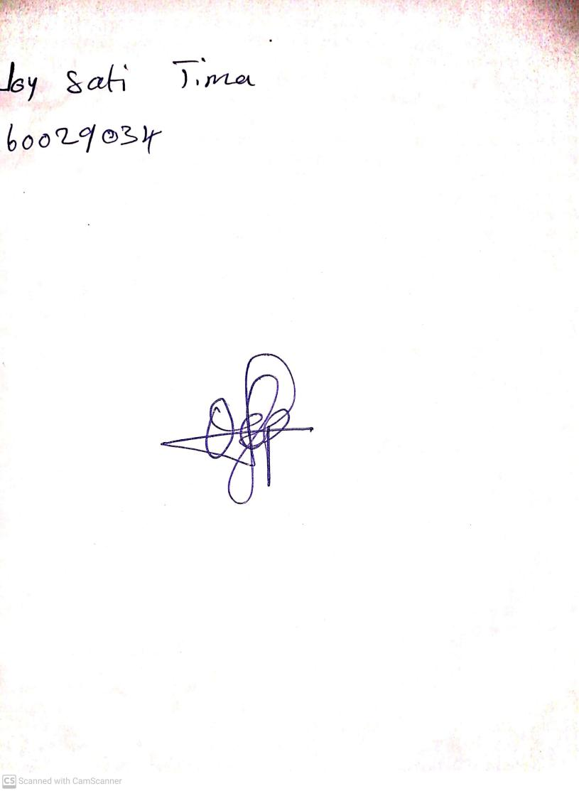

27th August, 2023

Perpetual Ojoma Ocheja

Stream Head Nursery