**LESSON PLAN AND NOTE 1 FOR WEEK 1 ENDING 5/5/2023**

**Term 3nd term**

**Week 1st week**

**Date 5/5/2023**

**Class Nursery one**

**Subject Letter work**

**Topic Coping words with letter Mm.**

**Sub-topic Naming three letter words with letter Mm.**

**Period 2nd period**

**Time 9:05 am**

**Duration 35 minutes**

**No in class 19**

**Average Age 3 years**

**Sex Mixed**

**Specific Objectives: By the end of the lesson the pupils should be able to;**

1. **Name letter word that with Mm**
2. **Trace letter word that with Mm**

**Rationale: To make sure the pupils mention and trace three letter words**

**with Mm**

**Previous knowledge: The pupils can write three letter words with Hh & Ii.**

**Instructional Resources: Chart, board, marker, exercise books, pencils.**

**Reference Materials: Online Research,chart,board.**

**LESSON PRESENTATION**

|  |  |  |  |
| --- | --- | --- | --- |
| **Steps** | **Teacher’s Activities** | **Pupils’ Activities** | **Learning points** |
| **Introduction** | **The teacher introduces the topic (coping word with letter Mm, to the pupils.** | **The pupils listen attentively to the teacher.** | **To arouse the interest of the pupils.** |
| **Step 1** | **The teacher starts by naming three letter words with Mm. for the pupils to repeat after ‘’mat’’,** | **The pupils repeat after the teacher the three letter words with Mm.** | **For proper understanding.** |
| **Step 2** | **The teacher guides the pupils in tracing three letter words with sound Mm,** | **The pupils trace the three letter words with Mm as the teacher guides them.** | **For better understanding.** |
| **Summary** | **The teacher summarizes the lesson by sounding letter words with Mm, : ‘’mat’’,** | **The pupils can sound three letter words with Mm,: ‘’mat’’, ’.** | **For onward study.** |
| **Evaluation** | **Question:**  **Mention the letter word starting with Mm?**  **Trace the letters starting with letter Mm?** | **The pupils answer the question correctly.** | **To ascertain the pupils’ understanding.** |
| **Conclusion** | **The teacher summarizes, reacts & corrects the pupils.** | **The pupils answer to the teacher’s questions.** | **To consolidate the lesson.** |
| **Assignment** | **Question:**  **Name words that starts with Mm?** | **The pupils copy and do their homework at home?** | **To encourage learning while at home.** |

**LESSON PLAN AND NOTE 2 FOR WEEK 1 ENDING 5/5/2023**

**Term 3rd term**

**Week 1st week**

**Date 5/5/2023**

**Class Nursery one**

**Subject Letter work**

**Topic Coping words with letter Mm,**

**Sub-topic Colouring objects & animals with Mm,**

**Period 2nd period**

**Time 9:32 am**

**Duration 35 minutes**

**No in class 19**

**Average Age 3 years**

**Sex Mixed**

**Specific Objectives: By the end of the lesson the pupils should be able to;**

1. **Identify three letter words &objects that start with Mm**
2. **Colour three letter words &objects that start with Mm**

**Rationale: To make the pupils identify &colour three letter words**

**with Mm**

**Previous knowledge: The pupils have name &trace letter words starting with Mm**

**Instructional Resources: Crayon, board, marker, exercise books, pencils.**

**Reference Materials: Online Research,marker,board.**

**LESSON PRESENTATION**

|  |  |  |  |
| --- | --- | --- | --- |
| **Steps** | **Teacher’s Activities** | **Pupils’ Activities** | **Learning points** |
| **Introduction** | **The teacher introduces the topic (coping words with letter Mm, to the pupils.** | **The pupils listen attentively to the teacher.** | **To arouse the interest of the pupils.** |
| **Step 1** | **The teacher draws objects that start with letter words Mm for the pupils to identify.** | **The pupils participate to identify objects that start with Mm** | **For proper understanding.** |
| **Step 2** | **The teacher draws and guides the pupils to colour objects starting with sound Mm** | **The pupils colour the objects that start with letter Mm** | **For better understanding.** |
| **Summary** | **The teacher summarizes the lesson by identifying other objects with letter Mm** | **The pupils have knowledge of identifying and colouring objects with letter Mm** | **For onward study.** |
| **Evaluation** | **Question:**  **Identify objects that starts with Mm? Colour the objects that starts with letter Mm?** | **The pupils answer the question correctly.** | **To ascertain the pupils’ understanding.** |
| **Conclusion** | **The teacher summarizes, reacts & corrects the pupils.** | **The pupils answer to the teacher’s questions.** | **To consolidate the lesson.** |
| **Assignment** | **Question;**  **Identify objects that starts with Mm?** | **The pupils copy and do their homework at home?** | **To encourage learning while at home.** |

**LESSON PLAN AND NOTE 3 FOR WEEK 1 ENDING 5/5/2023**

**Term 2nd term**

**Week 1st week**

**Date 12/5/2023**

**Class Nursery one**

**Subject Letter work**

**Topic Coping words with letter Mm**

**Sub-topic Matching objects & animals with three letter Mm on the cardboard**

**Period 2nd period**

**Time 9:43am**

**Duration 35 minutes**

**No in class 19**

**Average Age 3 years**

**Sex Mixed**

**Specific Objectives: By the end of the lesson the pupils should be able to;**

1. **Pick from a box a picture word with Mm & paste on the cardboard**
2. **Write three letter words with Mm**

**Rationale: To make the pupils match & write letter words with Mm**

**Previous knowledge: The pupils have identify&colour three letter words with Mm**

**Instructional Resources: Cardboard , exercise books, pencils.**

**Reference Materials: Online Research,Cardboard.**

**LESSON PRESENTATION**

|  |  |  |  |
| --- | --- | --- | --- |
| **Steps** | **Teacher’s Activities** | **Pupils’ Activities** | **Learning points** |
| **Introduction** | **The teacher introduces the topic (coping words with three letter Mm) to the pupils.** | **The pupils listen attentively to the teacher.** | **To arouse the interest of the pupils.** |
| **Step 1** | **The teacher present a box with picture words and assists the pupils using gum to paste on the cardboard the pictures starting with Mm.** | **The pupils participate actively in picking and pasting on the cardboard the word picture with letter Mm** | **For proper understanding.** |
| **Step 2** | **The teacher guides the pupils to write three letter words with Mm inside their notebooks**  **m a t** | **The pupils write letter words with Mm as the teacher guides them.** | **For better understanding.** |
| **Summary** | **The teacher summarizes the lesson by sounding random letter words with Mm.** | **The pupils have knowledge of letter words with Mm.** | **For onward study.** |
| **Evaluation** | **Question:**  **Pick from the box picture words that starts with Mm?**  **Write the three letter words with Mm below**   |  | | --- | | **m a t** | |  | | **The pupils answer the question correctly.** | **To ascertain the pupils’ understanding.** |
| **Conclusion** | **The teacher summarizes, reacts & corrects the pupils.** | **The pupils answer to the teacher’s questions.** | **To consolidate the lesson.** |
| **Assignment** | **Write the three letter words “mat”** | **The pupils copy and do their homework at home.** | **To ensure learning while at home.** |

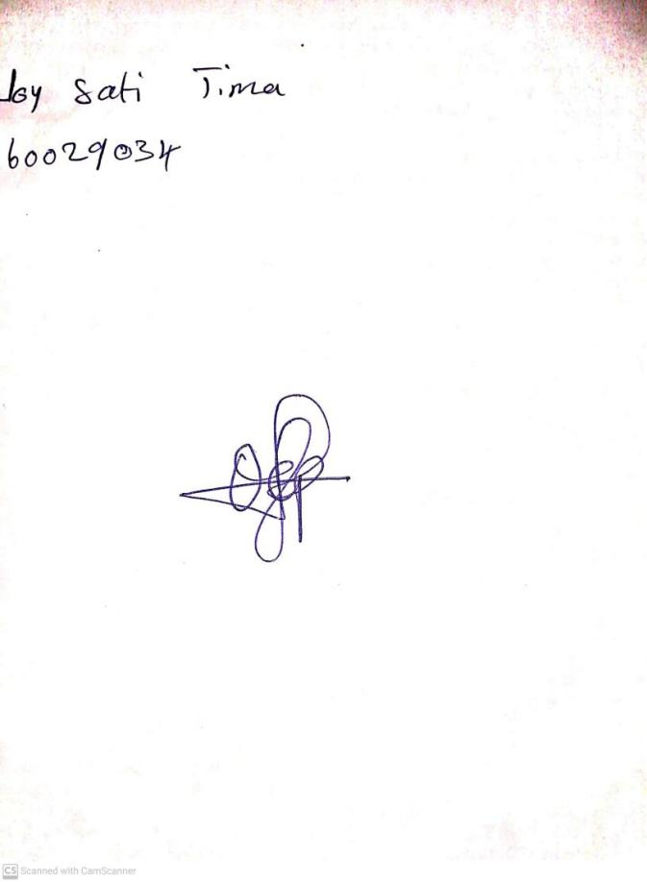

10th May, 2023

Perpetual Ojoma

Stream Head Nursery