**EMERALD ROYAL INTERNATIONAL SCHOOL**

**MPAPE, ABUJA.**

**LESSON PLAN AND NOTE FOR WEEK 9 ENDING 08/11/2024**

**TERM: 1st**

**WEEK: 9th**

**DATE: 04/11/2024**

**CLASS: Nursery 2**

**SUBJECT: Nature studies**

**TOPIC: Food**

**SUB—TOPIC: Meaning and types of food**

**PERIOD: 4th**

**TIME: 10:40—11:20am**

**DURATION: 40 minutes**

**NUMBER IN CLASS: 14**

**AVERAGE AGE: 5 years**

**SEX: Mixed**

**LEARNING OBJECTIVES: By the end of the lesson, the pupils should be able to:**

**1. Define food.**

**2. Mention the types of food.**

**3. State the reason why we eat food.**

**RATIONALE: For pupils to know more about food.**

**PREVIOUS KNOWLEDGE: Pupils have been eating food.**

**INSTRUCTIONAL MATERIALS: A plate of cook food.**

**REFERENCE MATERIALS: Basic science and technology for Nursery schools book 3 by OPEMIPO DADA.**

**LESSON DEVELOPMENT**

|  |  |  |  |
| --- | --- | --- | --- |
| **Steps** | **Teacher's activities** | **Pupils' activities** | **Learning point** |
| **Introduction** | **Teacher introduces the lesson by reviewing the previous lesson.** | **Pupils pay attention to the teacher.** | **To prepare pupils minds for the lesson ahead.** |
| **Presentation**  **step 1** | **Teacher defines food to pupils and then asks them to repeat after her.** | **Pupils listen to the teacher and repeat after her.** | **To improve pupils listening and speaking ability.** |
| **Step 2** | **Teacher mentions the types of food to pupils and also asks them to repeat after her.** | **Pupils pay attention to the teacher and repeat her.** | **To enhance pupils participation in the class.** |
| **Step 3** | **Teacher States the reasons why we eat food to pupils and also asks them to repeat after her.** | **Pupils listen very attentively to the teacher and repeat after her.** | **To improve pupils speaking ability.** |
| **Board summary** | **Teacher writes the whole note of lesson on the board for pupils to copy into their books. That is;**  **Food:**  **Food is anything we eat, drink or take into our body to give us energy and help us grow.**  **Examples of food eaten in our locality are:**   1. **Rice** 2. **Yam** 3. **Beans** 4. **Garri** 5. **Coco yam** 6. **Plantain** 7. **Eggs** 8. **Meat** 9. **Palm oil** 10. **Vegetables** 11. **Potatoes** 12. **Noddle** 13. **Spaghetti** 14. **Fish** 15. **Milk etc.**   **Reasons why we eat food:**   1. **We eat food to make our body strong.** 2. **We eat food to keep our body healthy.** 3. **We eat food to help us grow.** | **Pupils copy the note into their exercise books.** | **For onward study.** |
| **Evaluation** | **Teacher evaluates the lesson by asking pupils the following questions;**   1. **What is food?** 2. **Mention the types of food in our locality.** 3. **State the reasons for eating food.** | **Pupils answer the questions asked by the teacher.** | **To assess pupils level of understanding.** |
| **Conclusion** | **Teacher concludes the lesson by marking pupils books.** | **Pupils submit their books for marking.** | **For endorsement.** |
| **Assignment** | **Answer the following question:**  **Mention 10 other types of food that you know.** | **Pupils do their assignment at home.** | **To encourage learning at home.** |

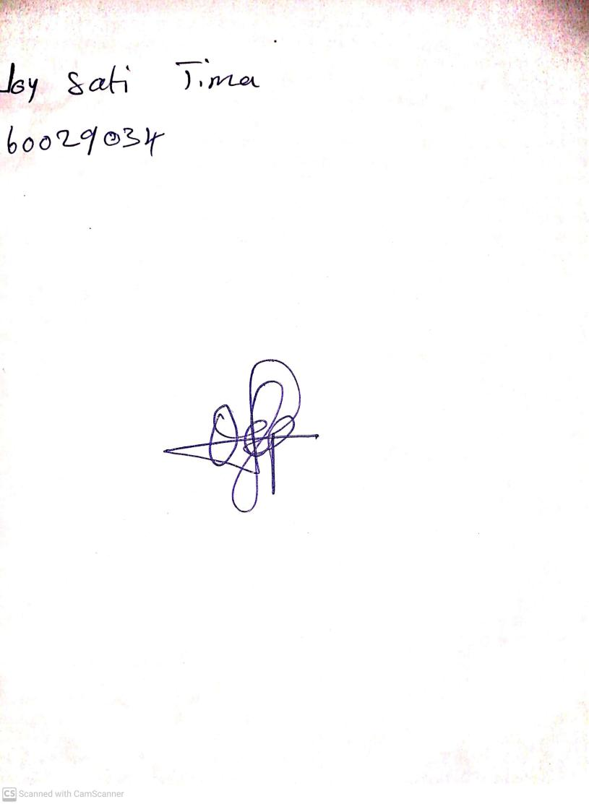

**1st November, 2024**

**Perpetual Ojoma Ocheja**

**Stream Head Nursery**