**EMERALD ROYAL INTERNATIONAL SCHOOL**

**MPAPE, ABUJA.**

**LESSON PLAN AND NOTE FOR WEEK 8 ENDING 23RD JUNE, 2023.**

TERM : Third term.

WEEK : 8th

SUBJECT: Social Norms

TOPIC: Our environment.

SUB-TOPIC: Meaning of an environment.

DATE: 23/6/2023

DURATION: 40 minutes

TIME: 10:40-11:20

PERIOD: 5th

CLASS: pre-nursery

NUMBER OF PUPILS: 11

AVERAGE AGE: 2

SEX: Mixed

SPECIFIC OBJECTIVES: By the end of the lesson, the pupils should be able to:-

1. Define an environment.

2. Identify objects in the environment.

RATIONALE: For pupils to be conversant with their environment.

PREVIOUS KNOWLEDGE: Pupils have been seeing their homes and school environment.

INSTRUCTIONAL MATERIAL:- pictures of television, chair and slide.

REFERENCE: Smart start Civic education for nursery Schools book 1 by T.Y. Alabi and A. M. Solu.

LESSON DEVELOPMENT

|  |  |  |  |
| --- | --- | --- | --- |
| Stages/steps | Teacher's activities | Pupils' activities | Learning points |
| Introduction | Teacher introduces the lesson by asking the pupils to look around the class and tell her what they see. | Pupils look around and tell the teacher that they see:- chair, board, television and table. | To arouse the interest of the pupils for the new lesson. |
| Presentation  Step 1 | Teacher explains the meaning of environment to the pupils . That is,  "An environment is the surroundings where a person, an animal or plant lives."  Teacher asks the pupils to repeat after the teacher. | Pupils say the meaning of environment after the teacher. | To improve pupils understanding. |
| Step 2 | Teacher leads the pupils to identify things found in the classroom. | Pupils identify and point at the picture of objects found in the classroom as:-  Chair.  Television.  Table  Books  Wall clock.  Pencil  Fan  Bag | To ensure active participation. |
| Summary | Teacher summarizes the lesson by explaining to the pupils that classroom is a learning environment where children stays and learn how to read and write. | Pupils pay attention to the teacher and repeat after the her. | To ensure proper understanding of the lesson. |
| Evaluation | Teacher asks the pupils to:-   1. Explain the meaning of environment. 2. Mention the objects in the classroom. | Pupils answer the questions correctly. | To assess the level of pupils understanding of the lesson. |
| Conclusion | Teacher ends the lesson by singing rhymes for the pupils. | Pupils sing along with the teacher. | To consolidate the lesson. |
| Assignment | Teacher asks pupils to mention the objects in their house. | Pupils do the assignment at home . | To encourage learning at home. |

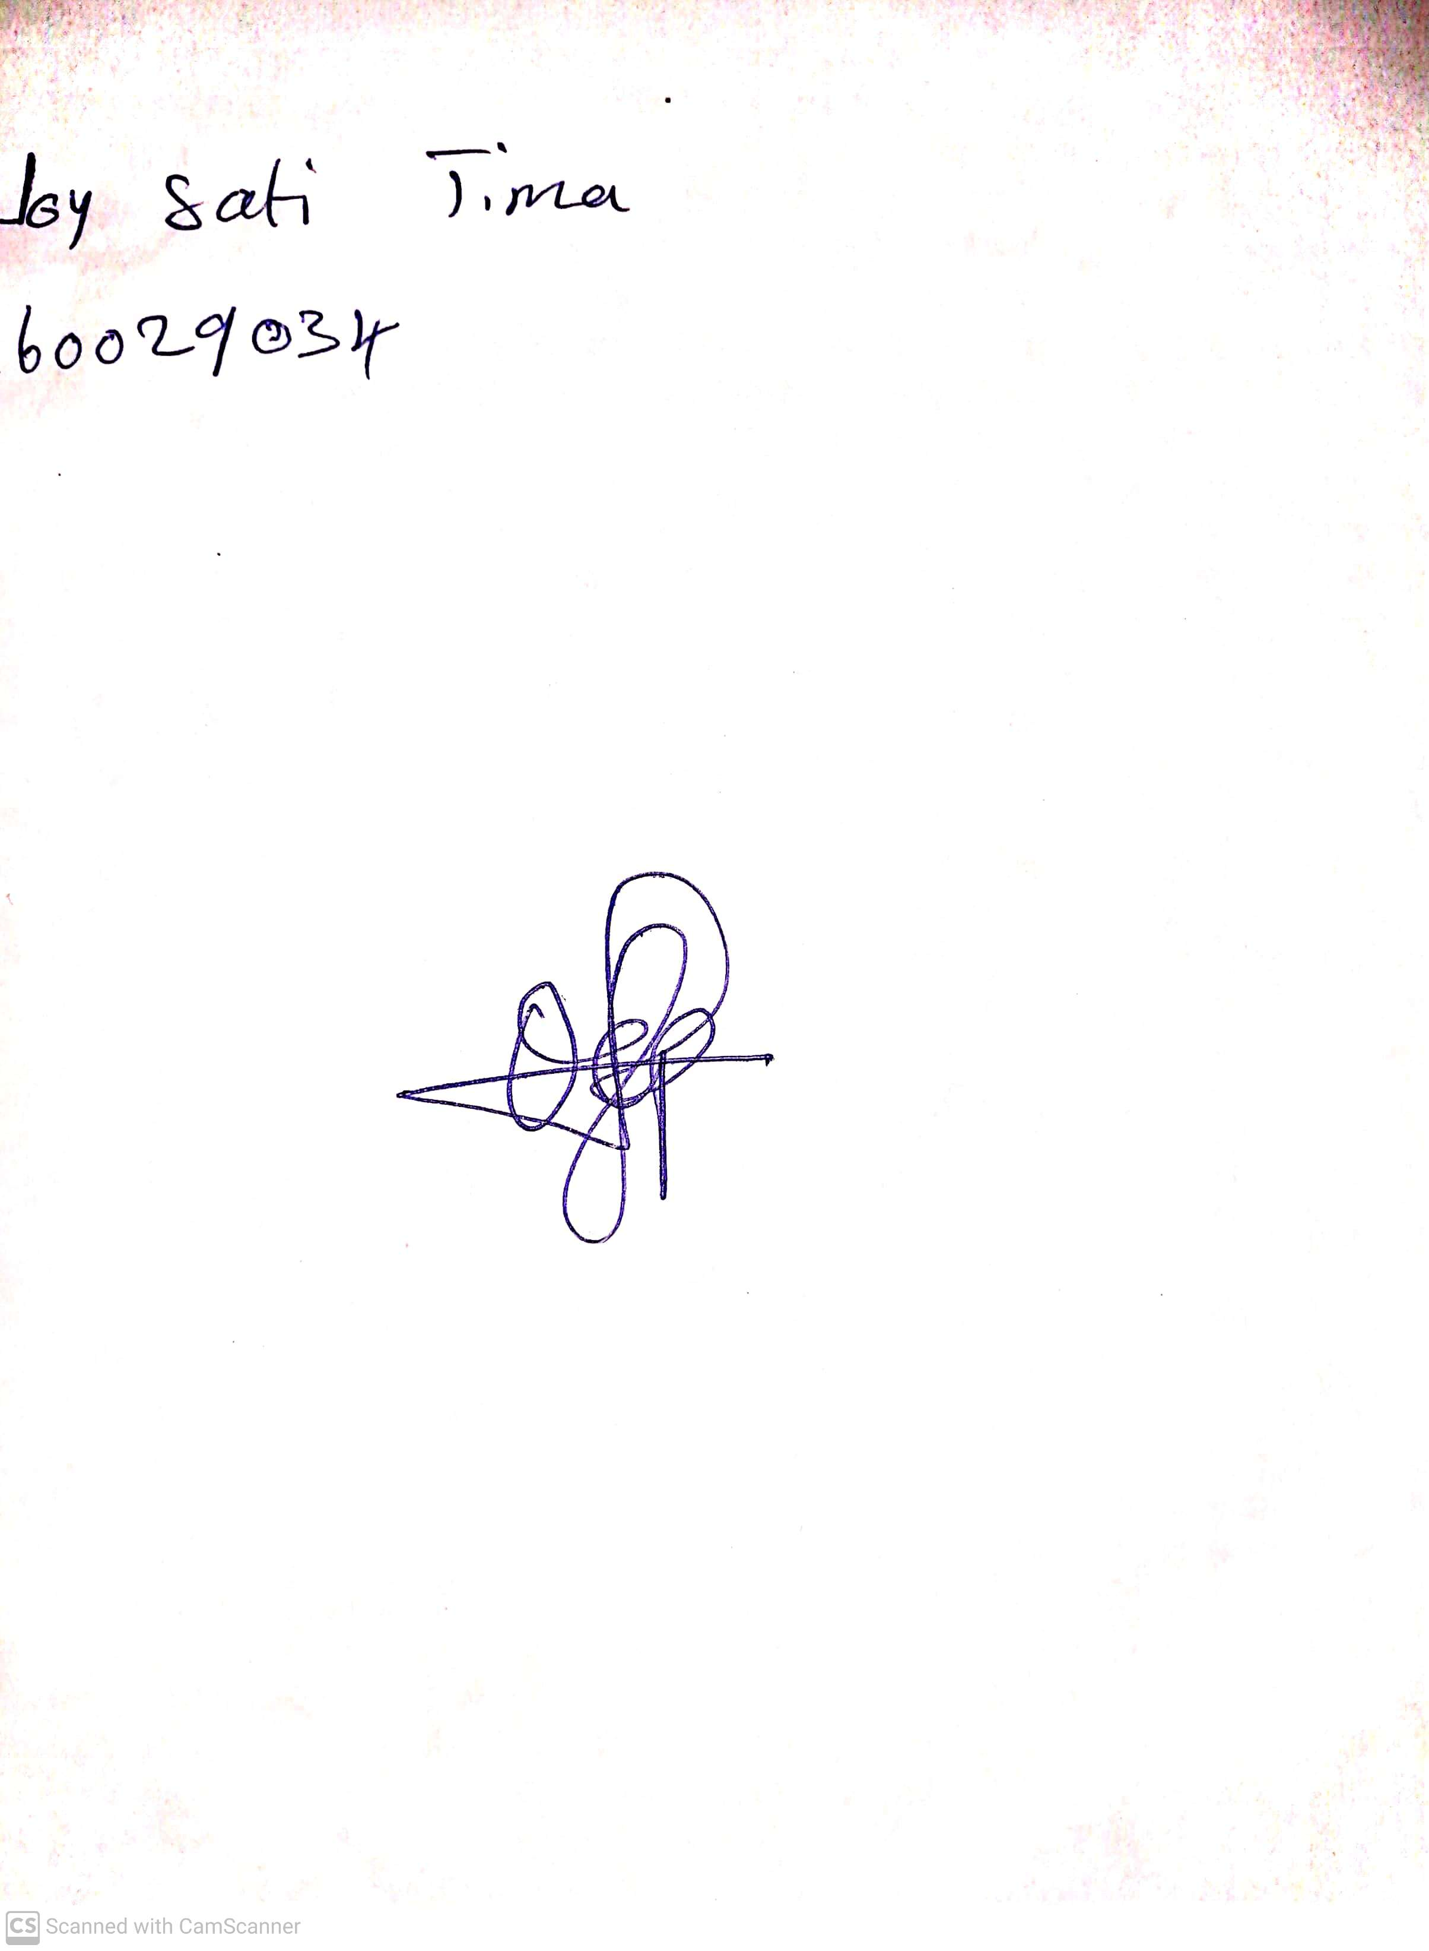

29th April, 2023

Perpetual Ojoma

Stream Head Nursery