LESSON PLAN AND NOTE FOR WEEK 3 ENDING 19/05/2023

TERM: 3rd

WEEK: 3rd

DATE: 15/05/2023

CLASS: Nursery 2

SUBJECT: Social norms

TOPIC: Violence (physical).

SUB—TOPIC: Meaning, harmful effect and examples.

PERIOD: 2nd period after long break

TIME: 11:20—12: 00pm

DURATION: 40 minutes

NUMBER IN CLASS: 14

AVERAGE AGE: 5 years

SEX: Mixed

LEARNING OBJECTIVES: By the end of the lesson, the Pupils should be able to:

1. Explain the meaning of physical violence.

2. State the examples of physical violence.

3. Mention the effect of physical violence.

RATIONALE: For pupils to have the awareness of violence

PREVIOUS KNOWLEDGE: Pupils have learnt Parental care in previous lesson

INSTRUCTIONAL MATERIALS: Pictures of people who have fall victim of physical violence.

REFERENCE MATERIALS: Google. com

LESSON DEVELOPMENT

|  |  |  |  |
| --- | --- | --- | --- |
| Steps | Teacher's activities | Pupils' activities | Learning point |
| Introduction | Teacher review the previous lesson. | Pupils pay attention to the teacher. | To prepare pupils minds for the lesson ahead. |
| Presentation step 1 | Teacher explains the meaning of physical violence to pupils and then asks them to repeat after her. | Pupils pay attention to the teacher and repeat after her. | For proper understanding. |
| Step 2 | Teacher states the examples.of.physical violence to pupils and also asks them to repeat after her. | Pupils listen to the teacher and repeat after her. | For better understanding. |
| Step 3 | Teacher mentions the effect of physical violence to pupils . | Pupils listen attentively to the teacher. | To enhance Pupils listening skills. |
| Board summary | Teacher summarizes the lesson by writing the whole note of lesson on the board for pupils to copy into their books. That is;  Violence (physical)  Physical violence is simply the use of physical force so as to injured, abuse,damage, or destroy. Physical violence occurs when a person close to the child deliberately commit an act that results in a physical injury to the child.  Examples of physical violence are:  1. Beating  2. Burning  3. Kicking  4. Punching  5. Biting  6. Maiming or killing  7. The use of objects or weapons.  Effect of physical violence.  1. Heart problems  2. High blood pressure  3. Digestive problems etc. | Pupils copy the note into their exercise books. | For onward study. |
| Evaluation | Teacher evaluates the lesson by asking pupils the following questions:  1. What is Physical violence?  2. State the examples of physical violence.  3. Mention the effects of physical violence.. | Pupils answer the questions asked by the teacher. | To assess pupils level of understanding. |
| Conclusion | Teacher concludes the lesson by marking pupils books. | Pupils submit their books for marking.. | For endorsement. |
| Assignment | Answer the following questions:  1. What is mental violence?  2. State the examples of mental violence.  3. Mention the effects of mental violence. | Pupils do their assignment at home. | To encourage learning at home. |

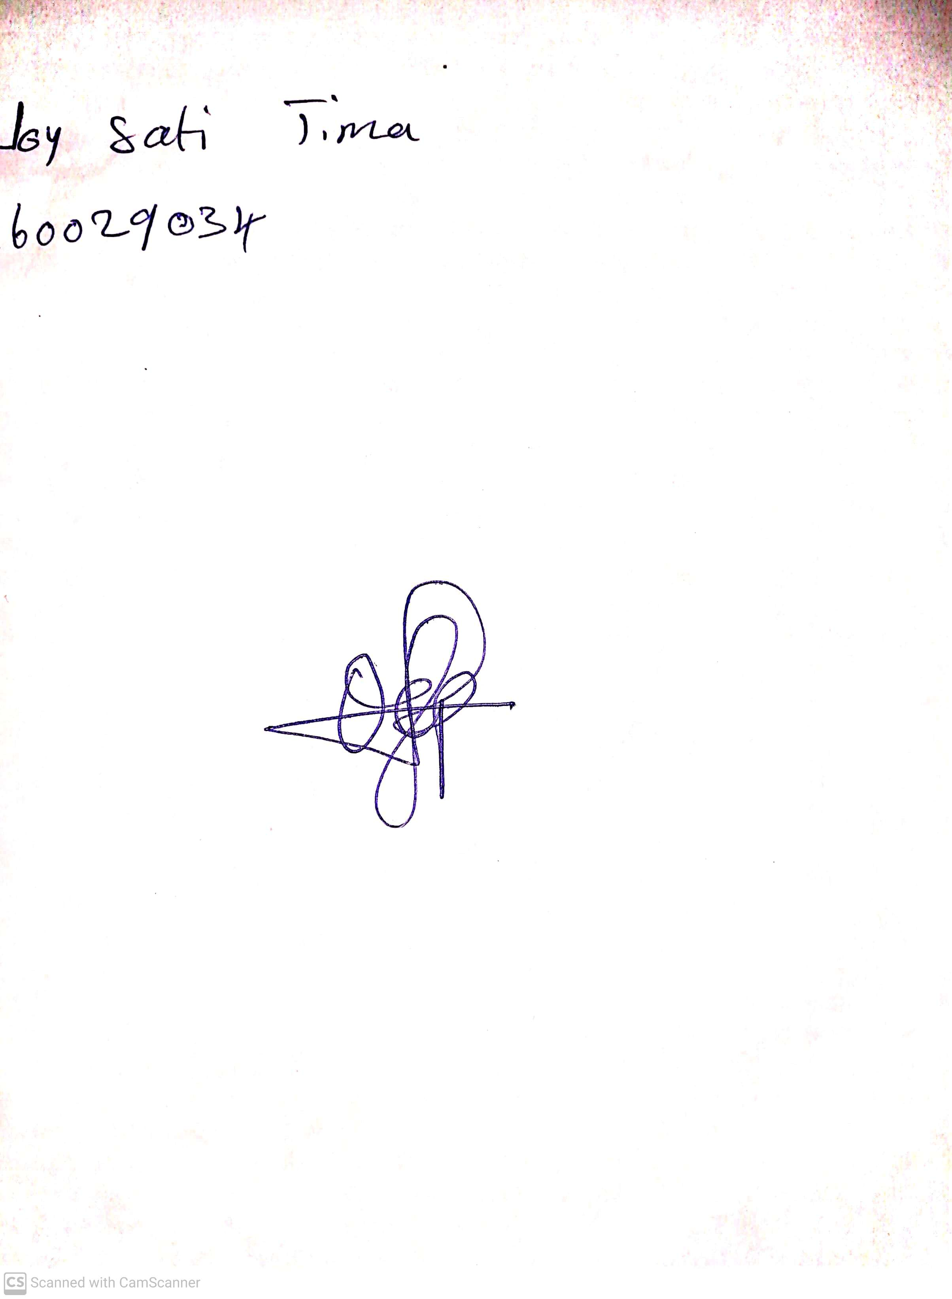

4th May, 2023

Perpetual Ojoma

Stream Head Nursery