**LESSON PLAN AND NOTE 1 FOR WEEK 2 ENDING 12/5/2023**

**Term 3nd term**

**Week 2nd week**

**Date 12/5/2023**

**Class Nursery one**

**Subject Letter work**

**Topic Coping words with letter Nn, Oo ,Pp.**

**Sub-topic Naming three letter words with letter Nn, Oo ,Pp.**

**Period 2nd period**

**Time 9:05 am**

**Duration 35 minutes**

**No in class 19**

**Average Age 3 years**

**Sex Mixed**

**Specific Objectives: By the end of the lesson the pupils should be able to;**

1. **Name three letter words that with Nn, Oo ,Pp.**
2. **Trace three letter words that with Nn, Oo ,Pp.**

**Rationale: To make sure the pupils mention and trace three letter words**

**with Nn, Oo ,Pp.**

**Previous knowledge: The pupils can write three letter words with Mm.**

**Instructional Resources: Chart, board, marker, exercise books, pencils.**

**Reference Materials: Online Research,chart,board.**

**LESSON PRESENTATION**

|  |  |  |  |
| --- | --- | --- | --- |
| **Steps** | **Teacher’s Activities** | **Pupils’ Activities** | **Learning points** |
| **Introduction** | **The teacher introduces the topic (coping words with letter Nn, Oo ,Pp.) to the pupils.** | **The pupils listen attentively to the teacher.** | **To arouse the interest of the pupils.** |
| **Step 1** | **The teacher starts by naming three letter words with Nn, Oo ,Pp. for the pupils to repeat after ‘’net’’, “oil”, “pot”.** | **The pupils repeat after the teacher the three letter words with Nn, Oo ,Pp.** | **For proper understanding.** |
| **Step 2** | **The teacher guides the pupils in tracing three letter words with sound Nn, Oo ,Pp.** | **The pupils trace the three letter words with Nn, Oo ,Pp. as the teacher guides them.** | **For better understanding.** |
| **Summary** | **The teacher summarizes the lesson by sounding three letter words with Nn, Oo ,Pp. : ‘’net’’, “oil”, “pot”.** | **The pupils can sound three letter words with Nn, Oo ,Pp. : ‘’hat’’, ‘’ink’’.** | **For onward study.** |
| **Evaluation** | **Question:**   1. **Mention the three letter word starting with Nn, Oo ,Pp.** 2. **Trace the three letter words with Nn, Oo ,Pp. : ‘’net’’, “oil”, “pot”.** | **The pupils answer the question correctly.** | **To ascertain the pupils’ understanding.** |
| **Conclusion** | **The teacher summarizes, reacts & corrects the pupils.** | **The pupils answer to the teacher’s questions.** | **To consolidate the lesson.** |
| **Assignment** | **Question:**  **Mention words that starts with Nn, Oo ,Pp.** | **The pupils copy and do their homework at home.** | **To encourage learning while at home.** |

**LESSON PLAN AND NOTE 2 FOR WEEK 2 ENDING 12/5/2023**

**Term 3rd term**

**Week 2nd week**

**Date 12/5/2023**

**Class Nursery one**

**Subject Letter work**

**Topic Coping words with letter Nn, Oo ,Pp**

**Sub-topic Colouring objects & animals with Nn, Oo ,Pp.**

**Period 2nd period**

**Time 9:32 am**

**Duration 35 minutes**

**No in class 19**

**Average Age 3 years**

**Sex Mixed**

**Specific Objectives: By the end of the lesson the pupils should be able to;**

1. **Identify three letter words &objects that start with Nn, Oo ,Pp**
2. **Colour three letter words &objects that start with Nn, Oo ,Pp**

**Rationale: To make the pupils identify &colour three letter words**

**with Nn, Oo ,Pp**

**Previous knowledge: The pupils have name &trace letter words starting with Nn, Oo ,Pp**

**Instructional Resources: Crayon, board, marker, exercise books, pencils.**

**Reference Materials: Online Research,marker,board.**

**LESSON PRESENTATION**

|  |  |  |  |
| --- | --- | --- | --- |
| **Steps** | **Teacher’s Activities** | **Pupils’ Activities** | **Learning points** |
| **Introduction** | **The teacher introduces the topic (coping words with letter Nn, Oo ,Pp) to the pupils.** | **The pupils listen attentively to the teacher.** | **To arouse the interest of the pupils.** |
| **Step 1** | **The teacher draws objects that start with three letter words Nn, Oo ,Pp for the pupils to identify.** | **The pupils participate to identify objects that start with Nn, Oo ,Pp** | **For proper understanding.** |
| **Step 2** | **The teacher draws and guides the pupils to colour objects starting with sound Nn, Oo ,Pp** | **The pupils colour the objects that start with letter Nn, Oo ,Pp** | **For better understanding.** |
| **Summary** | **The teacher summarizes the lesson by identifying other objects with letter Nn, Oo ,Pp** | **The pupils have knowledge of identifying and colouring objects with letter Nn, Oo ,Pp** | **For onward study.** |
| **Evaluation** | **Question:**  **Identify the objects with letter Nn, Oo ,Pp**  **Colour the objects with letter Nn, Oo ,Pp** | **The pupils answer the question correctly.** | **To ascertain the pupils’ understanding.** |
| **Conclusion** | **The teacher summarizes, reacts & corrects the pupils.** | **The pupils answer to the teacher’s questions.** | **To consolidate the lesson.** |
| **Assignment** | **Question:**  **Identify and colour objects with letter Nn, Oo ,Pp?** | **The pupils copy and do their homework at home.** | **To encourage learning while at home.** |

**LESSON PLAN AND NOTE 3 FOR WEEK 2 ENDING 12/5/2023**

**Term 2nd term**

**Week 2nd week**

**Date 12/5/2023**

**Class Nursery one**

**Subject Letter work**

**Topic Coping words with letter Nn, Oo ,Pp**

**Sub-topic Matching objects & animals with letter Nn, Oo ,Pp on the cardboard**

**Period 2nd period**

**Time 9:43am**

**Duration 35 minutes**

**No in class 19**

**Average Age 3 years**

**Sex Mixed**

**Specific Objectives: By the end of the lesson the pupils should be able to;**

1. **Pick from a box a picture word with Nn, Oo ,Pp & paste on the cardboard**
2. **Write three letter words with Nn, Oo ,Pp.**

**Rationale: To make the pupils match & write three letter words with Nn, Oo ,Pp**

**Previous knowledge: The pupils have identify&colour three letter words with Nn, Oo ,Pp**

**Instructional Resources: Cardboard , exercise books, pencils.**

**Reference Materials: Online Research,Cardboard.**

**LESSON PRESENTATION**

|  |  |  |  |
| --- | --- | --- | --- |
| **Steps** | **Teacher’s Activities** | **Pupils’ Activities** | **Learning points** |
| **Introduction** | **The teacher introduces the topic (coping words with letter Nn, Oo ,Pp) to the pupils.** | **The pupils listen attentively to the teacher.** | **To arouse the interest of the pupils.** |
| **Step 1** | **The teacher present a box with picture words and assists the pupils using gum to paste on the cardboard the pictures starting with Nn, Oo ,Pp.** | **The pupils participate actively in picking and pasting on the cardboard the word picture with letter Nn, Oo ,Pp.** | **For proper understanding.** |
| **Step 2** | **The teacher guides the pupils to write three letter words with Nn, Oo ,Pp inside their notebooks**    **o i l**  **n e t**  **p o t** | **The pupils write three letter words with Nn, Oo ,Pp as the teacher guides them.** | **For better understanding.** |
| **Summary** | **The teacher summarizes the lesson by sounding random three letter words with Nn, Oo ,Pp.** | **The pupils have knowledge of three letter words with Nn, Oo ,Pp.** | **For onward study.** |
| **Evaluation** | **Question:**  **Pick from a box picture word that starts with Nn, Oo ,Pp?**  **Write the three letter words with Nn, Oo ,Pp below**   |  | | --- | | **o i l** | |  | | **n e t** | |  | | **p o t** | |  | | **The pupils answer the question correctly.** | **To ascertain the pupils’ understanding.** |
| **Conclusion** | **The teacher summarizes, reacts & corrects the pupils.** | **The pupils answer to the teacher’s questions.** | **To consolidate the lesson.** |
| **Assignment** | **Write the three letter words “mat” & “oil”, “net”, “pot”.** | **The pupils copy and do their homework at home.** | **To ensure learning while at home.** |

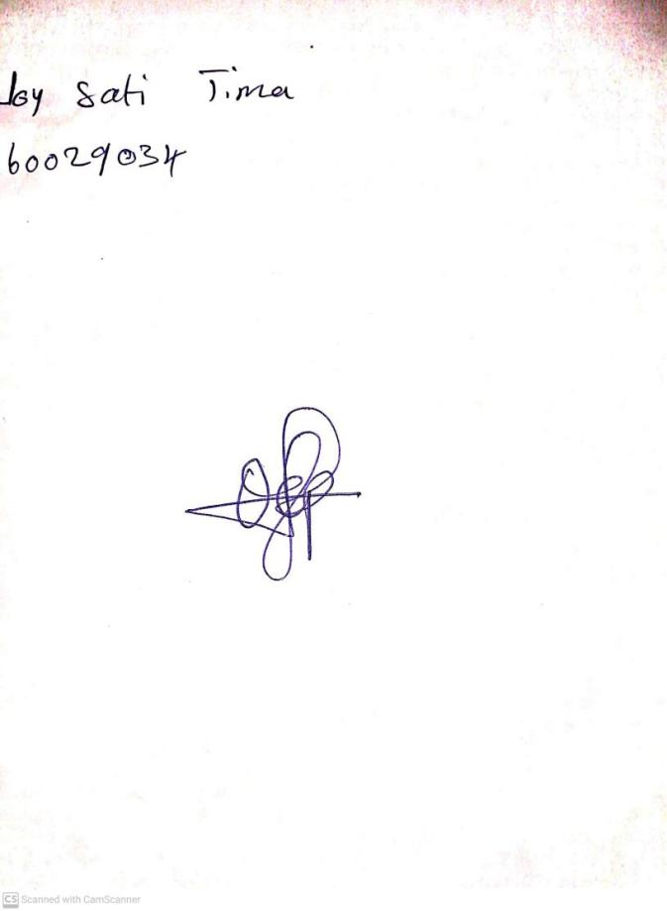

10th May, 2023

Perpetual Ojoma

Stream Head Nursery