**EMERALD ROYAL INTERNATIONAL SCHOOL, MPAPE ABUJA**

**LESSON PLAN AND NOTE 1 FOR WEEK 6 ENDING FRIDAY, 20TH OCTOBER, 2023**

**TERM:** FIRST TERM

**WEEK:** WEEK 6

**SUBJECT:** BASIC SCIENCE

**TOPIC:** ROAD

**SUB-TOPIC:** CROSSING THE ROAD

**DATE:** TUESDAY, 17TH AND WEDNESDAY, 18TH OCTOBER, 2023

**TIME:** 08:45 – 09:25AM AND 09:25 – 09:55AM

**DURATION:** 40 MINUTES

**PERIOD:** 2ND AND 3RD

**CLASS:** NURSERY 3

**NUMBER IN CLASS:** ELEVEN

**AVERAGE AGE:** FIVE

**SEX:** MIXED

**LEARNING OBJECTIVES:** By the end of the lesson, the pupils should be able to:

1. Explain the meaning of zebra crossing.
2. Highlight the rules guiding road crossing.

**RATIONALE:** for pupils to learn about how to cross the road.

**PREVIOUS KNOWLEGDE:** pupils have learnt how to walk along the road.

**INSTRUCTIONAL MATERIALS:**

1. Flash cards.
2. Road chart.

**REFERENCE MATERIALS:**

Smart Basic Science and Technology book 1 by D. I. Bika, Cambridge University Press

**LESSON DEVELOPMENT**

|  |  |  |  |
| --- | --- | --- | --- |
| **STAGES/STEPS** | **TEACHER’S ACTIVITIES** | **PUPILS’ ACTIVITIES** | **LEARNING POINTS** |
| **INTRODUCTION** | Review previous knowledge | Respond to the teacher | To arouse the pupils’ interest. |
| **PRESENTATION**  **STEP 1** | Teaches and explain the meaning of zebra crossing.  **Meaning of zebra crossing**  Zebra crossing is a road sign that indicate road users crossing the road.  Screenshot_20231015-185438 | Define zebra crossing. | Meaning of zebra crossing. |
| **STEP 2** | Teaches and explain the rules of crossing the road.  **Rules of crossing the road**   1. Do not cross the road alone as a child. 2. When crossing the road always use the zebra crossing. 3. Before you cross the road, you must look right and left and then right again to check if there is any oncoming cars. | Mention the rules of crossing the road. | Rules of crossing the road. |
| **SUMMARY** | Summarises the lesson by emphasising on the main concept and writes note on the board | Listen and copy their notes | For onward study |
| **EVALUATION** | Asks pupils to:   1. Define zebra crossing 2. Mention the rules of crossing the road. | Respond to the teacher’s question. | To test the pupils understanding on the lesson. |
| **CONCLUSION** | Summarizes, corrects and mark pupils’ notebooks | Submit their notebooks for marking. | Clarifying the concept. |
| **HOME WORK** | 1. Draw a zebra crossing sign. | Cope and return with task. | Extending lesson home. |

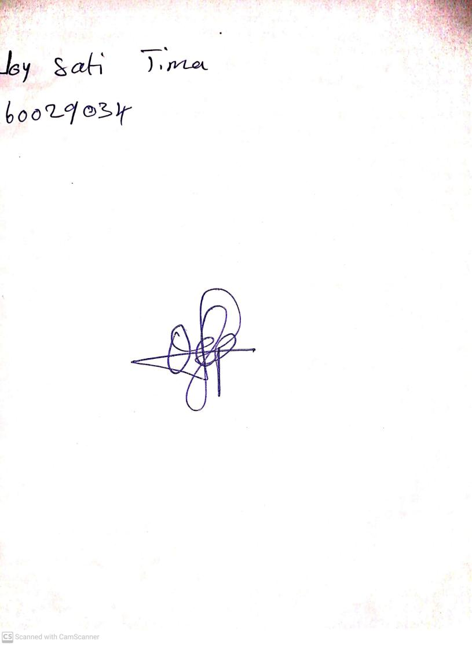

13TH October, 2023

Perpetual Ojoma Ocheja

Stream Head Nursery