**EMERALD ROYAL INTERNATIONAL SCHOOL**

**MPAPE, ABUJA.**

**LESSON PLAN AND NOTE FOR WEEK 1 ENDING 26/04/2024**

**TERM: THIRD**

**WEEK: 1ST**

**DATE: 22/04/2024**

**CLASS: NURSERY 2**

**SUBJECT: NATURE STUDY**

**TOPIC: WATER TRANSPORT .**

**SUB-TOPIC: MEANING AND EXAMPLES OF VEHICLESTHAT MOVES ON**

**WATER.**

**PERIOD: 1ST PERIOD AFTER LONG BREAK**

**TIME: 10: 40- 11: 20am**

**DURATION: 40 MINUTES.**

**NUMBER IN CLASS: 13**

**AVERAGE AGE: 5 YEARS.**

**SEX: MIXED.**

**SPECIFIC OBJECTIVES: BY THE END OF THE LESSON,THE PUPILS SHOULD BE**

**ABLE TO:**

1. **EXPLAIN THE MEANING OF WATER TRANSPORT.**
2. **MENTION THE VEHICLES THAT MOVES ON WATER.**
3. **STATE THE FIRST AID FOR DROWNING.**

**RATIONALE: FOR PUPILS KNOW THE MEANING OF WATER TRANSPORT.**

**PREVIOU KNOWLEDGE: PUPILS HAVE LEARNT THE MEANING OF WATER IN**

**PREVIOUS TERM.**

**INSTRUCTIONAL MATERIALS: PICTURES OF WATER VEHICLES IN PUPILS TEXTBOOKS.**

**REFERENCE MATERIALS: BASIC SCIENCE AND TECHNOLOGY NURSERY**

**SCHOOLS BOOK 3 BY OPEMIPO DADA.**

**LESSON DEVELOPMENT**

|  |  |  |  |
| --- | --- | --- | --- |
| **STAGES/STEPS** | **TEACHER’S ACTIVITIES** | **PUPILS’ ACTIVITIES** | **LEARNING POINTS** |
| **INTRODUCTION** | **Teacher introduces the lesson by asking pupils the following question:**  **Have you seen car on the road taking people from one place to another? People can also move around on water.** | **Pupils pay attention to the teacher and answer the question asked by the teacher.** | **To arouse pupils interest for the lesson ahead.** |
| **PRESENTATION**  **STEP 1** | **Teacher explains the meaning of water transport to pupils.** | **Pupils listen attentively to the teacher.** | **To build pupils attention span .** |
| **STEP 2** | **Teacher mentions the vehicles that moves on water to pupils and then asks them to repeat after her.** | **Pupils pay attention to the teacher and repeat after her.** | **For better understanding of the lesson.** |
| **STEP 3** | **Teacher states the first aid for drowning to pupils and also asks them to repeat after her.** | **Pupils listen to the teacher and repeat after her.** | **To enhance pupils participation in class.** |
| **BOARD SUMMARY** | **Teacher summarizes the lesson by writing the whole note of lesson on the board for pupils to copy into their books.ie,**  **WATER AS A MEANS OF**  **TRANSPORT**  **This simply means movement from one place to another through water.**  **There are different vehicles made specially to move on water.**  **Examples are:**   1. **Canoe** 2. **Boat** 3. **Ship**   **First aid for drowning:**  **When you see a drowning person,call an adult for help immediately. Do not try to save the person by yourself. After first aid treatment have been given , take the victim to the hospital.**   1. **Tilt the person head up .Remove remove any object blocking the mouth and nose . Pinch the nostrils shut and blow five puffs of air into the persons mouth.** 2. **Place the heel of your hand in the middle of the chest and interlock your fingers. Press down the chest thirty time sand blow two puffs of air into the victims mouth.** | **Pupils copy the note into their exercise books.** | **For onward study.** |
| **EVALUATION** | **Teacher evaluates the lesson by asking pupils the following questions:**   1. **What is water transport?** 2. **Mention the vehicles that move on water.** 3. **What are the first aid treatment for drowning?**   **:** | **Pupils answer the questions as by the teacher.** | **To assess pupils level of understanding.** |
| **CONCLUTION** | **Teacher concludes the lesson by marking pupils books.** | **Pupils submit their books for marking.** | **For endorsement.** |
| **ASSIGNMENT** | 1. **What is water?** 2. **Mention the sources of water** | **Pupils do their assignment at home.** | **To encourage learning at home.** |

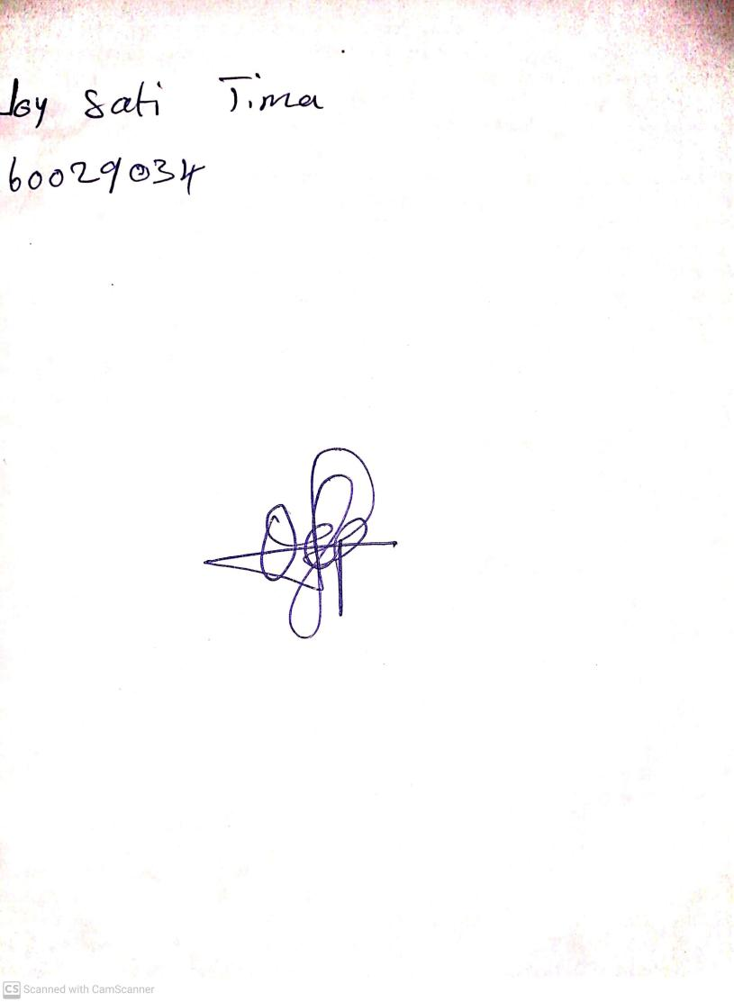

**19th April, 2024**

**Perpetual Ojoma Ocheja**

**Stream Head Nursery**