**Lesson Plan/Notes for week 6 Ending 17/2/2023.**

**Term:** 2nd

**Week**: 6

**Date:** 14/2/2023

**Class:** SS 2

**Subject:** Economics

**Topic:** Market structure

**Sub-Topic:** Price and quantity determination under imperfect competition (monopoly).

**Period:** 6th

**Time:** 11:50-12:30

**Duration:** 40 Minutes.

**Number in class:** 5 Students.

**Average Age:** 14 Years.

**Sex:** Mixed.

**Specific objectives:** By the end of the lesson, the students should be able to:

(1) Explain Price and Quantity Determination under imperfect competition (monopolistic competition).

(11) Describe Equilibrium of the monopolist (profit making monopolists)

(111) Draw Equilibrium of the monopolist (lost making monopolists).

**Rationale:** To be able to determine the equilibrium price of the monopolist when making profits and lost.

**Previous knowledge:** The students have been buying goods in both lower and higher prices at different interval.

**Instructional Material:** A chart showing curves in both profits and lost making monopolists.

**Reference material:** Ande C E (2020) Essential Economics for senior Secondary schools.

**LESSON DEVELOPMENT**

|  |  |  |  |
| --- | --- | --- | --- |
| **Stages/steps** | **Teacher's Activities** | **Students' Activities** | **Learning points.** |
| **Introduction** | Review the previous lesson | Participate actively in the class discussion. | To arouse the students’ interest to learn. |
| **Step 1** | Guides the students to explain price and quantity determination under imperfect competition (monopolistic competition). | Participate actively in the class discussion and copy Note. | For better understanding of the lesson. |
| **Step 11** | Asks the students to describe equilibrium of the monopolist (profits making monopolists). | Describe equilibrium of the monopolist as: Equilibrium is the most efficient operating levél for the monopolists. When this happen, the monopolist will not have the slightest intention to quit the business since he has control for both price and output. | To enable students to reason logically |
| **Step 111** | Leads the students to Draw Equilibrium of the monopolist (lost making monopolists) | Draw Equilibrium of the monopolist in their Note book. | To enhance their logical reasoning. |
| **Board Summary** | Summarises the lesson as:  **Price and quantity determination under monopoly.**  In an imperfect market, also known as monopolistic competition, prices of goods and services can easily be influenced by the sellers or buyers. This is due to the fact that only a single producer or supplier of a particular commodity exists even though there might be many buyers. In this case, they have full control over price or output and different prices rule the market.  **Equilibrium of the monopolists (Profits making monopolists).**  Equilibrium is the most efficient operating levél for the monopolist. In a situation when this happen, the monopolist will not have the slightest intention to quit the business since he has full control of both the price and output.  Equilibrium of the monopolist usually occurs where P> Mc and MC = MR. The monopolist does not attain equilibrium by equating price of the goods with marginal cost (MC). This is shown in figure C.    From the diagram, it is observed that the profit maximizing output is OQ1. Cost of production and market price are OP1 and OP2, respectively. The monopolist makes abnormal profit in the shaded area represented by P2 RSP1. This diagram explains the supernormal profit of a monopolist.  **Equilibrium of the monopolists (Lost making monopolists).**  There is a situation where a monopolist suffer some losses. As shown in figure D.    The average cost ( AC) curves are completely outside the revenue zone. Ac1 indicate that the monopolist makes zero profit because its total revenue equals cost. In any case, Ac indicates that when he produced and sold output of OQ2, its costs was over and above revenue. Thus, the monopolist made total loss as shown in the shaded area of the diagram. | Copy and submit the Note book for marking. | For future reference. |
| **Evaluation** | Evaluates the lesson as:  (1) Describe price and quantity determination under imperfect market (monopoly).  (11) Explain Equilibrium of the monopolists showing profit and loss. | Respond to the questions | Ascertaining the attainment of the stated objectives. |
| **Conclusion** | Rounds up the lesson by marking and correcting students work | Check and do their correction | Consolidation of the lesson. |
| **Assignment** | Gives home work as:  (1) with the aid of a diagram, explain the supernormal profit of a monopolist. | Respond by doing the home work at home. | To ensure continuity of learning. |

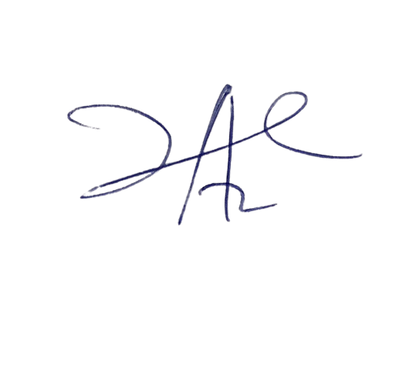

6/3/2023

Principal Head Instructor