LESSON PLAN AND NOTE FOR WEEK 10 ENDING 17/11/2023

TERM: 1st

WEEK: 10th

DATE: 03/11/2023

CLASS: Nursery 2

SUBJECT: Nature studies

TOPIC: Garden tools.

SUB—TOPIC: Meaning of garden tools and examples.

PERIOD: 4th

TIME: 10:40—11:20am

DURATION: 40 minutes

NUMBER IN CLASS: 14

AVERAGE AGE: 5 years

SEX: Mixed

LEARNING OBJECTIVES: By the end of the lesson, the pupils should be able to:

1. Explain the meaning of garden tools.

2. Mention the examples of garden tools.

3. State the uses of garden tools.

RATIONALE: For pupils to know about garden tools.

PREVIOUS KNOWLEDGE: Pupils have in one way or the other seen a wheelbarrow or cut lass before.

INSTRUCTIONAL MATERIALS: A cutlass, shovel and gloves.

REFERENCE MATERIALS: Basic science and technology for Nursery schools book 3 by OPEMIPO DADA.

LESSON DEVELOPMENT

|  |  |  |  |
| --- | --- | --- | --- |
| Steps | Teacher's activities | Pupils' activities | Learning point |
| Introduction | Teacher introduces the lesson by reviewing the previous lesson. | Pupils pay attention to the teacher. | To prepare pupils minds for the lesson ahead. |
| Presentation step 1 | Teacher explains the meaning of garden tools to pupils and then asks them to repeat after her. | Pupils listen to the teacher and repeat after her. | To improve pupils listening and speaking ability. |
| Step 2 | Teacher mentions the examples of garden tools to pupils and also asks them to repeat after her. | Pupils pay attention to the teacher and repeat her. | To enhance pupils participation in the class. |
| Step 3 | Teacher state the uses of garden tools to pupils and also asks them to repeat after her. | Pupils listen very attentively to the teacher and repeat after her. | To improve pupils speaking ability. |
| Board summary | Teacher writes the whole note of lesson on the board for pupils to copy into their books. That is;  Garden tools:  Garden tools are tools or materials that we use to keep our surroundings clean and do simple farm work.  Examples of garden tools are:   1. Hoe. 2. Trowel. 3. Spade. 4. Rake. 5. Gardening gloves. 6. Shovel. 7. Cutlass. 8. Wheelbarrow . 9. Watering can. 10. Axe .   Uses of garden tools are:   1. A cutlass is used for cutting grass. 2. A hoe is used for digging up soil. 3. A shovel is used for carrying soil. 4. An axe is used for cutting trees. 5. A rake is used for gathering dirt. 6. A water can is used to water flowers. 7. A wheelbarrow is used to carry dirt and tools. | Pupils copy the note into their exercise books. | For onward study. |
| Evaluation | Teacher evaluates the lesson by asking pupils the following questions;   1. What is Garden tools? 2. Mention the examples of garden tools. 3. State the uses of garden tools. | Pupils answer the questions asked by the teacher. | To assess pupils level of understanding. |
| Conclusion | Teacher concludes the lesson by marking pupils books. | Pupils submit their books for marking. | For endorsement. |
| Assignment | Summarize your note at home for examination. | Pupils read their books at home. | To encourage learning at home. |

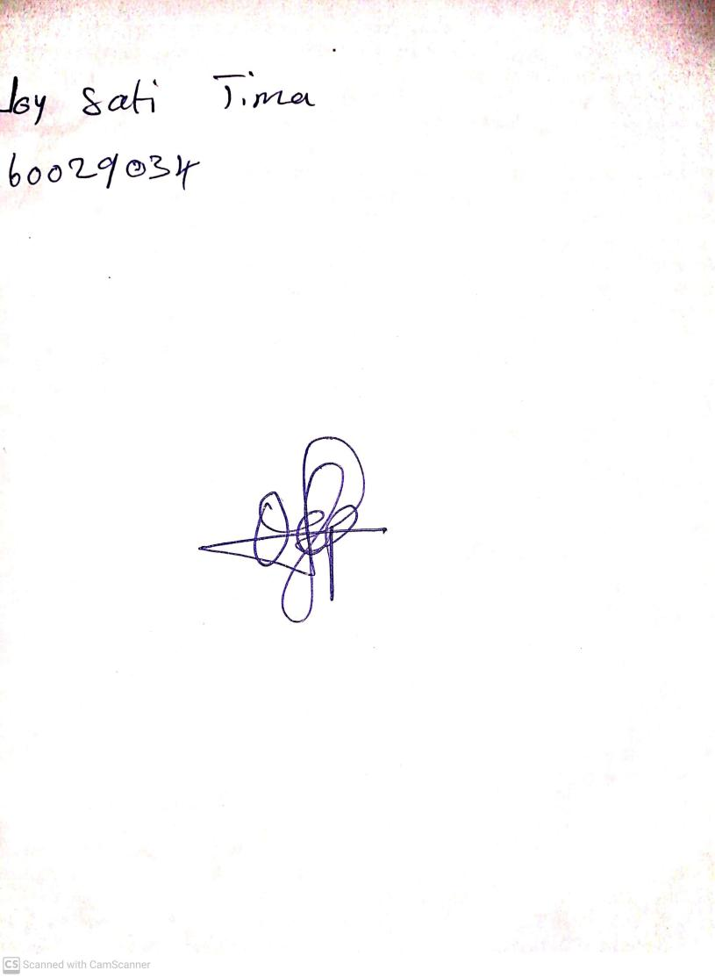

27th August, 2023

Perpetual Ojoma Ocheja

Stream Head Nursery