**EMERALD ROYAL INTERNATIONAL SCHOOL MPAPE, ABUJA**

**LESSON PLAN AND NOTE FOR WEEK 6 ENDING 16/02/2024**

**TERM: 2nd**

**WEEK: 6th**

**DATE: 12/ 02/2024**

**CLASS: Nursery 2**

**SUBJECT: Letter work**

**TOPIC: Things in my house and things in my school**

**SUB—TOPIC: Mentioning things in our house**

**PERIOD: 3rd**

**TIME: 09:30—10:10am**

**DURATION: 40 minutes**

**NUMBER IN CLASS: 13**

**AVERAGE AGE : 5 years**

**SEX: Mixed**

**LEARNING OBJECTIVES: By the end of the lesson, the Pupils should be able to:**

**1. Mention the things in our house.**

**2. Spell and pronounce the items in our house.**

**RATIONALE: For Pupils to know how to spell and pronounce the things in their house's**

**PREVIOUS KNOWLEDGE : Pupils have been seeing things in their houses**

**INSTRUCTIONAL MATERIALS: Broom, mat,chairs**

**REFERENCE MATERIALS: The New Mastering English for Nursery schools book 3 by J.M OMOGBAI.**

**LESSON DEVELOPMENT**

|  |  |  |  |
| --- | --- | --- | --- |
| **STEPS** | **TEACHER'S ACTIVITIES** | **PUPILS' ACTIVITIES** | **LEARNING POINT** |
| **Introduction** | **Teacher introduces the lesson by asking pupils to mention the things in their house's.** | **Pupils listen to the teacher and answer the questions ask by the teacher.** | **To prepare pupils minds for the lesson ahead.** |
| **Presentation step 1** | **Teacher mentions the things in our house and then asks Pupils to repeat after her.** | **Pupils listen to the teacher and repeat after the teacher** | **For proper understanding.** |
| **Step 2** | **Teacher guides pupils to spell and pronounce the things in their house's.** | **Pupils attempt spelling the things in their house's.** | **To enhance Pupils participation in class.** |
| **Board summary** | **Teacher summarizes the lesson by writing the whole note of lesson on the board for pupils to copy into their books. That is;**  **THINGS IN MY HOUSE**  **Things in my house are;**  **1. Bed**  **2. Chairs**  **3. Table**  **4. Mop**  **5. Broom**  **6. Bags**  **7. Television**  **8. Pillow**  **10.Remote**  **11.Door**  **12. Holy Bible**  **13. Holy Qur'an**  **14. Shoe rack**  **15. Plate**  **16. Spoons**  **17. Electric iron**  **18. Knife**  **19. Mirror**  **20. Comb**  **21. Shoes**  **22. Sponge**  **23.Clothes**  **24. Pot**  **25. Fan etc** | **Pupils copy the note into their exercise books.** | **For onward study.** |
| **Evaluation** | **Teacher evaluates the lesson by asking pupils to spell and pronounce the words on the board one after another.** | **Pupils spell and pronounce the words on the board one after another.** | **To assess Pupils reading ability.** |
| **Conclusion** | **Teacher concludes the lesson by marking pupils books.** | **Pupils submit their books for marking.** | **For endorsement.** |
| **Assignment** | **Identify and write 10 other things you can see at home.** | **Pupils do their assignment at home.** | **To encourage learning at home.** |

**LESSON PLAN AND NOTE FOR WEEK 6 ENDING 16/02/2024**

**TERM: Second**

**WEEK: 6th**

**DATE: 16/ 02/2024**

**CLASS: Nursery 2**

**SUBJECT: Letter work**

**TOPIC: Things in my house and things in my class**

**SUB—TOPIC: Things in my class**

**PERIOD: 2nd**

**TIME: 08:50—09:30am**

**DURATION: 40 minutes**

**NUMBER IN CLASS: 13**

**AVERAGE AGE: 5 years**

**SEX: Mixed**

**LEARNING OBJECTIVES: By the end of the lesson, the Pupils should be able to:**

**1. Mention things in the school environment.**

**2. Spell and pronounce things in the school environment.**

**RATIONALE: For Pupils to know how to spell and pronounce words.**

**PREVIOUS KNOWLEDGE: Pupils have learnt about things in our house.**

**INSTRUCTIONAL MATERIALS: slide and swing,**

**REFERENCE MATERIALS: The New Mastering English for Nursery schools book 3 by J. M. OMOGBAI**

**LESSON DEVELOPMENT**

|  |  |  |  |
| --- | --- | --- | --- |
| **STEPS** | **TEACHER'S ACTIVITIES** | **PUPILS' ACTIVITIES** | **LEARNING POINT** |
| **Introduction** | **Teacher introduces the lesson by reviewing the previous lesson.** | **Pupils pay attention to the teacher.** | **To prepare pupils minds for the lesson ahead.** |
| **Presentation step 1** | **Teacher mentions the things in the school environment and then asks Pupils to repeat after her.** | **Pupils listen to the teacher and repeat after her.** | **For proper understanding.** |
| **Step 2** | **Teacher writes the things in the school environment on the board, spell, pronounce and then asks Pupils to repeat after her. As;**  **1. Field**  **2. Swing**  **3. Slide**  **4. See –saw**  **5. Tenis balls**  **6. Skeleton**  **7. Television**  **8. School bus**  **9. Fishes**  **10. Water**  **11. Computers**  **12. National flag**  **13. Flowers**  **14. Bower bikes**  **15. CCTV camera etc** | **Pupils pay attention to the teacher and also spell and pronounce the things in the school environment after the teacher.** | **For better understanding.** |
| **Board summary** | **Teacher summarizes the lesson by preparing pupils books for them to copy the note on the board .** | **Pupils copy the note on the board into their exercise books.** | **For onward study.** |
| **Evaluation** | **Teacher evaluates the lesson by going through the note on the board over and over again.** | **Pupils listen attentively to the teacher.** | **To create platform for slow learners.** |
| **Conclusion** | **Teacher concludes the lesson by marking pupils books.** | **Pupils submit their books for marking.** | **For endorsement.** |
| **Assignment** | **1. Mention 10 things in your mummy's kitchen.**  **2. List 10/things in your sitting room.** | **Pupils do their assignment at home.** | **To encourage learning at home.** |

**LESSON PLAN AND NOTE FOR WEEK 6 ENDING 16/02/2024**

**TERM: Second**

**WEEK: 6th**

**DATE: 16/02/2024**

**CLASS: Nursery 2**

**SUBJECT: Letter work**

**TOPIC: Things in my house and things in my class.**

**SUB—TOPIC: Rings in my classroom**

**PERIOD: 3rd**

**TIME: 09:30 —10:10am**

**DURATION: 40 minutes**

**NUMBER IN CLASS: 13**

**AVERAGE AGE: 5 years**

**SEX: Mixed**

**LEARNING OBJECTIVES: By the end of the lesson, the Pupils should be able to:**

**1. List the things in the classroom.**

**2. Spell and pronounce the things in the classroom.**

**RATIONALE: For Pupils to know how to spell the things in their classroom.**

**PREVIOUS KNOWLEDGE: Pupils have learnt things in the school environment.**

**INSTRUCTIONAL MATERIALS: Board, books and pencils.**

**REFERENCE MATERIALS: The New Mastering English for Nursery schools book 3 by J. M OMOGBAI.**

**LESSON DEVELOPMENT**

|  |  |  |  |
| --- | --- | --- | --- |
| **STEPS** | **TEACHER'S ACTIVITIES** | **PUPILS' ACTIVITIES** | **LEARNING POINT** |
| **Introduction** | **Teacher introduces the lesson by singing nursery rhymes.** | **Pupils sing the rhymes along with the teacher.** | **To arouse pupils interest for the lesson.** |
| **Presentation step 1** | **Teacher lists out the things in the classroom and asks Pupils to repeat after her.** | **Pupils listen to the teacher and repeat after her.** | **For proper understanding.** |
| **Step 2** | **Teacher spells and pronounce the words on the board and also asks Pupils to repeat after her.** | **Pupils pat attention to the teacher and repeat after her.** | **For better understanding.** |
| **Board summary** | **Teacher writes the whole note of lesson on the board for pupils to copy. As;**  **THINGS IN THE CLASSROOM ARE:**  **1. Note books**  **2. Desk**  **3. Pencils**  **4. Pen**  **5. Markers**  **6. Eraser**  **7. Board**  **8. Chairs**  **9. Bags**  **10. Lunch box**  **11. Clock**  **12. Chart**  **13. Shelf**  **14. Crayons**  **15. Dustbin**  **16. Balls**  **17. Tissue**  **18. Textbooks etc.** | **Pupils copy the note into their books.** | **For onward study.** |
| **Evaluation** | **Teacher asks pupils to go to the board one after the other to spell and pronounce the things on the board.** | **Pupils spell and pronounce the things on the board one after another.** | **To create platform for slow learners.** |
| **Conclusion** | **Teacher concludes the lesson by marking pupils books.** | **Pupils submit their books for marking.** | **For endorsement.** |
| **Assignment** | **Spell and write 20 things you can find in your school environment and in your classroom.** | **Pupils do their assignment at home.** | **To encourage learning at home.** |

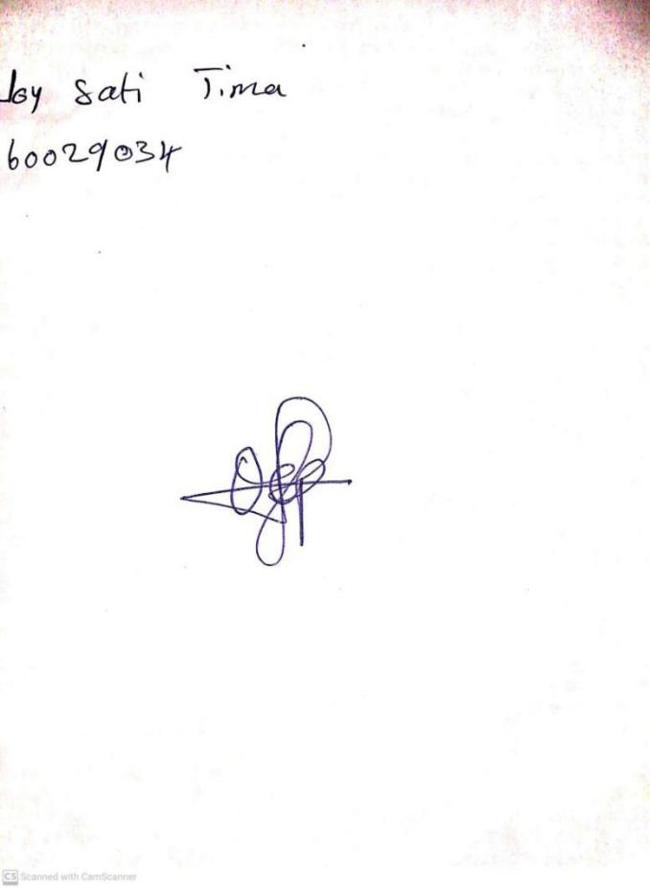

**9THFEBRUARY, 2024**

**Perpetual Ojoma Ocheja**

**Stream Head Nursery**