**EMERALD ROYAL INTERNATIONAL SCHOOL**

**MPAPE, ABUJA.**

**LESSON PLAN AND NOTE FOR WEEK 4 ENDING 06/10/2023**

TERM: FIRST

WEEK: 4TH

DATE: 02/10/2023

CLASS: NURSERY 2

SUBJECT: SOCIAL NORMS

TOPIC: STIGMATIZATION .

SUB-TOPIC: EXPLAIN THE MEANING OF STIGMATIZATION AND

EFFECTS.

PERIOD: 2ND PERIOD AFTER LONG BREAK

TIME: 11: 20- 12: 00PM

DURATION: 40 MINUTES.

NUMBER IN CLASS: 14

AVERAGE AGE: 5 YEARS.

SEX: MIXED.

SPECIFIC OBJECTIVES: BY THE END OF THE LESSON,THE PUPILS SHOULD BE

ABLE TO:

1. EXPLAIN THE MEANING OF STIGMATIZATION
2. MENTION THE EFFECTS OF STIGMATIZATION

RATIONALE: FOR PUPILS TO KNOW ABOUT STIGMATIZATION

PREVIOU KNOWLEDGE: PUPILS HAVE LEARNT THE FORMS OF CHILD ABUSE IN PREVIOUS LESSON.

INSTRUCTIONAL MATERIALS: A SHORT VIDEO CLIP ON HOW A CHILD WAS STIGMATIZED

REFERENCE MATERIALS: GOOGLE.COM

**LESSON DEVELOPMENT**

|  |  |  |  |
| --- | --- | --- | --- |
| STAGES/STEPS | TEACHER’S ACTIVITIES | PUPILS’ ACTIVITIES | LEARNING POINTS |
| INTRODUCTION | Teacher introduces the lesson by reviewing the previous lesson. | Pupils pay attention to the teacher. | To arouse pupils interest for the lesson ahead. |
| PRESENTATION  STEP 1 | Teacher explains the meaning of stigmatization to pupils and then asks them to repeat after her. | Pupils listen attentively to the teacher and repeat after her. | For proper understanding . |
| STEP 2 | Teacher mentions the effect of stigmatization to pupils and also asks them to repeat after her. | Pupils pay attention to the teacher and repeat after her. | For better understanding of the lesson. |
| BOARD SUMMARY | Teacher summarizes the lesson by writing the whole note of lesson on the board for pupils to copy into their books. That is;  STIGMATIZATION  Stigmatization is the action of describing or regarding someone or something as worthy of disgrace or great disapproval.  EFFECT OF STIGMATIZATION   1. Feeling of shame 2. Hopelessness 3. Isolation 4. Low self-esteem 5. Lack of self-confidence 6. Fear etc. | Pupils copy the note into their exercise books. | For onward study. |
| EVALUATION | Teacher evaluates the lesson by asking the following questions;   1. What is stigmatization? 2. Mention the effects of stigmatization. | Pupils answer the questions asked by the teacher. | To assess pupils level of understanding. |
| CONCLUSION | Teacher concludes the lesson by marking pupils books. | Pupils submit their books for marking. | For endorsement. |
| ASSIGNMENT | 1. Define responsibility 2. Mention 5 responsibilities at home. | Pupils do their assignment at home. | To encourage learning at home. |

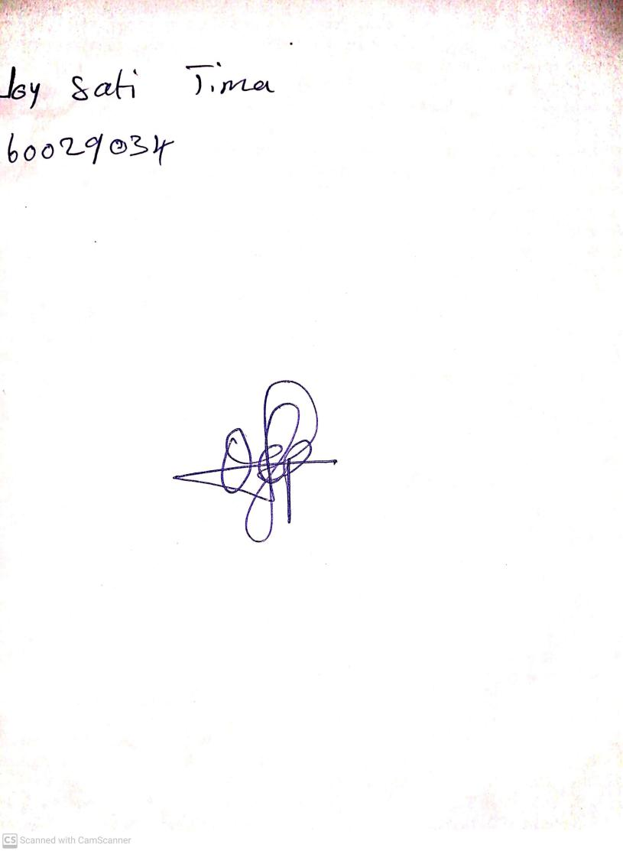

18th September, 2023

Perpetual Ojoma Ocheja

Stream Head Nursery