**EMERALD ROYAL INTERNATIONAL SCHOOL MPAPE, ABUJA**

**LESSON PLAN AND NOTE FOR WEEK 4 PERIOD 1 ENDING 04/10/2024**

**TERM: FIRST**

**WEEK: 4TH**

**DATE: 30/09/2024**

**CLASS: NURSERY 2**

**SUBJECT: NUMBER WORK**

**TOPIC: TIME MEASUREMENT OCLOCK AND HALF PAST.**

**SUB-TOPIC: TELLING THE TIME IN O CLOCK.**

**PERIOD: 1ST**

**TIME: 08: 50-09: 30 am**

**DURATION: 40 MINUTES**

**NUMBER IN CLASS: 16**

**AVERAGE AGE: 4**

**SEX: MIXED**

**SPECIFIC OBJECTIVES: BY THE END OF THE LESSON, THE PUPILS SHOULD BE ABLE**

**TO:**

**1.IDENTIFY A CLOCK**

**2.EXPLAIN THE LONGER HAND AND THE SHORTER HAND**

**ON A CLOCK.**

1. **TELL THE TIME ON CLOCK FACES.**

**RATIONALE: FOR PUPILS TO BE ABLE TO KNOW HOW TO TELL TIME.**

**PREVIOUS KNOWLEDGE: PUPILS HAVE BEEN WEARING WRIST WATCH TO SCHOOL.**

**INSTRUCTIONAL MATERIALS: A CLOCK.**

**REFERENCE MATERIALS: MY CHOICE OF MATHEMATICS STAGE 3 BY TOP STAR.**

**LESSON DEVELOPMENT**

|  |  |  |  |
| --- | --- | --- | --- |
| **STAGES/STEPS** | **TEACHER’S ACTIVITIES** | **PUPILS’ ACTIVITIES** | **LEARNING POINT** |
| **INTODUCTION** | **Teacher introduces the lesson by reviewing the previous lesson.** | **Pupils listen attentively to the teacher.** | **To arouse pupils interest for the lesson ahead.** |
| **PRESENTATION STEP 1** | **Teacher draws a clock on the board, identify to pupils and then asks them to repeat after her.** | **Pupils pay attention to the teacher and repeat after her.** | **For proper understanding.** |
| **STEP 2** | **Teacher explains the longer hand and the shorter hand in the clock to pupils and also asks them to repeat after her.** | **Pupils listen very attentively to the teacher and repeat after her.** | **For better understanding of the lesson.** |
| **STEP 3** | **Teacher also draws different clock faces on the board and then guides pupils to tell the time on the clock faces.** | **Pupils pay attention to the board and tell the time.** | **To create plat form for slow learners.** |
| **BOARD SUMMARY** | **Teacher summarizes the lesson by writing the whole note of lesson on the board for pupils to copy into their books. As;**  **TELLING THE TIME**  **Time tells us when things are done.**  **Telling the time in o clock**  **The hands of a clock move to show what time it is.**   1. **The longer hand is called the minutes hand. It moves round about the face of the clock to read minutes.** 2. **The shorter hand is called the hour hand.**   **It moves round about the face of the clock to read hours.**  **Examples:**   1. **When the longer hand is on 12, and the shorter hand is on 3, we say the time is 3, o'clock.** 2. **When the longer hand is on 12, and the shorter hand is on 7, we say the time is 7 o'clock.** 3. **When the longer hand is on 12, and the shorter hand is on 10, we say the time is 10 o'clock etc.** | **Pupils copy the note on the board into their exercise books.** | **For onward study.** |
| **EVALUATION** | **Teacher evaluates the lesson by asking the following questions:**   1. **Time tells us when things are done .**   **True or false.**   1. **The longer hand in a clock is called ---------** 2. **The shorter hand in the clock is called -------** 3. **When the longer hand is on 12, and the shorter hand is on 4, we say the time is ------** 4. **When the longer hand is on 12, and the shorter hand is on 12, we say the time is ------** | **Pupils answer the questions asked by the teacher.** | **To asses pupils level of understanding of the lesson.** |
| **CONCLUSION** | **Teacher concludes the lesson by marking pupils books.** | **Pupils submit their books for marking.** | **For endorsement.** |
| **ASSIGNMENT** | 1. **Say the time in each clock face on page 74.** 2. **Draw the shorter hand in each clock to indicate the time shown under each clock on page 75.** 3. **Draw the shorter hand in each clock to indicate the time shown under each clock.on page 76.** | **Pupils do their assignment at home.** | **To encourage learning at home.** |

**EMERALD ROYAL INTERNATIONAL SCHOOL MPAPE, ABUJA**

**LESSON PLAN AND NOTE FOR WEEK 4 PERIOD 2 ENDING 04/10/2024**

**TERM: FIRST**

**WEEK: 4TH**

**DATE: 01/10/2024**

**CLASS: NURSERY 2**

**SUBJECT: NUMBER WORK**

**TOPIC: TIME MEASUREMENT**

**SUB-TOPIC: TELLING THE TIME IN QUARTER PAST**

**PERIOD: 2ND**

**TIME: 08: 50-09: 30 am**

**DURATION: 40 MINUTES**

**NUMBER IN CLASS: 16**

**AVERAGE AGE: 4**

**SEX: MIXED**

**SPECIFIC OBJECTIVES: BY THE END OF THE LESSON, THE PUPILS SHOULD BE ABLE**

**TO:**

**1.EXPLAIN THE TIME WHEN IS QUARTER PAST.**

**2.SAY THE TIME ON THE CLOCK FACE.**

**RATIONALE: FOR PUPILS TO BE ABLE TO TELL TIME WHEN IS QUARTER PAST.**

**PREVIOUS KNOWLEDGE: PUPILS HAVE LEARNT ABOUT HANDS IN THE CLOCK IN PREVIOUS LESSON.**

**INSTRUCTIONAL MATERIALS: A CLOCK.**

**REFERENCE MATERIALS: MY CHOICE OF MATHEMATICS STAGE 3 BY TOP STAR.**

**LESSON DEVELOPMENT**

|  |  |  |  |
| --- | --- | --- | --- |
| **STAGES/STEPS** | **TEACHER’S ACTIVITIES** | **PUPILS’ ACTIVITIES** | **LEARNING POINT** |
| **INTODUCTION** | **Teacher introduces the lesson by reviewing the previous lesson.** | **Pupils listen attentively to the teacher.** | **To arouse pupils interest for the lesson ahead.** |
| **PRESENTATION STEP 1** | **Teacher explains how to tell time when is quarter past to pupils and then asks them to repeat after her.** | **Pupils pay attention to the teacher and repeat after her.** | **For proper understanding.** |
| **STEP 2** | **Teacher draws some clock faces on the board, and then guides pupils to say the time as shown on the clock.** | **Pupils listen very attentively to the teacher and say the time.** | **For better understanding of the lesson.** |
| **BOARD SUMMARY** | **Teacher summarizes the lesson by writing the whole note of lesson on the board for pupils to copy into their books. That is;**  **Telling the time in quarter past**  **Whenever the longer hand is on 3, the time will read quarter past the number the number where the shorter hand is leaving.**  **Examples:**   1. **When the longer hand is on 3, and the shorter hand is leaving 5, we say the time is quarter past 5.** 2. **When the longer hand is on 3, and the shorter hand is leaving 12, we say the time is quarter past 12.** 3. **When the longer hand is on 3, and the shorter hand is leaving 9, we say the time is quarter past 9 etc..** | **Pupils copy the note on the board into their exercise books.** | **For onward study.** |
| **EVALUATION** | **Teacher evaluates the lesson by drawing some clocks on the board showing quarter past, after which asks the pupils question relating to what she draws.** | **Pupils answer the questions asked by the teacher.** | **To asses pupils level of understanding of the lesson.** |
| **CONCLUSION** | **Teacher concludes the lesson by marking pupils books.** | **Pupils submit their books for marking.** | **For endorsement.** |
| **ASSIGNMENT** | **Tell the time in each picture on page 78.** | **Pupils do their assignment at home.** | **To encourage learning at home.** |

**EMERALD ROYAL INTERNATIONAL SCHOOL MPAPE, ABUJA**

**LESSON PLAN AND NOTE FOR WEEK 4 PERIOD 3 ENDING 04/10/2024**

**TERM: FIRST**

**WEEK: 4TH**

**DATE: 04/10/2024**

**CLASS: NURSERY 2**

**SUBJECT: NUMBER WORK**

**TOPIC: TIME MEASUREMENT.**

**SUB-TOPIC: TELLING THE TIME IN QUARTER TO .**

**PERIOD: 1ST**

**TIME: 08: 10-08:50 am**

**DURATION: 40 MINUTES**

**NUMBER IN CLASS: 16**

**AVERAGE AGE: 4**

**SEX: MIXED**

**SPECIFIC OBJECTIVES: BY THE END OF THE LESSON, THE PUPILS SHOULD BE ABLE**

**TO:**

**1.EXPLAIN THE TIME WHEN IS QUARTER TO**

**2. SAY THE TIME ON THE CLOCK FACE**

**RATIONALE: FOR PUPILS TO BE ABLE TO TELL THE TIMEWHEN IS QUARTER TO.**

**PREVIOUS KNOWLEDGE: PUPILS HAVE LEARNT ABOUT TIME WHEN IS QUARTER PAST IN PREVIOUS LESSON.**

**INSTRUCTIONAL MATERIALS: A WALL CLOCK**

**REFERENCE MATERIALS: TOP STAR MY CHOICE OF MATHEMATICS STAGE 3 BY TOP STAR PUBLISHING LTD.**

**LESSON DEVELOPMENT**

|  |  |  |  |
| --- | --- | --- | --- |
| **STAGES/STEPS** | **TEACHER’S ACTIVITIES** | **PUPILS’ ACTIVITIES** | **LEARNING POINT** |
| **INTODUCTION** | **Teacher introduces the lesson by reviewing the previous lesson.** | **Pupils listen attentively to the teacher.** | **To arouse pupils interest for the lesson ahead.** |
| **PRESENTATION STEP 1** | **Teacher explains the time when is quarter to, to pupils and then asks them to repeat after her.** | **Pupils pay attention to the teacher and repeat after her.** | **For proper understanding.** |
| **STEP 2** | **Teacher draws a clock on the board showing quarter to, and then say the time to pupils and also asks them to repeat after her.** | **Pupils listen very attentively to the teacher and repeat after her.** | **For better understanding of the lesson.** |
| **BOARD SUMMARY** | **Teacher summarizes the lesson by writing the whole note of lesson on the board for pupils to copy into their books. That is;**  **TIME MEASUREMENT**  **Telling the time when in quarter to**  **When the longer hand is on 9,the time will read quarter to the number where the shorter hand is going.**  **Example**   1. **When the longer hand is in 9, and the shorter hand is going to 2, we say the time is quarter to 2.** 2. **When the longer hand is in 9, and the shorter hand is going to 4, we say the time is quarter to 4 etc.** | **Pupils copy the note on the board into their exercise books.** | **For onward study.** |
| **EVALUATION** | **Teacher evaluates the lesson by drawing some clocks on the board showing quarter to, after which she asks the pupils questions relating to what she draws.** | **Pupils answer the questions asked by the teacher.** | **To asses pupils level of understanding of the lesson.** |
| **CONCLUSION** | **Teacher concludes the lesson by marking pupils books.** | **Pupils submit their books for marking.** | **For endorsement.** |
| **ASSIGNMENT** | **Assigment page 80** | **Pupils do their assignment at home.** | **To encourage learning at home.** |

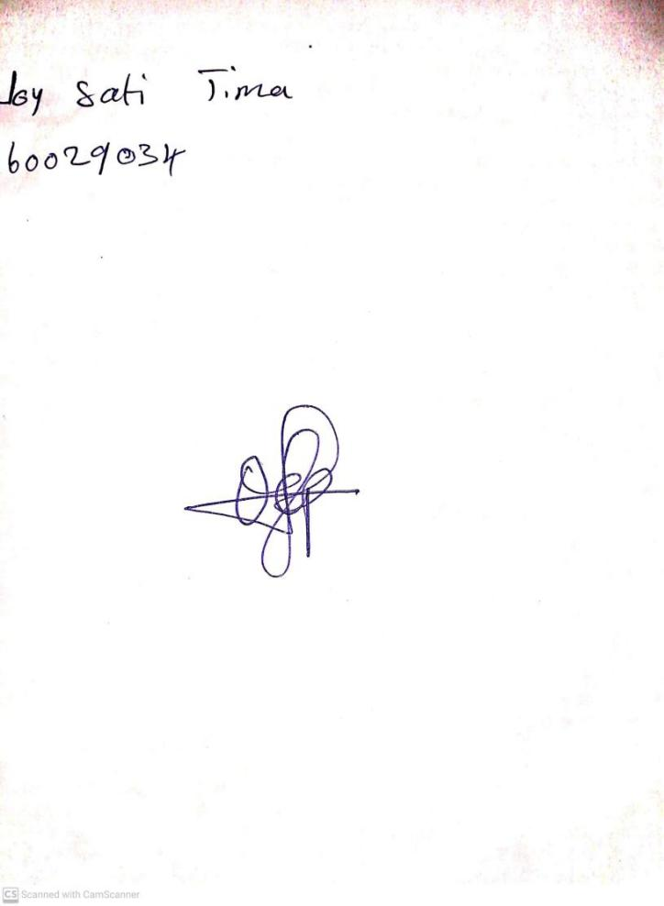

**20th SS September, 2024**

**Perpetual Ojoma Ocheja**

**Stream Head Nursery**