EMERALD ROYAL INTERNATIONAL SCHOOL

MPAPE, ABUJA.

LESSON PLAN AND NOTE 1 FOR WEEK 4 ENDING 6TH OCTOBER, 2023.

SUBJECT: Literacy

TOPIC: Picture reading.

SUB-TOPIC: Identification of objects in the classroom.

DATE: 3/10/2023.

DURATION: 40 minutes.

TIME: 08:50--09:30.

PERIOD: 2nd

CLASS: Pre-nursery

NUMBER OF PUPILS: 11

AVERAGE AGE: 2 YEARS

SEX: Mixed.

SPECIFIC OBJECTIVES: By the end of the lesson, the pupils should be able to:-

1. Identify the objects in the classroom.
2. Colour the objects mentioned above.

RATIONALE: For pupils to be able to identify objects around them.

PREVIOUS KNOWLEDGE: Pupils have been seeing objects in their various houses.

INSTRUCTIONAL MATERIALS: objects in the classroom.

REFERENCE:Mastering English for nursery schools book 1 by J.M.Omogbai.

LESSON DEVELOPMENT

|  |  |  |  |
| --- | --- | --- | --- |
| STAGES/STEPS | TEACHER’S ACTIVITIES | PUPILS’ ACTIVITIES | LEARNING POINTS |
| INTRODUCTION | Teacher introduces the lesson by singing nursery rhymes for the pupils to sing. | Pupils listen attentively to the teacher and try to emulate the teacher to sing. | To arouse the interest of the pupils for the lesson. |
| PRESENTATION  STEP 1 | Teacher draws some objects on the board and asks the pupils to identify them.  What is this?  what is this?    What is this? | Pupils identify the objects.  It is a fan.  It is a table.  It is a ball. | For better identification of object . |
| STEP2 | Teacher draws two of the objects inside the pupils books and asks them to colour them . | Pupils colour the fan and the ball in their books.  It is a fan.      It is a ball. | For proper understanding of the lesson. |
| SUMMARY | Teacher summarizes the lesson by touching various objects in the classroom for the pupils to identify. | Pupils listen to the teacher and identify the objects. | For more understanding of the lesson. |
| EVALUATION | Teacher asks the pupils to   1. Touch the various objects in the classroom. 2. Mention the names of the objects in the classroom. | Pupils answer the teacher’s question. | To assess the level of pupils understanding of the lesson. |
| CONCLUSION | Teacher marks the pupils books and make corrections where necessary. | Pupils submit their books for marking and corrections . | For onwards study. |
| ASSIGNMENT | Teacher asks the pupils to colour this objects.    A table. | Pupils do their Home work at home. | To ensure learning takes place at home. |

EMERALD ROYAL INTERNATIONAL SCHOOL

MPAPE, ABUJA.

LESSON PLAN AND NOTE 2 FOR WEEK 2 ENDING 29TH SEPTEMBER, 2023.

SUBJECT: Literacy

TOPIC: picture reading.

SUB-TOPIC: Identification of objects at home.

DATE: 26/9/2023.

DURATION: 40 minutes.

TIME: 08:50--09:30.

PERIOD: 2nd

CLASS: Pre-nursery

NUMBER OF PUPILS: 14

AVERAGE AGE: 2 YEARS

SEX: Mixed.

SPECIFIC OBJECTIVES: By the end of the lesson, the pupils should be able to:-

1. Identify objects at home.
2. State the use of the objects.

RATIONALE: For pupils to be able to identify objects around them.

PREVIOUS KNOWLEDGE: Pupils have been been seeing different kinds of things around the house.

INSTRUCTIONAL MATERIALS: picture books.

REFERENCE:Mastering English for nursery schools book 1 by J.M.Omogbai.

LESSON DEVELOPMENT

|  |  |  |  |
| --- | --- | --- | --- |
| STAGES/STEPS | TEACHER’S ACTIVITIES | PUPILS’ ACTIVITIES | LEARNING POINTS |
| INTRODUCTION | Teacher introduces the lesson by asking the pupils to mention the names objects in the classroom. | Pupils listen and mention the names of objects in the classroom as:-  School bag.  Fan.  Table.  Television e.t.c. | To arouse the interest of the pupils for the lesson. |
| PRESENTATION  STEP 1 | Teacher draws some of the objects found at home for the pupils to identify.  what is this?  what is this?  what is this? | Pupils identify the objects as-:  It is a cup.  It is a pot.  It is a spoon. | For better understanding of the lesson. |
| STEP2 | Teacher explains to the pupils the use of the above mentioned objects.   1. CUP:- It is used for drinking water, juice or liquid substances. 2. POT:- It is used for cooking of food. 3. SPOON:- It is used for eating of food. | Pupils listen to the teachers' explanations and repeat after her. | To ensure better understanding of the lesson. |
| SUMMARY | Teacher summarizes the lesson by explaining again the uses of some objects found at home. | Pupils listen attentively to the teacher's explanations. | For more understanding of the lesson. |
| EVALUATION | Teacher asks the pupils to:-   1. Mention the names of objects found at home. 2. State the use of objects found at home. | Pupils answer the questions correctly. | To assess the level of pupils understanding of the lesson. |
| CONCLUSION | Teacher marks the pupils books and make corrections where necessary. | Pupils submit their books for marking and corrections . | For onwards study. |
| ASSIGNMENT | Teacher asks the pupils to colour the objects found at home in their Elementary science text book( page 10) | Pupils do their Home work at home. | To ensure learning takes place at home. |

EMERALD ROYAL INTERNATIONAL SCHOOL

MPAPE, ABUJA.

LESSON PLAN AND NOTE 3 FOR WEEK 4ENDING 6TH OCTOBER, 2023.

SUBJECT: Literacy

TOPIC: Picture reading.

SUB-TOPIC: Identification of things in the school environment.

DATE: 6/10/2023.

DURATION: 40 minutes.

TIME: 08:50--09:30.

PERIOD: 2nd

CLASS: Pre-nursery

NUMBER OF PUPILS: 14

AVERAGE AGE: 2 YEARS

SEX: Mixed.

SPECIFIC OBJECTIVES: By the end of the lesson, the pupils should be able to:-

1. Identify objects in the school environment.

2. Mention the names of the objects in the school compound.

RATIONALE: For pupils to be able to identify objects around them..

PREVIOUS KNOWLEDGE: Pupils have seen school buses parked at the school compound.

INSTRUCTIONAL MATERIALS: objects within the school.

REFERENCE:Mastering English for nursery schools book 1 by J.M.Omogbai.

LESSON DEVELOPMENT

|  |  |  |  |
| --- | --- | --- | --- |
| STAGES/STEPS | TEACHER’S ACTIVITIES | PUPILS’ ACTIVITIES | LEARNING POINTS |
| INTRODUCTION | Teacher introduces the lesson by reviewing the last lesson on objects found at home. | Pupils listen as the teacher reviews the last lesson. | To arouse the interest of the pupils for the lesson proper. |
| PRESENTATION  STEP 1 | Teacher takes the pupils out of the classroom to the school environment to show them some of the things or objects in the school environment. | Pupils follow the teacher as she takes them out to see things or objects in the school environment. The pupils touch them. | For proper recognition of objects. |
| STEP2 | Teacher touches the objects in the school environment one after another and mention their names respectively as:-   1. Slide. 2. See-saw. 3. School buses. 4. Swing. 5. Goal post.   Teacher asks the pupils to repeat after her. | Pupils listen as the teacher call the names of the objects in the school environment. Pupils also repeat after the teacher to mention their names.   1. Slide. 2. See-saw. 3. School buses. 4. Swing. 5. Goal post. | To ensure proper identification and recognition of objects. |
| SUMMARY | Teacher summarizes the lesson by mentioning the things found in the school environment again for the pupils to remember and memorize. | Pupils pay attention to the teacher and repeat after teacher. | For more understanding of the lesson. |
| EVALUATION | Teacher asks the pupils to:-   1. Identify objects within the school compound. 2. Mention three names of those objects identified above. | Pupils answer the teacher’s questions. | To assess the level of pupils understanding of the lesson. |
| CONCLUSION | Teacher ends the lesson by allowing the pupils to play on the slide. | Pupils we're happy playing on the slide. | For onwards study. |
| ASSIGNMENT | Teacher asks the pupils to colour the school bus that is inside their text books. Elementary science book 1 (page 12). | Pupils do their Home work at home. | To ensure learning takes place at home. |

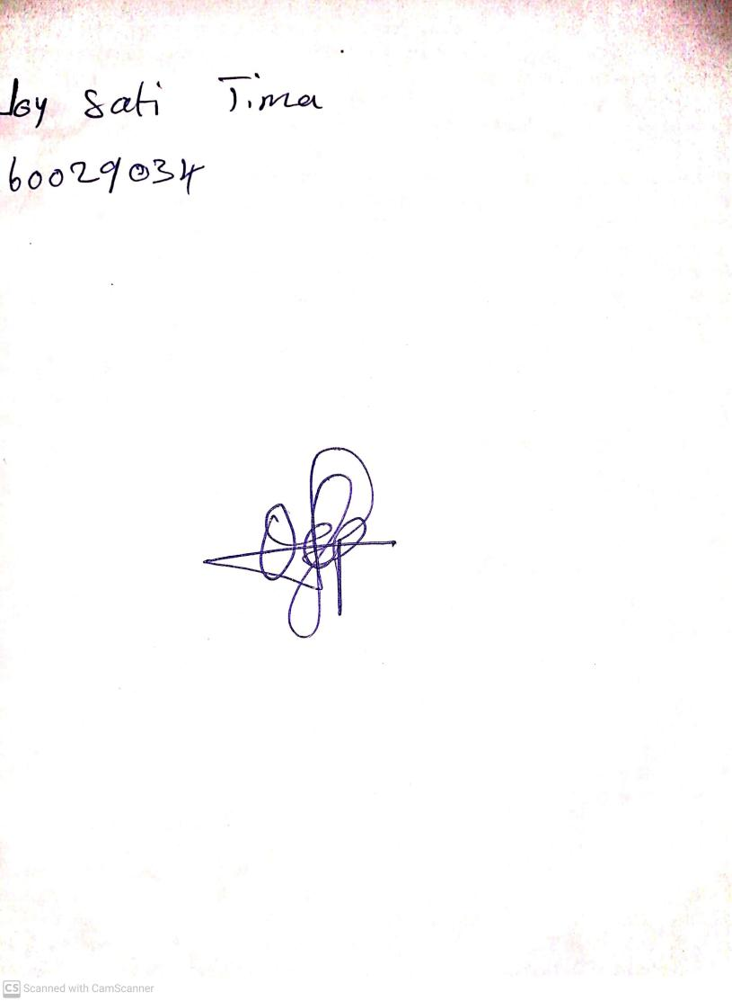

29TH September, 2023

Perpetual Ojoma Ocheja

Stream Head Nursery