LESSON PLAN/ NOTE FOR WEEK 9 ENDING 10/03/2023

TERM:2nd

WEEK:9th

DATE: 09/03/2023

CLASS: Nursery 2

SUBJECT: Letter work

TOPIC: Consonant Digraphs 2

SUB—TOPIC: Words with consonant digraphs ‘wr’

PERIOD: 2nd

TIME: 08:50–09:30am

DURATION: 40 minutes

NUMBER IN CLASS: 14

AVERAGE AGE:5 years

SEX: Mixed

LEARNING OBJECTIVES: By the end of the lesson, the Pupils should be able to:

1. Generate Words with consonant digraphs ‘wr’

2. Spell and pronounce words with consonant digraphs ‘wr’

RATIONALE: For Pupils to know how to pronounce words has ‘wr’ as thier first two letters.

PREVIOUS KNOWLEDGE: Pupils have learnt consonant digraphs ' th' and 'wh' in previous lesson.

INSTRUCTIONAL MATERIALS: Chart of words with consonant digraphs 'wr'

REFERENCE MATERIALS: Google. com

LESSON DEVELOPMENT

|  |  |  |  |
| --- | --- | --- | --- |
| Steps | Teacher's activities | Pupils' activities | Learning point |
| Introduction | Teacher reviews the previous lesson on consonant digraphs 'th' and 'wh' with the Pupils. | Pupils pay attention to the teacher. | To arouse pupils interest for the lesson ahead. |
| Presentation step 1 | Teacher generates words with consonant digraphs 'wr' to pupils on the board and ask them to repeat after her. | Pupils listen attentively to the teacher and repeat after her. | For proper understanding. |
| Step 2 | Teacher guides pupils to spell and pronounce the words with consonant digraphs 'wr' on the board all together. | Pupils spell and pronounce the words on the board all together. | For better understanding. |
| Board summary | Teacher summarizes the lesson by writing the words with consonant digraphs 'wr' on the board for pupils to copy. As;  Consonant digraphs 'wr' are:  'wr' as in write  'wr' as in wrap  'wr' as in worst  'wr' as in wrist  'wr' as in wrestle  'wr' as in wring  'wr' as in wrong etc. | Pupils copy the note into their exercise books. | For onward study. |
| Evaluation | Teacher asks pupils to spell and pronounce the words on the board one after another. | Pupils go to the board one after another and read the words on the board. | To build Pupils reading ability. |
| Conclusion | Teacher concludes the lesson by marking pupils books. | Pupils submit their books for marking. | For endorsement |
| Assignment | Spell, pronounce and write at least 10 words with consonant digraphs 'mb'. | Pupils do their assignment at home. | To encourage learning at home. |

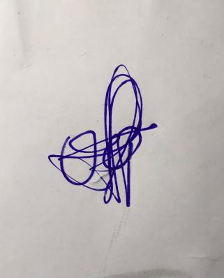

**29th March, 2023**

**Perpetual Ojoma Ocheja**

**Stream Head Nursery**