**EMERALD ROYAL INTERNATIONAL SCHOOL**

**MPAPE, ABUJA.**

**LESSON PLAN AND NOTE FOR WEEK 2 PERIOD 1 ENDING 03/05/2024**

**TERM: THIRD**

**WEEK: 2ND**

**DATE: 29/04/2024**

**CLASS: NURSERY 2**

**SUBJECT: LETTER WORK**

**TOPIC: VOWEL DIGRAPHS 1**

**SUB-TOPIC: MEANING OF VOWEL DIGRAPHS**

**PERIOD: 1ST PERIOD**

**TIME: 09: 30 - 10:10am**

**DURATION: 40 MINUTES.**

**NUMBER IN CLASS: 13**

**AVERAGE AGE: 5 YEARS.**

**SEX: MIXED.**

**SPECIFIC OBJECTIVES: BY THE END OF THE LESSON,THE PUPILS SHOULD BE**

**ABLE TO:**

**1. DEFINE VOWEL DIGRAPHS.**

**2. MENTION WORDS WITH VOWEL DIGRAPHS “EE”**

**RATIONALE: FOR PUPILS TO KNOW THE MEANING OF VOWEL**

**DIGRAPHS**

**PREVIOU KNOWLEDGE: PUPILS HAVE LEARNT ABOUT CONSONANT DIGRAPHS**

**IN PREVIOUS LESSON.**

**REFERENCE MATERIALS: GOOGLE.COM .**

**LESSON DEVELOPMENT**

|  |  |  |  |
| --- | --- | --- | --- |
| **STAGES/STEPS** | **TEACHER’S ACTIVITIES** | **PUPILS’ ACTIVITIES** | **LEARNING POINTS** |
| **INTRODUCTION** | **Teacher reviews the previous lesson on consonant digraphs to pupils.** | **Pupil listen attentively to the teacher.** | **To prepare pupils minds for the lesson ahead.** |
| **PRESENTATION**  **STEP 1** | **Teacher defines vowel digraphs to pupils and asks them to repeat after her.** | **Pupils listen attentively to the teacher and repeat after her.** | **For proper understanding .** |
| **STEP 2** | **Teacher writes the words with vowel digraphs “ee” on the board, spell and pronounce and also asks pupils to repeat after her.** | **Pupils pay attention to the teacher and repeat after her.** | **For better understanding of the lesson.** |
| **BOARD SUMMARY** | **Teacher writes the whole not of lesson on the board for pupils to copy.ie,**  **VOWEL DIGRAPH**  **Vowel digraphs are two vowels that, when placed together, generate one sound.**  **Example: vowel digraph “ee”**  **“ee” as in feet**  **“ee” as in meet**  **“ee” as in see**  **“ee” as in bee**  **“ee” as in tree**  **“ee” as in leek**  **“ee” as in week**  **“ee” as in cheek**  **“ee” as in feed**  **“ee”as in weed etc.** | **Pupils copy the note into their exercise books.** | **For onward study.** |
| **EVALUATION** | **Teacher evaluates the lesson by spelling and pronouncing the words on the board and then asks pupils to repeat after her and also asks them to read one after another.** | **Pupils listen to the teacher and read the note on the board one after another.** | **To assess pupils reading skills.** |
| **CONCLUTION** | **Teacher concludes the lesson by marking pupils books.** | **Pupils submit their books for marking.** | **For endorsement.** |
| **ASSIGNMENT** | **Answer the following questions:**   1. **Define vowel digraphs** 2. **Mention 10 words with vowel “ea”** | **Pupils do their assignment at home.** | **To encourage learning at home.** |

**LESSON PLAN AND NOTE FOR WEEK 2 PERIOD 2 ENDING 03/05/2024**

**TERM: THIRD**

**WEEK: 2ND**

**DATE: 30/04/2024**

**CLASS: NURSERY 2**

**SUBJECT: LETTER WORK**

**TOPIC: VOWEL DIGRAPHS 1**

**SUB-TOPIC: WORDS WITH VOWEL DIGRAPHS “EA”**

**PERIOD: 2ND PERIOD**

**TIME: 08: 50 - 09:30am**

**DURATION: 40 MINUTES.**

**NUMBER IN CLASS: 13**

**AVERAGE AGE: 5 YEARS.**

**SEX: MIXED.**

**SPECIFIC OBJECTIVES: BY THE END OF THE LESSON,THE PUPILS SHOULD BE**

**ABLE TO:**

**1. MENTION WORDS WITH VOWEL DIGRAPHS “EA”**

**2. SPELL AND PRONOUNCE WORDS WITH VOWEL**

**DIGRAPHS "EA"**

**RATIONALE: FOR PUPILS TO KNOW WORDS WITH VOWEL DIGRAPHS**

**DIGRAPHS "EA"**

**PREVIOU KNOWLEDGE: PUPILS HAVE LEARNT MEANING OF VOWEL DIGRAPHS IN PREVIOUS LESSON.**

**REFERENCE MATERIALS: GOOGLE.COM .**

**LESSON DEVELOPMENT**

|  |  |  |  |
| --- | --- | --- | --- |
| **STAGES/STEPS** | **TEACHER’S ACTIVITIES** | **PUPILS’ ACTIVITIES** | **LEARNING POINTS** |
| **INTRODUCTION** | **Teacher reviews the previous lesson on vowel digraphs to pupils.** | **Pupil listen attentively to the teacher.** | **To prepare pupils minds for the lesson ahead.** |
| **PRESENTATION**  **STEP 1** | **Teacher mentions words with vowel digraphs “ea” to pupils and asks them to repeat after her.** | **Pupils listen attentively to the teacher and repeat after her.** | **For proper understanding .** |
| **STEP 2** | **Teacher writes the words with vowel digraph “ea” on the board, spell and pronounce and also asks pupils to repeat after her.** | **Pupils pay attention to the teacher and repeat after her.** | **For better understanding of the lesson.** |
| **BOARD SUMMARY** | **Teacher writes the whole not of lesson on the board for pupils to copy.ie,**  **VOWEL DIGRAPH “EA”**  **“ea” as in steak**  **“ea” as in break**  **“ea” as in great**  **“ea” as in bear**  **“ea” as in tear**  **“ea” as in wear**  **“ea” as in pear**  **“ea” as in swear etc** | **Pupils copy the note into their exercise books.** | **For onward study.** |
| **EVALUATION** | **Teacher evaluates the lesson by spelling and pronouncing the words on the board and then asks pupils to repeat after her and also asks them to read one after another.** | **Pupils listen to the teacher and read the note on the board one after another.** | **To assess pupils reading skills.** |
| **CONCLUTION** | **Teacher concludes the lesson by marking pupils books.** | **Pupils submit their books for marking.** | **For endorsement.** |
| **ASSIGNMENT** | **Make 10 words with vowel “oo”** | **Pupils do their assignment at home.** | **To encourage learning at home.** |

**LESSON PLAN AND NOTE FOR WEEK 2 PERIOD 3 ENDING 03/05/2024**

**TERM: THIRD**

**WEEK: 2ND**

**DATE: 03/05/2024**

**CLASS: NURSERY 2**

**SUBJECT: LETTER WORK**

**TOPIC: VOWEL DIGRAPHS 1**

**SUB-TOPIC: WORDS WITH VOWEL DIGRAPHS “OO”**

**PERIOD: 3RD PERIOD**

**TIME: 09: 30 -10:10am**

**DURATION: 40 MINUTES.**

**NUMBER IN CLASS: 13**

**AVERAGE AGE: 5 YEARS.**

**SEX: MIXED.**

**SPECIFIC OBJECTIVES: BY THE END OF THE LESSON,THE PUPILS SHOULD BE**

**ABLE TO:**

**1. MENTION WORDS WITH VOWEL DIGRAPHS “OO”**

**2. SPELL AND PRONOUNCE WORDS WITH VOWEL**

**DIGRAPHS "OO"**

**RATIONALE: FOR PUPILS TO KNOW WORDS WITH VOWEL DIGRAPHS**

**"OO"**

**PREVIOU KNOWLEDGE: PUPILS HAVE LEARNT VOWEL DIGRAPHS “EA” IN PREVIOUS LESSON.**

**REFERENCE MATERIALS: GOOGLE.COM .**

**LESSON DEVELOPMENT**

|  |  |  |  |
| --- | --- | --- | --- |
| **STAGES/STEPS** | **TEACHER’S ACTIVITIES** | **PUPILS’ ACTIVITIES** | **LEARNING POINTS** |
| **INTRODUCTION** | **Teacher reviews the previous lesson on vowel digraphs “ea” to pupils.** | **Pupil listen attentively to the teacher.** | **To prepare pupils minds for the lesson ahead.** |
| **PRESENTATION**  **STEP 1** | **Teacher mentions words with vowel digraphs “oo” to pupils and asks them to repeat after her.** | **Pupils listen attentively to the teacher and repeat after her.** | **For proper understanding .** |
| **STEP 2** | **Teacher writes the words with vowel digraph “oo” on the board, spell and pronounce and also asks pupils to repeat after her.** | **Pupils pay attention to the teacher and repeat after her.** | **For better understanding of the lesson.** |
| **BOARD SUMMARY** | **Teacher writes the whole not of lesson on the board for pupils to copy.ie,**  **VOWEL DIGRAPH “OO”**  **“oo” as in moon**  **“oo” as in food**  **“oo” as in good**  **“oo” as in foot**  **“oo” as in book**  **“oo” as in room**  **“oo” as in hook**  **“oo” as in look etc** | **Pupils copy the note into their exercise books.** | **For onward study.** |
| **EVALUATION** | **Teacher evaluates the lesson by spelling and pronouncing the words on the board and then asks pupils to repeat after her and also asks them to read one after another.** | **Pupils listen to the teacher and read the note on the board one after another.** | **To assess pupils reading skills.** |
| **CONCLUTION** | **Teacher concludes the lesson by marking pupils books.** | **Pupils submit their books for marking.** | **For endorsement.** |
| **ASSIGNMENT** | **Make 10 words each with the following:**   1. **“ee”** 2. **“ea”** 3. **“oo”** | **Pupils do their assignment at home.** | **To encourage learning at home.** |

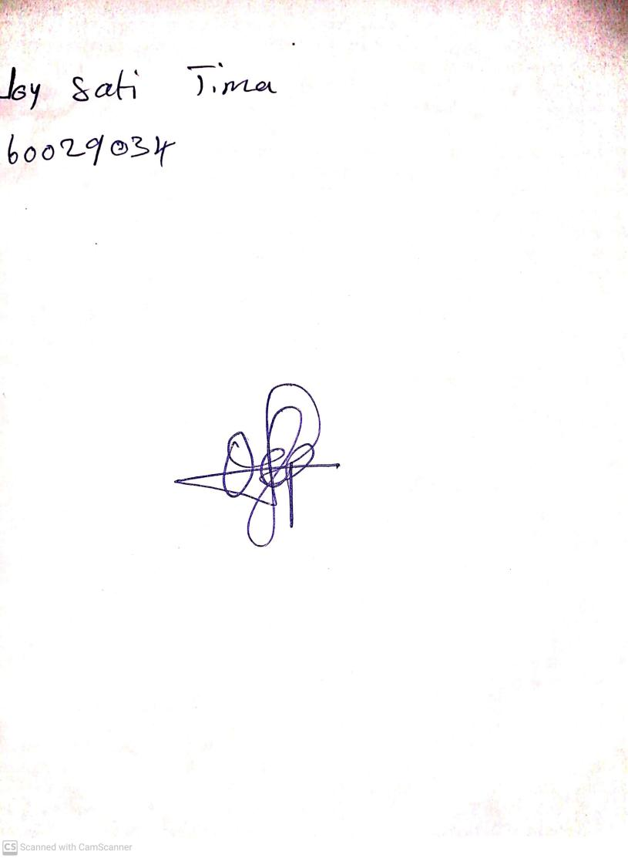

**26th April, 2024**

**Perpetual Ojoma**

**Stream Head Nursery**