EMERALD ROYAL INTERNATIONAL SCHOOL

MPAPE, ABUJA.

LESSON PLAN AND NOTE FOR WEEK 9 ENDING 9TH NOVEMBER,2023

TERM: First term.

WEEK: Nine

SUBJECT: Nature studies.

TOPIC: Common seeds.

SUB-TOPIC: Identification of different seeds.

DATE: 5/11/2023

DURATION: 40 minutes

TIME: 08:50-09:30

PERIOD: 3rd

CLASS: Pre-nursery

NUMBER OF PUPILS: 11

AVERAGE AGE: 2 years

SEX: Mixed

SPECIFIC OBJECTIVES: By the end of the lesson, the pupils should be able to:-

I Mention some seeds.

2. Identify different seeds.

RATIONALE: For Pupils to identify some seeds.

PREVIOUS KNOWLEDGE: Pupils have seen where new plants are growing.

INSTRUCTIONAL MATERIALS: Chart and text books.

REFERENCE: Showers kiddies books Elementary science book nursery 1 by Showers kiddies books.

LESSON DEVELOPMENT

|  |  |  |  |
| --- | --- | --- | --- |
| Stages/steps | Teacher's activities | Pupils' activities | Learning points |
| Introduction | Teacher introduces the lesson by reviewing the meaning of seeds to the pupils. | Pupils listen as the teacher review the last lesson. | To arouse the interest of the pupils for the lesson ahead. |
| Presentation  Step 1 | Teacher mentions the different types of seeds to the pupils as:-   1. Corn seed. 2. Mango seed. 3. Cashew seed. 4. Tomato seed. 5. Paw-paw seed.   The teacher explains and asks the pupils to repeat after the her. | Pupils listen to the teacher and repeat after the teacher. | For better understanding of the lesson. |
| Step 2 | Teacher draws some common seeds for the pupils to identify.  Cashew seed  Mango seed    Beans seed    Corn seed | Pupils pay attention to the teacher and identify the common seeds drawn by the teacher. | For better understanding of the lesson. |
| Summary | Teacher summarizes the lesson by going over the lesson again for better understanding of the lesson. | Pupils listen attentively to the teacher as she is going over the lesson again. | To ensure better understanding. |
| Evaluation | Teacher asks the Pupils to :-   1. Identify the common seeds on the chart. 2. Mention the name of the seeds. | Pupils answer the teacher's questions correctly. | To ascertain the level of pupils understanding of the lesson. |
| Conclusion | Teacher concludes the lesson by singing nursery rhymes for the pupils. | Pupils sing the rhymes along with the teacher . | For onwards learning. |
| Assignment | Teacher asks the pupils to colour the seeds in their text books. Elementary science page 45 | Pupils do the assignment at home. | To encourage Learning at home. |

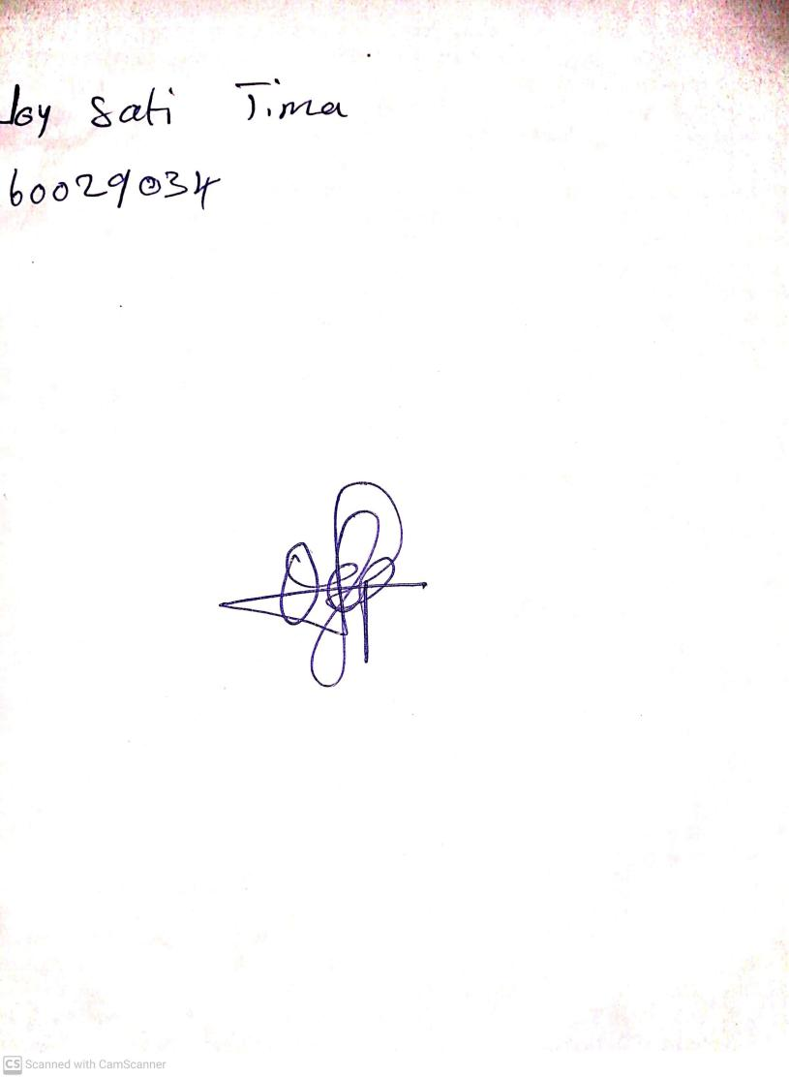

20th August, 2023

Perpetual Ojoma Ocheja

Stream Head Nursery