**EMERALD ROYAL INTERNATIONAL SCHOOL**

**MPAPE, ABUJA.**

**LESSON PLAN AND NOTE FOR WEEK 9 PERIOD 1 ENDING 30/06/2023**

TERM: 3RD

WEEK: 9TH

DATE: 26/06/2023

CLASS: NURSERY 2

SUBJECT: NUMBER WORK

TOPIC: SIMPLE ADDITION( NUMBER 1-9) .

SUB-TOPIC: MEANING AND ITS SIGN(+) AND EXAMPLES

PERIOD: 1ST

TIME: O8:50-09:30.

DURATION: 40 MINUTES.

NUMBER IN CLASS: 17

AVERAGE AGE: 5 YEARS.

SEX: MIXED.

SPECIFIC OBJECTIVES: BY THE END OF THE LESSON,THE PUPILS SHOULD BE

ABLE TO:

1. EXPLAIN THE MEANING OF ADDITION AND ITS SIGN
2. ADD NUMBERS 1-3

RATIONALE: FOR PUPILS TO KNOW ADDITION OF NUMBERS

PREVIOU KNOWLEDGE: PUPILS HAVE LEARNT NUMBERS IN WORDS 1-20 PREVIOUS LESS0N.

INSTRUCTIONAL MATERIALS: NOTE BOOKS, PENCILS AND CHAIRS FOR COUNTING

REFERENCE MATERIALS: THE NEW MASTERING MATHEMATICS FOR NURSERY SCHOOLS BOOK 3 BY HENRY.Z.IDOGUN.

**LESSON DEVELOPMENT**

|  |  |  |  |
| --- | --- | --- | --- |
| STAGES/STEPS | TEACHER’S ACTIVITIES | PUPILS’ ACTIVITIES | LEARNING POINTS |
| INTRODUCTION | Teacher introduces the lesson by reviewing the previous lesson. | Pupil listen to the teacher. | To arouse pupils interest for the lesson ahead. |
| PRESENTATION  STEP 1 | Teacher explains the meaning of addition and it's sign to pupils and then asks them to repeat after her. | Pupils listen attentively to the teacher and repeat after her. | For proper understanding of the lesson . |
| STEP 2 | Teacher solves some questions on the board from 1-3. | Pupils pay attention to the teacher. | For better understanding of the lesson. |
| BOARD SUMMARY | Teacher summarizes the lesson by writing the whole note of lesson on the board for pupils to copy into their books.that is,  ADDITION OF NUMBERS  Addition: is the process of combining two or more numbers.  OR  The action or process of adding something to something else.  Addition sign is(+).  Examples   1. 1+2=3 2. 2+1=3 3. 1+1+1=3 4. 1+1=2 5. 2+2=4 6. 3+3=6 7. 3+2=5 etc. | Pupils copy the note into their exercise books. | For onward study. |
| EVALUATION | Teacher displays pencils in group on the desk and then asks pupils to add them one after the other and then say their answers . | Pupils go out one after another and then count the pencils and add the pencils according to the instructions. | To assess pupils understanding of the lesson. |
| CONCLUSION | Teacher marks pupils books. | Pupils submit their books for marking. | For endorsement. |
| ASSIGNMENT | Add the following numbers   1. 1+2= 2. 3+1= 3. 2+4= 4. 2+2+2= 5. 3+3+1= | Pupils do their assignment at home. | To encourage learning at home. |

**LESSON PLAN AND NOTE FOR WEEK 9 PERIOD 2 ENDING 30/06/2023**

TERM: 3RD

WEEK: 9TH

DATE: 27/06/2023

CLASS: NURSERY 2

SUBJECT: NUMBER WORK

TOPIC: SIMPLE ADDITION (NUMBER 1-9) .

SUB-TOPIC: ADDITION OF NUMBERS 4-6

PERIOD: 2nd

TIME: O8:50-09:30.

DURATION: 40 MINUTES.

NUMBER IN CLASS: 17

AVERAGE AGE: 5 YEARS.

SEX: MIXED.

SPECIFIC OBJECTIVES: BY THE END OF THE LESSON,THE PUPILS SHOULD BE

ABLE TO:

1. SOLVE QUESTIONS ON ADDITION OF NUMBERS 4-6
2. FIND ANSWERS TO QUESTIONS ON ADDITION OF NUMBERS 4-6

RATIONALE: FOR PUPILS TO BE ABLE TO ADD NUMBERS 4–6 .

PREVIOU KNOWLEDGE: PUPILS HAVE LEARNT ADDITION OF NUMBERS 1-3 IN PREVIOUS LESS0N.

INSTRUCTIONAL MATERIALS: STONES, BOTTLE TOPS AND PENCILS FOR COUNTING.

REFERENCE MATERIALS: THE NEW MASTERING MATHEMATICS FOR NURSERY SCHOOLSBOOK 3 BY HENRY.Z.IDOGUN.

**LESSON DEVELOPMENT**

|  |  |  |  |
| --- | --- | --- | --- |
| STAGES/STEPS | TEACHER’S ACTIVITIES | PUPILS’ ACTIVITIES | LEARNING POINTS |
| INTRODUCTION | Teacher introduces the lesson by asking pupils to all stand and count numbers 1-10. | Pupil all stand and count numbers 1-10 | To prepare pupils minds for the lesson ahead. |
| PRESENTATION  STEP 1 | Teacher presents the lesson by writing some questions on the board from 4-6 on the board,,solve and asks pupils to repeat after her. | Pupils pay attention to the teacher and the repeat after her. | For proper understanding of the lesson . |
| STEP 2 | Teacher writes questions from 4-6 on the board and then asks pupils to find the answers. | Pupils pay attention to the teacher and find the answers to the questions on the board. | For better understanding of the lesson. |
| BOARD SUMMARY | Teacher summarizes the lesson by writing the whole note of lesson on the board for pupils to copy into their books .That is,  ADDITION OF NUMBERS 4-6   1. Add the following numbers   4+5, 5+4, 6+5, 4+6, 5+6, 4+4, 5+5, 6+6.  Solution:   1. 4+5= 9   0000+00000=9   1. 5+4= 9   00000+0000=9   1. 6+5= 11   000000+00000=11   1. 4+6= 10   0000+000000=10   1. 5+6= 11   00000+000000=11   1. 4+4= 8   0000+0000= 8   1. 5+5= 10   00000+00000= 10   1. 6+6= 12   000000+000000=12 | Pupils copy the note into their exercise books. | For onwardstudy. |
| EVALUATION | Teacher displays stones on the desk and asks pupils random questions for them to add the stones and find their answers. | Pupils count and find answers according to the teachers questions. | To create platform for slow learners. |
| CONCLUSION | Teacher marks pupils books. | Pupils submit their books for marking. | For endorsement. |
| ASSIGNMENT | Add the following.   1. 2+3= 2. 3+2= 3. 1+4= 4. 4+5= 5. 6+2= 6. 3+5 7. 1+5= 8. 3+1= 9. 5+5= 10. 6+6= | Pupils do their assignment at home. | To encourage learning at home. |

**LESSON PLAN AND NOTE FOR WEEK 9 PERIOD 3 ENDING 30/06/2023**

TERM: 3RD

WEEK: 9TH

DATE: 30/06/2023

CLASS: NURSERY 2

SUBJECT: NUMBER WORK

TOPIC: SIMPLE ADDITION (NUMBERS 1-9) .

SUB-TOPIC: ADDITION OF NUMBERS 7-9

PERIOD: 3RD

TIME: 08:10- 08:50am

DURATION: 40 MINUTES.

NUMBER IN CLASS: 17

AVERAGE AGE: 5 YEARS.

SEX: MIXED.

SPECIFIC OBJECTIVES: BY THE END OF THE LESSON,THE PUPILS SHOULD BE

ABLE TO:

1. SOLVE QUESTIONS ON ADDITION OF NUMBERS 7-9

2. FIND ANSWERS TO QUESTIONS ON ADDITION OF NUMBERS7-9

RATIONALE: FOR PUPILS TO KNOW ADDITION OF NUMBERS 7-9

PREVIOU KNOWLEDGE: PUPILS HAVE LEARNT ADDITION OF NUMBERS 1-6

INSTRUCTIONAL MATERIALS: PENCILS AND BOTTLE TOPS .

REFERENCE MATERIALS: THE NEW MASTERING MATHEMATICS FOR NURSERY

SCHOOL BOOK 3 BY J.M OMOGBAI.

**LESSON DEVELOPMENT**

|  |  |  |  |
| --- | --- | --- | --- |
| STAGES/STEPS | TEACHER’S ACTIVITIES | PUPILS’ ACTIVITIES | LEARNING POINTS |
| INTRODUCTION | Teacher introduces the lesson by singing nursery numbers rhymes . As;  1 little, 2little, 3little fingers  4little, 5little,6little figers……… | Pupils sing the rhymes along with the teacher. | To arouse pupils interest for the lesson ahead. |
| PRESENTATION STEP 1 | Teacher presents the lesson by writing some questions from 7-9 on the board,solve and asks pupils to repeat after her. | Pupils pay attention to the teacher and then repeat after her. | For better understanding. |
| STEP 2 | Teacher writes questions from 7-9 on the board and then asks pupils to find the answers. | Pupils find the answers to the questions on the board. | To create platform for slow learners. |
| BOARD SUMMARY | Teacher writes notes on the board for pupils to copy. As,  ADDITION OF NUMBERS 7-9  Add the following numbers 9+8, 7+9, 8+7, 8+8, 7+7  Solution:   1. 9+8=17 000000000+00000000=17 2. 7+9= 16   0000000+000000000=16   1. 8+7= 15   00000000+0000000=15   1. 8+8= 16   00000000+00000000=16   1. 7+7= 14   0000000+0000000=14 | Pupils copy the note into their books | For onward study |
| EVALUATION | Teacher evaluates the lesson by asking the following questions:  Answer the following questions.  1 .1+2=.  2 .2+3=   1. 6+7= 2. 8+9= etc. | Pupils answer the questions ask by the teacher. | To assess pupils level of understanding.. |
| CONCLUTION | Teacher concludes the lesson by marking pupils books | Pupils submit their books for marking. | For endorcement |
| ASSIGNMENT | Add the following:   1. 1+6= 2. 3+7= 3. 3+8= 4. 5+4= 5. 9+3 6. 6+1= 7. 6+5 8. 3+8= 9. 7+2= 10. 1+2= | Pupils do their assignment at home. | To encourage learning at home |

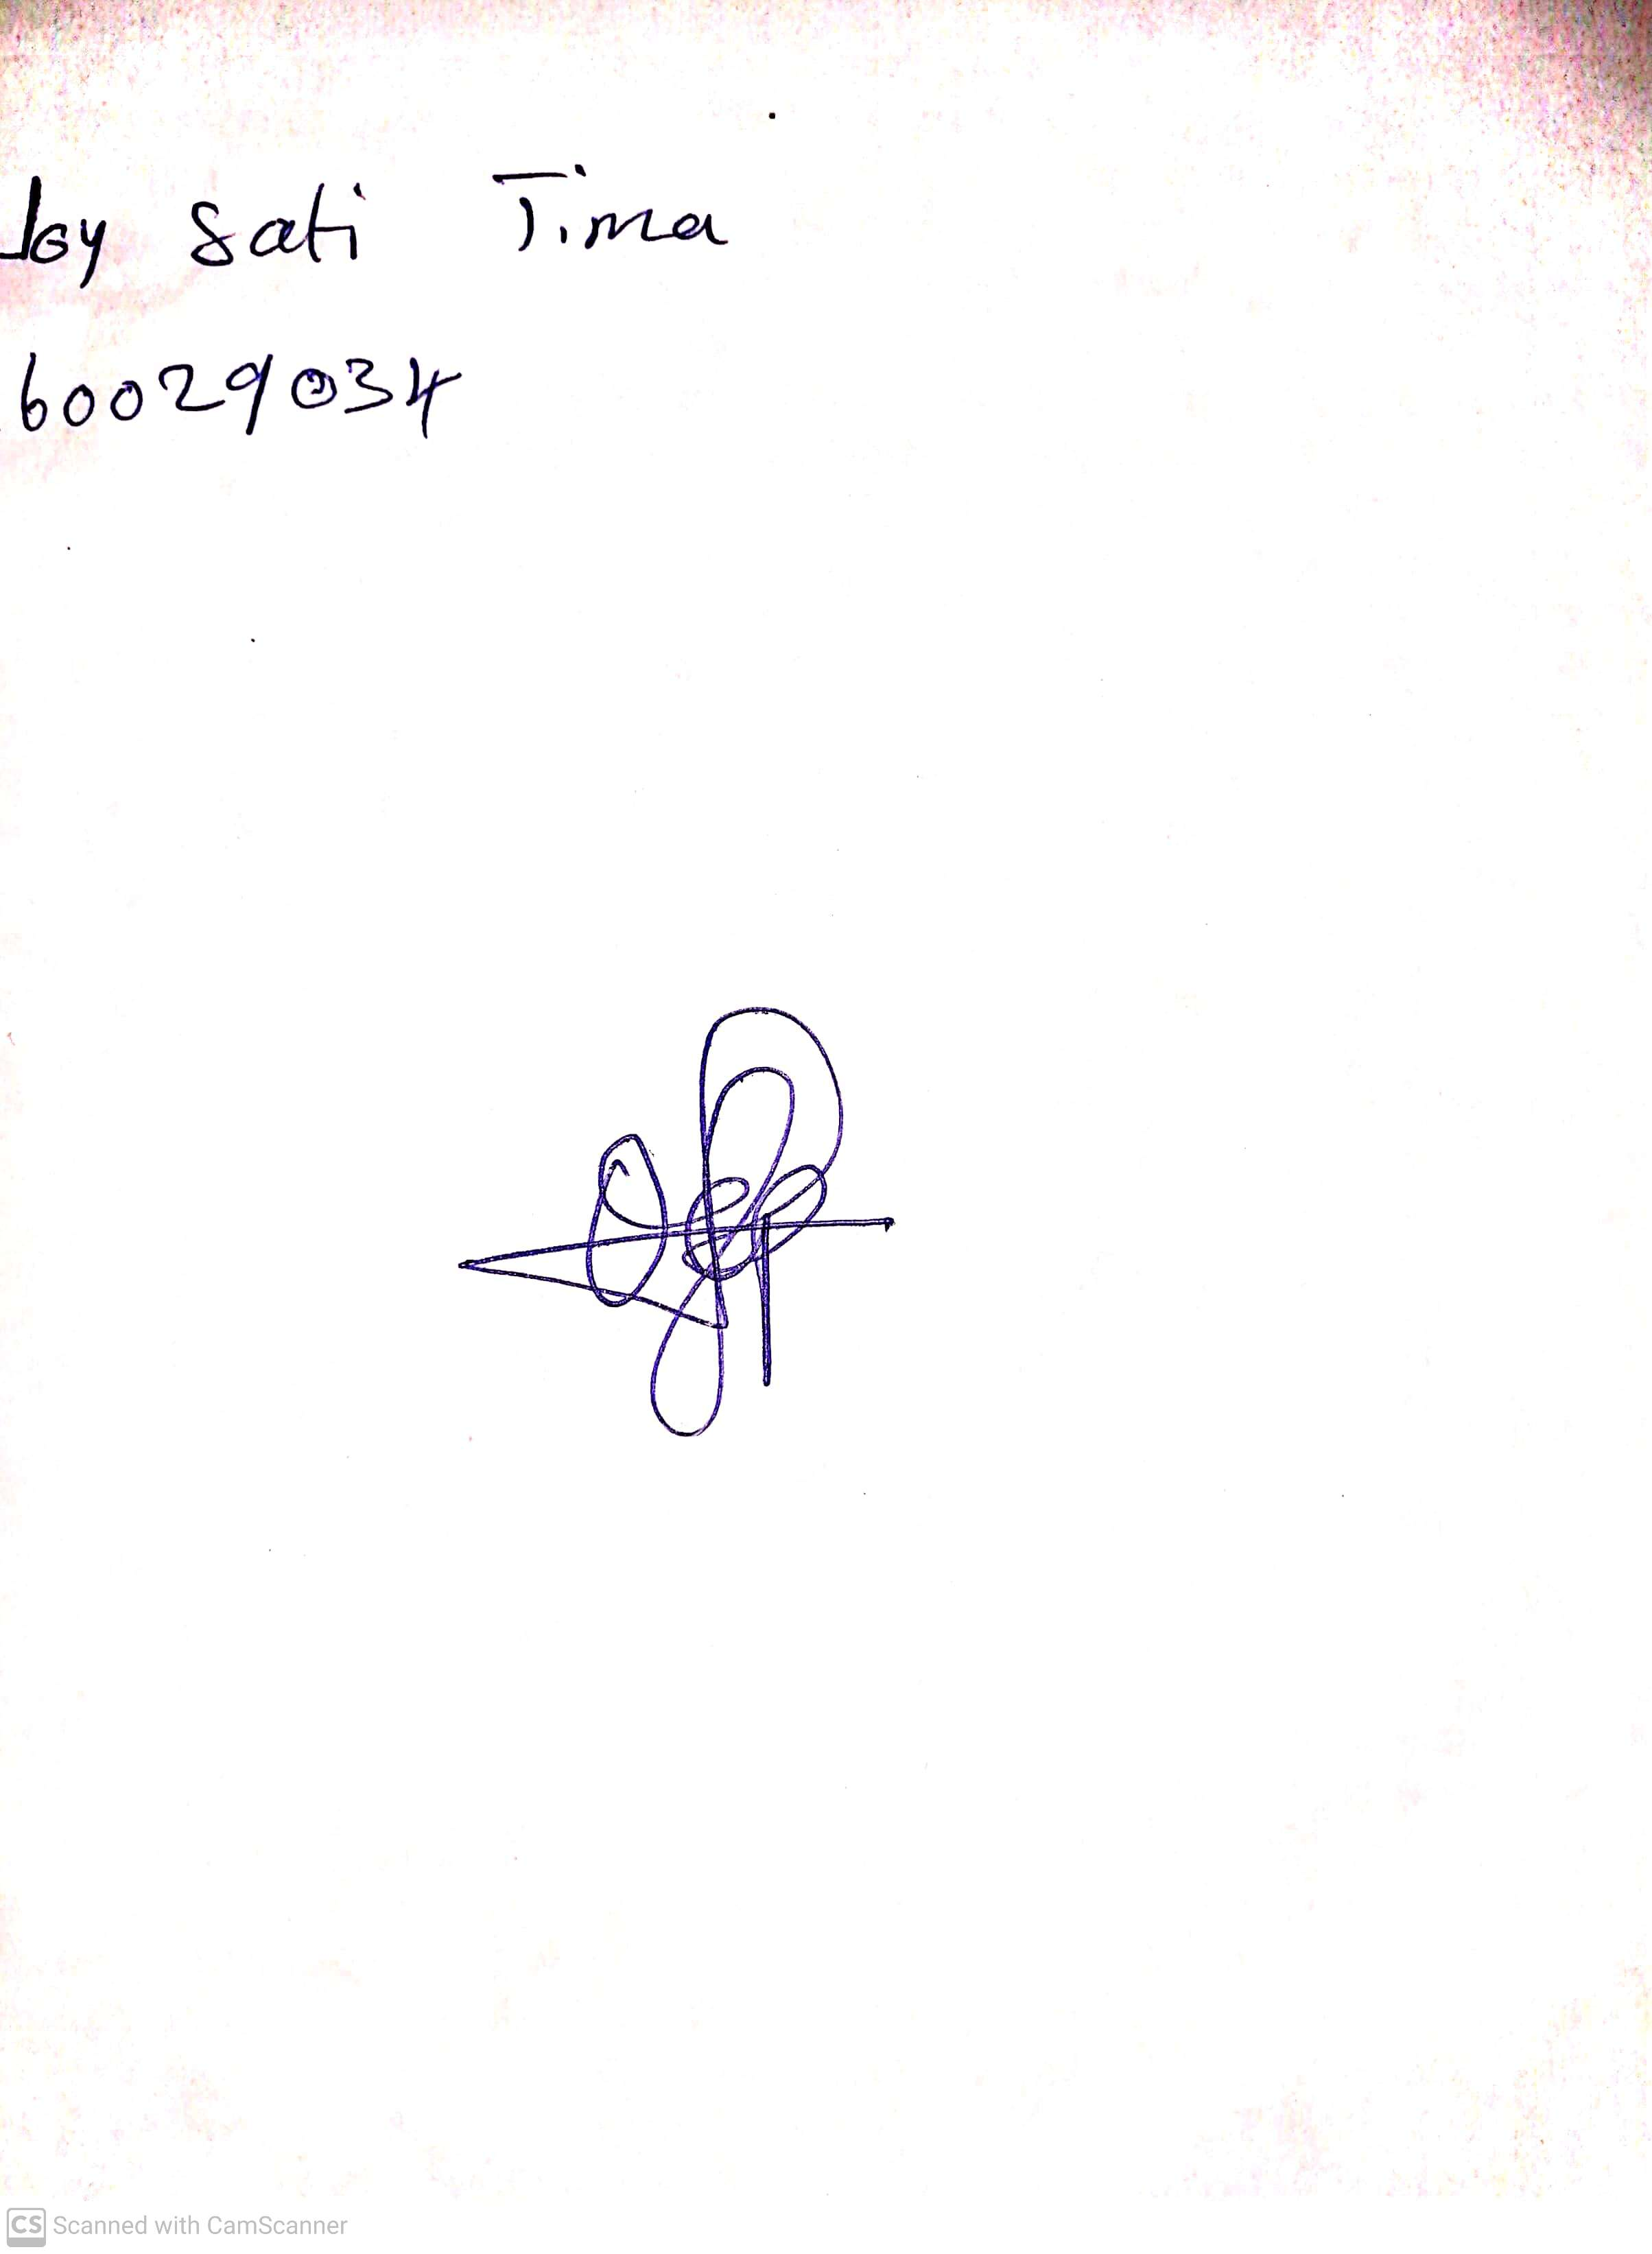

14th May, 2023

Perpetual Ojoma

Stream Head Nursery