EMERALD ROYAL INTERNATIONAL SCHOOL

MPAPE, ABUJA.

LESSON PLAN AND NOTE FOR WEEK 2 ENDING 21ST SEPTEMBER,2023

TERM: First term.

WEEK: Second

SUBJECT: Nature studies.

TOPIC: Importance of the parts of the body.

SUB-TOPIC: Functions of the parts of the body.

DATE: 18/9/2023

DURATION: 40 minutes

TIME: 08:50-09:30

PERIOD: 3rd

CLASS: Pre-nursery

NUMBER OF PUPILS: 8

AVERAGE AGE: 2 years

SEX: Mixed

SPECIFIC OBJECTIVES: By the end of the lesson, the pupils should be able to:-

I Mention the uses of hands.

2. Itemize the uses of mouth.

RATIONALE: For Pupils to identify their body parts and the uses of the body parts.

PREVIOUS KNOWLEDGE: Pupils have been taught the parts of the body.

INSTRUCTIONAL MATERIALS: Charts video clips.

REFERENCE: Showers kiddies books Elementary science book nursery 1 by Showers kiddies books.

LESSON DEVELOPMENT

|  |  |  |  |
| --- | --- | --- | --- |
| Stages/steps | Teacher's activities | Pupils' activities | Learning points |
| Introduction | Teacher introduces the lesson by asking the pupils to touch their hands, mouth,ear and eyes. | Pupils touch the parts of the body the teacher mentioned. | To arouse the interest of the pupils. |
| Presentation  Step 1 | Teacher explains to the pupils what we use our hands to do as:-   1. I clap with my hands. 2. I write with my hands. | Pupils listen as the teacher is explaining the uses of hands. | For better understanding of the uses of hands. |
| Step 2 | Teacher leads the pupils to mention the uses of mouth. | Pupils mention the uses of mouth as:-   1. I eat with my mouth. 2. I talk with my mouth. | For better understanding of the uses of mouth. |
| Summary | Teacher summarizes the lesson by going over the lesson again for more understanding of the lesson. | Pupils listen attentively to the teacher as she is going over the lesson. | To ensure better understanding. |
| Evaluation | Teacher asks the Pupils to :-  I. Mention the uses of the hands.  II. State the uses of mouth. | Pupils answer the teacher's questions correctly. | To ascertain the level of pupils understanding of the lesson. |
| Conclusion | Teacher concludes the lesson by singing nursery rhymes for the pupils. | Pupils sing along with the teacher. | For onwards learning. |
| Assignment | Teacher tells the pupils to match the objects that can be touched by hands to the hand in their text books. | Pupils do the assignment at home. | To encourage Learning at home. |

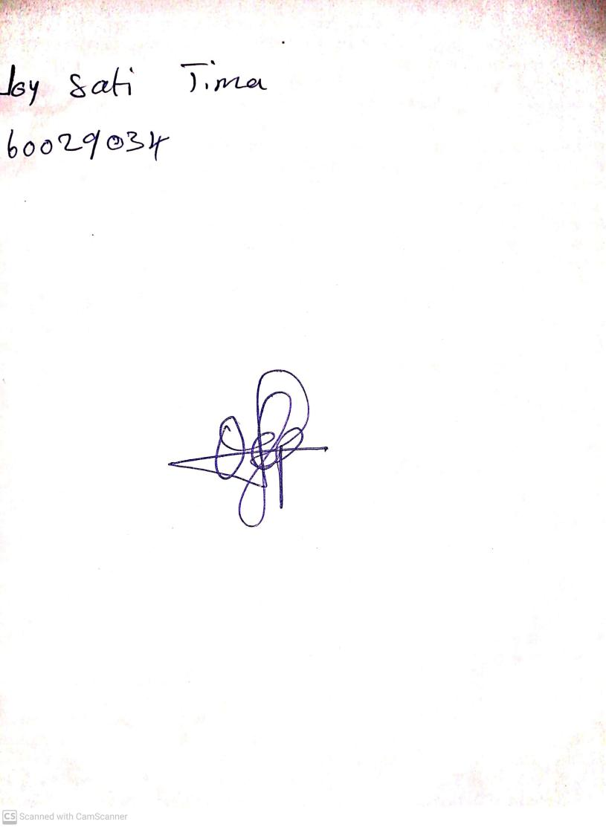

20th August, 2023

Perpetual Ojoma Ocheja

Stream Head Nursery