**LESSON PLAN FOR WEEK 2 ENDING 20th January,2023**

|  |  |
| --- | --- |
| TERM | 2ND |
| WEEK | 2 |
| DATE | 16th-20th January, 2023 |
| SUBJECT | Government |
| TOPIC | Pre-Colonial System |
| SUB-TOPIC | The Political System of Oyo Empire |
| PERIOD | 3rd |
| TIME | 9:30-10:10 |
| DURATION | 35 Minutes |
| CLASS | SS2 |
| NO IN CLASS | 2 |
| AVERAGE AGE | 14-15 Years |
| SEX | Mixed |
| LEARNING OBJECTIVES | By the end of the lesson, scholars should be able to:  i.Explain the political organization of the Oyo Empire.  ii.State the functions of the Oyomesi in the Oyo Empire. |
| RATIONALE | To familiarize scholars with the political system of the Oyo Empire. |
| PREVIOUS KNOWLEDGE | The scholars have been exposed to the Igbo political system. |
| INSTRUCTIONAL RESOURCES | Charts from textbook explaining the topic. |
| REFERENCE MATERIAL | Essential Government for Senior Secondary Schools.  Debie.C.Chris (2017). |

**LESSON DEVELOPMENT**

|  |  |  |  |
| --- | --- | --- | --- |
| **STEPS** | **TEACHERS ACTIVITIES** | **SCHOLARS ACTIVITIES** | **LEARNING POINTS** |
| Introduction | The teacher introduces the lesson by asking the scholars to give the name of the head of the Ofo title holders. | The scholars give the name of the head of the Ofo title holders as Okpara. | To stimulate their interest towards the topic. |
| Step 1 | The teacher explains the political system of the Oyo Empire. | The scholars pay attention. | To enhance proper understanding of the lesson. |
| Step 2 | The teacher states the functions of the Oyomesi in the Oyo Empire. | The scholars listen and ask questions. | To encourage critical thinking on the topic. |
| Board Summary | The teacher summarises the lesson thus:  **The political System of the Oyo Empire.**  Oyo was a vast empire or territory divided into different provinces. It happened to be the most populous and outstanding of all the empires and kingdoms in Yoruba political system. Oyo was able to influence issues in other areas like Dahomey (Republic of Benin), Ekiti, Ijebu and Ife.  **Political Organization of Oyo Empire**:  (1)Political Head: The Alaafin was seen as the political head of the empire.  (2)The Aremo: He was the eldest son of the Alaafin but cannot succeed his father at his demise.  (3)The Oyomesi: These are the seven hereditary kingmakers in the empire.The leader was Bashorun. They are responsible for installing a new Alaafin if the ruling one happens to die.  (4)Provincial Governors (Baale or Oba): Each province was administered by Ajele or Oba. They guarantee the payment of tribute and homage to Oyo.  (5)The Army: Are-Ona-Kakanfo was the head of the army.Oyo had a strong army and were involved indifferent wars.  (6)The Ogboni Society: The society possessed judicial powers and was involved also in policy making.  **Functions of the Oyomesi in the Oyo Empire:**  1.Selection: They took part in the selection of a new Alaafin.  2.Initiated Laws: They are part of the body initiating and making laws in the empire.  3.Power control: They acted as checks and balances on the powers of the Oba e.g removal of the Alaafin from office.  4.Policy implementation: They made sure that policies decided for the empire were fully implemented.  5.Religious Functions: The Oyomesi performed religious functions.  6.Judicial Functions: They equally performed judicial functions in the empire.  7.Communal development: They assisted in the organization of youths for communal development.  8.Good Governance:They advised the Alaafin on good governance.  9.Maintenance of law and order: They helped in the maintenance of law and order.  10.Kingship Installation: The Oyomesi in the pre-colonial Oyo empire took part in the installation of a new Alaafin. | The scholars copy notes into their notebooks. | For reference purposes. |
| Evaluation | The teacher evaluates the students thus:  i.Explain briefly the political organization of the Oyo Empire.  ii.Mention three functions of the Oyomesi in the Oyo Empire. | The students attempts the questions. | To ascertain the students understanding of the lesson. |
| Conclusion | The teacher check students notes and make corrections. | The students take corrections made by the teacher. | For better understanding of the lesson. |
| Assignment | The teacher gives the scholars home work:  -Explain three functions of the Oba or Baale in the Oyo empire. | The students copy their home work to do it at home. | To encourage students to learn and study while at home. |

Note: You should use the lesson note template given for your notes. Take note of the highlighted word(s) or sentence(s); red indicates omission or wrong spelling while yellow indicates need for rephrasing or preferred information.

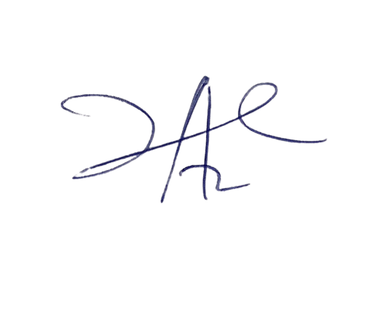

2/2/2023

Head Instructor