**EMERALD ROYAL INTERNATIONAL SCHOOL, MPAPE ABUJA**

**LESSON PLAN AND NOTE FOR WEEK 4 ENDING FRIDAY, 6TH OCTOBER, 2023**

**TERM:** FIRST TERM

**WEEK:** WEEK 4

**SUBJECT:** SOCIAL STUDIES

**TOPIC:** CULTURE AND SOCIAL VALUES

**SUB-TOPIC:** MEANING OF CULTURE

**DATE:** TUESDAY, 3RD ANDWEDNESDAY, 4TH OCTOBER, 2023

**TIME:** 11:50 – 12:30PM AND 01:20 – 02:00PM

**DURATION:** 40 MINUTES

**PERIOD:** 6TH AND 8TH

**CLASS:** NURSERY 3

**NUMBER IN CLASS:** ELEVEN

**AVERAGE AGE:** FIVE

**SEX:** MIXED

**LEARNING OBJECTIVES:** By the end of the lesson, the pupils should be able to:

1. Explain the meaning of culture.
2. List the types of culture.

**RATIONALE:** for pupils to learn the meaning and types of culture.

**PREVIOUS KNOWLEGDE:** pupils learnt the types of family and the qualities of a family.

**INSTRUCTIONAL MATERIALS:**

1. Charts.
2. Textbook.

**REFERENCE MATERIALS:**

1. Social Studies for primary schools book 1 by Olufemi J. Olugasa, Olusola H. Bamidele, Felix K. Alonge, Julius O. Onwuka

|  |  |  |  |
| --- | --- | --- | --- |
| **STAGES/STEPS** | **TEACHER’S ACTIVITIES** | **PUPILS’ ACTIVITIES** | **LEARNING POINTS** |
| **INTRODUCTION** | Review previous knowledge. | Respond to the teacher | To arouse the pupils’ interest. |
| **PRESENTATION**  **STEP 1** | Teaches and explain the meaning of culture.  **Meaning of culture**  Culture is the way of life of group of people. It consist of language, the type of food, clothes, beliefs, the way they dance etc. | Listen attentively and learn. | Meaning of culture. |
| **STEP 2** | Teaches the pupils the types of culture.  **Types of culture**  Culture is subdivided into two main parts.   1. Material culture. 2. Non material culture   **Material culture**   1. Clothes 2. Houses 3. Painting and drawing 4. Food 5. Art work   **Non material culture**   1. Language 2. Beliefs 3. Norms 4. Values 5. Greeting | Listen attentively and learn. | Types of culture. |
| **SUMMARY** | Summarises the lesson by emphasising on the main concept and writes note on the board | Listen and copy their notes | For onward study |
| **EVALUATION** | Asks pupils to:   1. Define culture. 2. List the types of culture. | Respond to the teacher’s question. | To test the pupils understanding on the lesson. |
| **CONCLUSION** | Summarizes, corrects and mark pupils’ notebooks | Submit their notebooks for marking. | Clarifying the concept. |
| **HOME WORK** | 1. Arrange these in the appropriate place under material and noon material culture, 2. Food 3. Clothes 4. Greeting 5. Art work 6. Dancing 7. Houses 8. Painting and drawing 9. Language 10. Beliefs 11. values | Cope and return with task. | Extending lesson home. |

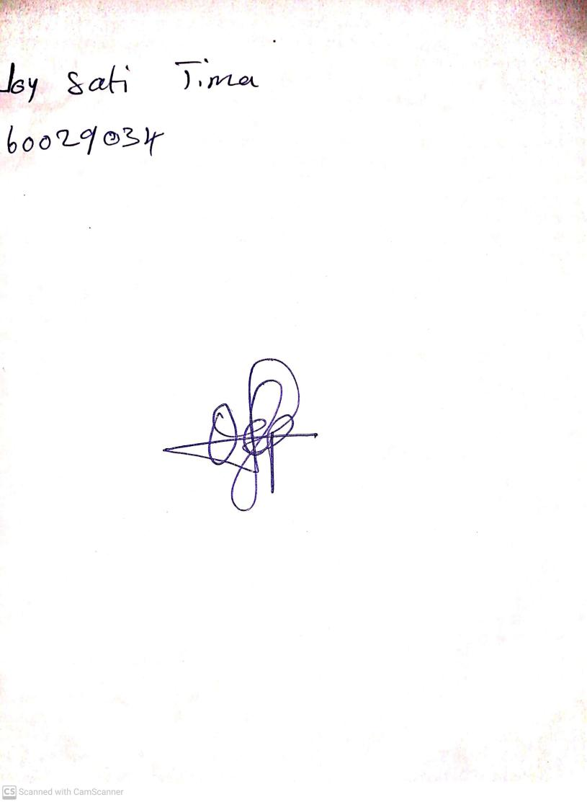

29TH September, 2023

Perpetual Ojoma Ocheja

Stream Head Nursery