**EMERALD ROYAL INTERNATIONAL SCHOOL**

**MPAPE, ABUJA.**

**LESSON PLAN AND NOTE FOR WEEK 2 PERIOD 1 ENDING 12/05/2023**

TERM: 3RD

WEEK: 2ND

DATE: 08/05/2023

CLASS: NURSERY 2

SUBJECT: NUMBER WORK

TOPIC: NUMBERS 41- 45 .

SUB-TOPIC: IDENTIFY,COUNT AND WRITE NUMBER 41- 45

PERIOD: 1ST

TIME: O8:50-09:30.

DURATION: 40 MINUTES.

NUMBER IN CLASS: 17

AVERAGE AGE: 5 YEARS.

SEX: MIXED.

SPECIFIC OBJECTIVES: BY THE END OF THE LESSON,THE PUPILS SHOULD BE

ABLE TO:

1. COUNT NUMBER 41 - 45
2. WRITE NUMBER 41 - 45

RATIONALE: FOR PUPILS TO BE ABLE TO COUNT NUMBERS 41–45.

PREVIOU KNOWLEDGE: PUPILS HAVE LEARNT COUNTING OF NUMBERS 1- 40 IN PREVIOUS LESS0N.

INSTRUCTIONAL MATERIALS: NUMBER CHART .

REFERENCE MATERIALS: THE NEW MASTERING MATHEMATICS FOR NURSERY SCHOOLSBOOK 3 BY HENRY.Z.IDOGUN.

**LESSON DEVELOPMENT**

|  |  |  |  |
| --- | --- | --- | --- |
| STAGES/STEPS | TEACHER’S ACTIVITIES | PUPILS’ ACTIVITIES | LEARNING POINTS |
| INTRODUCTION | Teacher introduces the lesson by reviewing the previous lesson. | Pupil listen to the teacher. | To arouse pupils interest for the lesson ahead. |
| PRESENTATION  STEP 1 | Teacher presents the lesson by counting numbers from 41- 45 and then asks pupils to repeat after. | Pupils count the numbers after the teacher. | For proper understanding of the lesson . |
| STEP 2 | Teacher writes numbers on the board randomly for pupils to identify numbers 41- 45 among others. Ie, 1 3 4 8 41 6 42 9 10 43 2 44 7 15 45 19 20 13. | Pupils identify the numbers 41- 45 on the board. | For better understanding of the lesson. |
| BOARD SUMMARY | Teacher summarizes the lesson by writing the whole note of lesson on the board for pupils to copy into their books.that is,  COUNTING OF NUMBERS 41- 45  4 and 1= 41  4 and 2 = 42  4 and 3= 43  4 and 4 = 44  4 and 5 = 45. | Pupils copy the note into their exercise books. | For onwardstudy. |
| EVALUATION | Teacher asks pupils to count numbers 41- 45 on the board one after the other. | Pupils count numbers 41- 45 on the board one after another. | To assess pupils understanding of the lesson. |
| CONCLUSION | Teacher marks pupils books. | Pupils submit their books for marking. | For endorsement. |
| ASSIGNMENT | Identify, count and write numbers 45- 41. | Pupils do their assignment at home. | To encourage learning at home. |

**LESSON PLAN AND NOTE FOR WEEK 2 PERIOD 2 ENDING 12/05/2023**

TERM: 3RD

WEEK: 2ND

DATE: 09/05/2023

CLASS: NURSERY 2

SUBJECT: NUMBERWORK

TOPIC: NUMBERS 41- 45 .

SUB-TOPIC: IDENTIFY,COUNT AND WRITE NUMBER 45- 41

PERIOD: 2nd

TIME: O8:50-09:30.

DURATION: 40 MINUTES.

NUMBER IN CLASS: 17

AVERAGE AGE: 5 YEARS.

SEX: MIXED.

SPECIFIC OBJECTIVES: BY THE END OF THE LESSON,THE PUPILS SHOULD BE

ABLE TO:

1. COUNT NUMBERS 45 - 41
2. IDENTIFY NUMBERS 51 - 41

RATIONALE: FOR PUPILS TO KNOW BACKWARD COUNTING OF

NUMBERS 45–41.

PREVIOU KNOWLEDGE: PUPILS HAVE LEARNT COUNTING OF NUMBERS 41- 45 IN PREVIOUS LESS0N.

INSTRUCTIONAL MATERIALS: NUMBER CHART .

REFERENCE MATERIALS: THE NEW MASTERING MATHEMATICS FOR NURSERY SCHOOLSBOOK 3 BY HENRY.Z.IDOGUN.

**LESSON DEVELOPMENT**

|  |  |  |  |
| --- | --- | --- | --- |
| STAGES/STEPS | TEACHER’S ACTIVITIES | PUPILS’ ACTIVITIES | LEARNING POINTS |
| INTRODUCTION | Teacher introduces the lesson by asking pupils to count number 41-45. | Pupil count number 41-45.. | To arouse pupils interest for the lesson ahead. |
| PRESENTATION  STEP 1 | Teacher presents the lesson by counting numbers from 45- 41 and then asks pupils o repeat after. | Pupils count the numbers after the teacher. | For proper understanding of the lesson . |
| STEP 2 | Teacher writes numbers 45- 41 on the board and then asks pupils to identify and count. | Pupils identify the numbers 54- 41 on the board and count. | For better understanding of the lesson. |
| BOARD SUMMARY | Teacher summarizes the lesson by writing the whole note of lesson on the board for pupils to copy into their books.that is,  COUNTING OF NUMBERS 45- 41.  45 44 43 42 41. | Pupils copy the note into their exercise books. | For onwardstudy. |
| EVALUATION | Teacher asks Pupils to count numbers 45- 41 on the board one after the other. | Pupils count numbers 45- 41 on the board one after another. | To assess pupils understanding of the lesson. |
| CONCLUSION | Teacher marks pupils books. | Pupils submit their books for marking. | For endorsement. |
| ASSIGNMENT | Identify, count and write numbers 1- 45. | Pupils do their assignment at home. | To encourage learning at home. |

**LESSON PLAN AND NOTE FOR WEEK 2 PERIOD 3 ENDING 12/05/2023**

TERM: 3RD

WEEK: 2ND

DATE: 10/05/2023

CLASS: NURSERY 2

SUBJECT: NUMBERWORK

TOPIC: NUMBERS 41- 45 .

SUB-TOPIC: IDENTIFY,COUNT AND WRITE NUMBER 41- 45

PERIOD: 3RD

TIME: 08:10- 08:50am

DURATION: 40 MINUTES.

NUMBER IN CLASS: 17

AVERAGE AGE: 5 YEARS.

SEX: MIXED.

SPECIFIC OBJECTIVES: BY THE END OF THE LESSON,THE PUPILS SHOULD

BE ABLE TO:

1.COUNT NUMBERS 1- 45

2. WRITE NUMBER 1- 45

RATIONALE: FOR PUPILS TO KNOW COUNTING OF NUMBERS 1- 45 .

PREVIOU KNOWLEDGE: PUPILS HAVE LEARNT COUNTING OF NUMBERS 1- 45 IN PREVIOUS LESS0N.

INSTRUCTIONAL MATERIALS: NUMBER CHART .

REFERENCE MATERIALS: THE NEW MASTERING MATHEMATICS FOR NURSERY

SCHOOLS BOOK 3 BY J.M OMOGBAI.

**LESSON DEVELOPMENT**

|  |  |  |  |
| --- | --- | --- | --- |
| STAGES/STEPS | TEACHER’S ACTIVITIES | PUPILS’ ACTIVITIES | LEARNING POINTS |
| INTRODUCTION | Teacher introduces the lesson by jumping and counting numbers 1- 45. | Pupils jump and count the numbers along with the teacher. | To arouse pupils interest for the lesson ahead. |
| PRESENTATION  STEP 1 | Teacher presents the lesson by writing number 1- 45 on the board,count and then asks pupils to repeat after her. | Pupils listen to the teacher and repeat after her. | For proper understanding of the lesson . |
| STEP 2 | Teacher guides pupils to count and identify the numbers on the board often and often. | Pupils count and identify the numbers on the board. | For better understanding of the lesson. |
| BOARD SUMMARY | Teacher summarizes the lesson by preparing pupils books for them to copy the note on the board.ie,  COUNTING AND WRITING OF NUMBERS 1- 45;  1 2 3 4 5 6 7 8 9 10 11 12 13 14 15 16 17 18 19 20 21 22 23 24 25 26 27 28 29 30 31 32 33 34 35 36 37 38 39 40 41 42 43 44 45. | Pupils copy the note into their exercise books. | For onwardstudy. |
| EVALUATION | Teacher evaluates the lesson by asking pupils to all stand and count the numbers on the board all together. | Pupils all stand and count the numbers on the board. | To create platform for slow learners. |
| CONCLUSION | Teacher concludes the lesson by marking pupils notes . | Pupils submit their books for marking. | For endorsement. |
| ASSIGNMENT | Fill in the missing numbers.  1 2 _ 4 _ 6 _ 8 _ 10 _ 12 _ 14 _ 16 _ 18 _ 20 _ 22 _ 24 _ 26 _ 28 _ 30 _ 32 _ 34 _ 36 _ 38 _ 40 _ 42 _ 44 _. | Pupils do their assignment at home. | To encourage learning at home. |

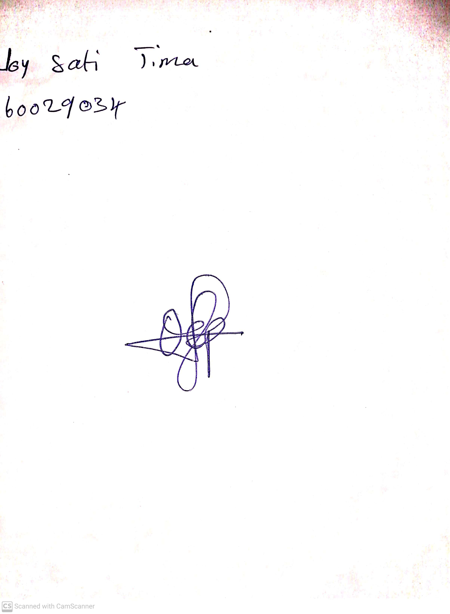

14th May, 2023

Perpetual Ojoma

Stream Head Nursery