**EMERALD ROYAL INTERNATIONAL SCHOOL**

**MPAPE, ABUJA.**

LESSON NOTE FOR WEEK 10 ENDING 28th JUNE,2024.

TERM: Third term.

WEEK: 10th

SUBJECT: Nature studies.

TOPIC: Simple machines

SUB-TOPIC: Definition of simple machines and examples of simple machines.

DATE: 27/6/2024

DURATION: 40 minutes

TIME: 08:50-09:30

PERIOD: 3rd

CLASS: Pre-nursery

NUMBER OF PUPILS: 19

AVERAGE AGE: 2 years

SEX: Mixed

SPECIFIC OBJECTIVES: By the end of the lesson, the pupils should be able to:-

I Define simple machines

2. List the examples and uses of simple machines.

RATIONALE: For Pupils to know the meaning and examples of simple machines.

PREVIOUS KNOWLEDGE: Pupils have been seeing knife, spoon and broom

INSTRUCTIONAL MATERIALS: broom, spoon, pencil and book

REFERENCE: Showers kiddies books Elementary science book nursery 1 by showers kiddies books.

LESSON DEVELOPMENT

|  |  |  |  |
| --- | --- | --- | --- |
| Stages/steps | Teacher's activities | Pupils' activities | Learning points |
| Introduction | Teacher introduces the lesson by asking the pupils these questions:-  What are you using to write in school?  What is mummy using to cook food at home?  After getting the responses, the teacher introduces the topic of the day as "Simple machines". | Pupils listen to the teacher and answer the teacher's question and pay attention as she introduces the lesson | To arouse the interest of the pupils. |
| Presentation  Step 1 | Teacher defines simple machines to the pupils as:  Simple machines are those tools that makes work easy.  "Teacher asks the pupils to repeat after the teacher. | Pupils listen to the teacher and repeat after the teacher. | For better understanding of the lesson. |
| Step 2 | Teacher lists the examples of simple machines and their uses for the pupils to see and learn.  Knife:- A knife is a tool, which has s sharp blade and a handle. It is used for cutting, slicing or spreading.  Broom:- A broom is used for sweeping.  Blender:- A blender is an electrical appliance used to grind pepper and mixing food.  Cutlery:- Cutlery are knives,fork and spoons. They are used for eating.  Phone:- It is a tool used for communication. | Pupils pay attention to the teacher. | For proper understanding of the lesson. |
| Summary | Teacher summarizes the lesson by going over the lesson again for better understanding. | Pupils listen attentively to the teacher as she is going over the lesson. | To ensure better understanding. |
| Evaluation | Teacher asks the pupils to :-   1. Define simple machines. 2. What is this simple tool used for? | Pupils answer the teacher's questions correctly. | To ascertain the level of pupils understanding of the lesson. |
| Conclusion | Teacher concludes the lesson by singing a nursery rhyme for the pupils and make necessary corrections. | Pupils sing along with the teacher. | For onwards learning. |
| Assignment | Teacher asks the pupils to answer the following questions:-   1. What is this tool used for?      1. What is the name of this simple machines?      1. Where do we use this simple tool? | Pupils do the assignment at home. | To encourage Learning at home. |

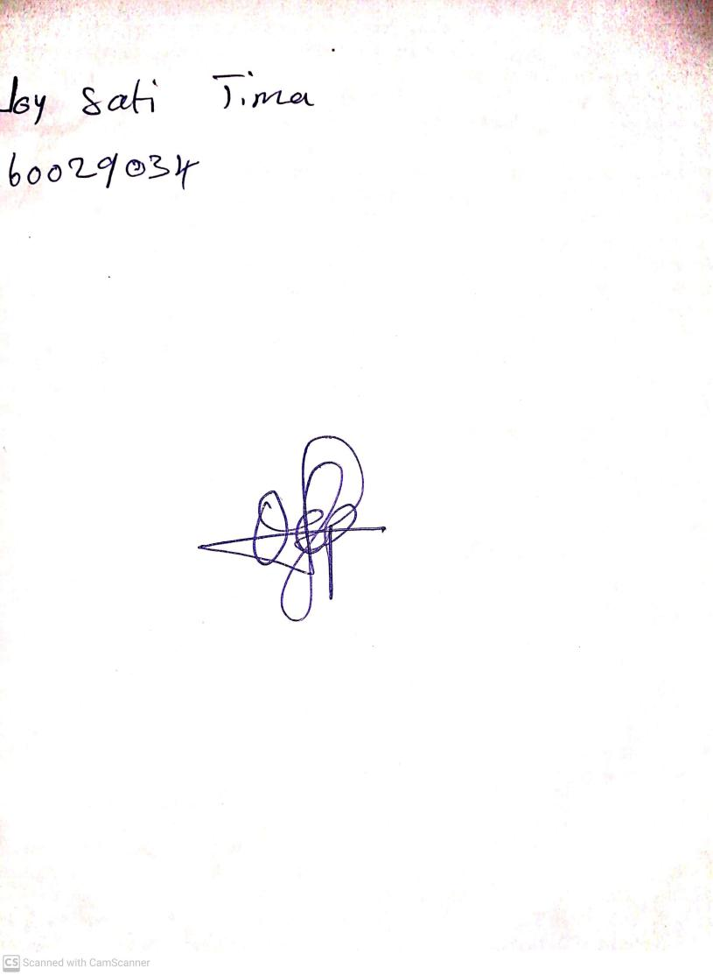

**21ST June, 2024**

**Perpetual Ojoma Ocheja**

**Stream Head Nursery**