**LESSON PLAN AND NOTE 1 FOR WEEK 5 ENDING 13/10/2023**

**Term 1st term**

**Week 5th week**

**Date 9th October,2023**

**Class Nursery One**

**Subject Number Work**

**Topic End numbers and ten numbers.**

**Sub-topic Meaning of end and ten numbers.**

**Period 2nd period**

**Time 8:50 am**

**Duration 35 minutes**

**No in class 15**

**Average Age 3 years**

**Sex Mixed**

**Specific Objectives: By the end of the lesson ,the pupils should be able to:**

1. **Define end and ten numbers.**
2. **Count end numbers 10, 20, 30, 40, 50.**

**Rationale: To make sure the pupils define and count end numbers 10-50.**

**Previous Knowledge: The pupils can count, identify and write numbers 1-40.**

**Instructional Resources: Chart, board, marker, etc.**

**Reference Material: The new mastering mathematics.**

**LESSON PRESENTATION**

|  |  |  |  |
| --- | --- | --- | --- |
| **Steps** | **Teacher’s Activities** | **Pupils’ Activities** | **Learning Points** |
| **Introduction** | **The teacher introduces the topic (end numbers and ten numbers) to the pupils.** | **The pupils listen to the teacher attentively.** | **To arouse the pupils’ interest.** |
| **Step 1** | **The teacher teaches the pupils continuously the meaning of end numbers and ten numbers as “the numbers at the end of the real numbers” E.g 10, 20, 30, 40, 50 etc.** | **The pupils listen and repeat continuously the meaning of end numbers.** | **For proper understanding.** |
| **Step 2** | **The teacher assists the pupils to count the end numbers 10 - 50**  **10 20 30**  **40 50** | **The pupils participates individually with the teacher in counting the end numbers 10 – 50**  **10 20 30**  **40 50** | **For better understanding.** |
| **Summary** | **The teacher summarizes the lesson by counting the end numbers**  **10, 20, 30, 40, 50.** | **The pupils have master and count end numbers 10, 20, 30, 40, 50.** | **For onward study.** |
| **Evaluation** | **Define end numbers?**  **Count end numbers 10 – 50?** | **The pupils answers the question correctly.** | **To ascertain the pupils’ understanding.** |
| **Conclusion** | **The teacher summarizes, reacts and corrects the lesson.** | **The pupils answers to the teacher’s questions** | **To consolidate the lesson** |
| **Assignment** | **Define end numbers?**  **Count end numbers 10 – 50?**  **Write the following end numbers 10 - 50**   |  |  | | --- | --- | | **10** | **10** | |  |  | | **20** | **20** | |  |  | | **30** | **30** | |  |  | | **40** | **40** | |  |  | | **50** | **50** | |  |  | | **The pupils copy and do their homework at home.** | **To encourage learning while at home.** |

**LESSON PLAN AND NOTE 2 FOR WEEK 5 ENDING 13/10/2023**

**Term 1st term**

**Week 5th week**

**Date 11th October,2023**

**Class Nursery One**

**Subject Number Work**

**Topic End numbers and ten numbers.**

**Sub-topic Count end numbers 60 - 100**

**Period 4th period**

**Time 10:40 am**

**Duration 35 minutes**

**No in class 15**

**Average Age 3 years**

**Sex Mixed**

**Specific Objectives: By the end of the lesson ,the pupils should be able to:**

1. **Count end numbers 60 – 100.**
2. **Identify end numbers 10 - 100 .**
3. **Write end numbers 10 - 100.**

**Rationale: To make sure the pupils count end numbers 60 - 100.**

**Previous Knowledge: The pupils knows how to count end numbers 10 - 50.**

**Instructional Resources: Chart, board, marker, etc.**

**Reference Material: The new mastering mathematics.**

**LESSON PRESENTATION**

|  |  |  |  |
| --- | --- | --- | --- |
| **Steps** | **Teacher’s Activities** | **Pupils’ Activities** | **Learning Points** |
| **Introduction** | **The teacher introduces the topic (end and ten numbers) to the pupils.** | **The pupils listen to the teacher for more knowledge.** | **To arouse the pupils’ interest.** |
| **Step 1** | **The teacher together with the pupils count the end numbers 60 - 100**  **60 70 80**  **90 100** | **The pupils individually count the end numbers 60 - 100 with their teacher.**  **60 70 80**  **90 100** | **For proper understanding.** |
| **Step 2** | **The teacher leads the pupils to identify end numbers 10 - 100**  **10 20 30 40**  **50 60 70 80**  **90 100** | **The pupils participate with the teacher in identifying the end numbers 10 - 100.**  **10 20 30 40**  **50 60 70 80**  **90 100** | **For better understanding.** |
| **Step 3** | **The teacher guides the pupils to write end numbers 10 - 100 inside their notebooks.**   |  |  | | --- | --- | | **10** | **20** | |  |  | | **30** | **40** | |  |  | | **50** | **60** | |  |  | | **70** | **80** | |  |  | | **90** | **100** | |  |  | | **The pupils write end numbers 10 - 100 as the teacher guides them.** | **For further understanding** |
| **Summary** | **The teacher summarizes the lesson by counting end numbers 10 - 100** | **The pupils have master and count numbers 10 - 100.** | **For onward study.** |
| **Evaluation** | **Count end numbers 60 – 100**  **Identify the following end numbers 60, 30, 90, 100, 70.**  **Write the following end numbers below?**   |  |  | | --- | --- | | **10** | **20** | |  |  | | **30** | **40** | |  |  | | **50** | **60** | |  |  | | **70** | **80** | |  |  | | **90** | **100** | | **The pupils answers the question correctly.** | **To ascertain the pupils’ understanding.** |
| **Conclusion** | **The teacher summarizes, reacts and corrects the lesson.** | **The pupils answers to the teacher’s questions** | **To consolidate the lesson** |
| **Assignment** | **Count end numbers 60 – 100**  **Identify the following end numbers 60, 30, 90, 100, 70.**  **Write the following end numbers below**   |  |  | | --- | --- | | **50** | **60** | |  |  | | **70** | **80** | |  |  | | **90** | **100** | |  |  | | **The pupils copy and do their homework at home.** | **To encourage learning while at home.** |

**LESSON PLAN AND NOTE 3 FOR WEEK 5 ENDING 13/10/2023**

**Term 1st term**

**Week 5th week**

**Date 13th October,2023**

**Class Nursery One**

**Subject Number Work**

**Topic End numbers and ten numbers.**

**Sub-topic Matching end numbers 10 – 100.**

**Period 2nd period**

**Time 8:50 am**

**Duration 35 minutes**

**No in class 15**

**Average Age 3 years**

**Sex Mixed**

**Specific Objectives: By the end of the lesson ,the pupils should be able to:**

1. **Match end numbers 10-50.**
2. **Match the end numbers 60 - 100.**

**Rationale: To make sure the pupils match numbers 10 - 100.**

**Previous Knowledge: The pupils can count end numbers 10 - 100.**

**Instructional Resources: Chart, board, marker, etc.**

**Reference Material: The new mastering mathematics.**

**LESSON PRESENTATION**

|  |  |  |  |
| --- | --- | --- | --- |
| **Steps** | **Teacher’s Activities** | **Pupils’ Activities** | **Learning Points** |
| **Introduction** | **The teacher introduces the topic (end numbers and ten numbers) to the pupils by rhyming the end numbers.** | **The pupils participate with the teacher by rhyming it.** | **To arouse the pupils’ interest.** |
| **Step 1** | **The teacher assists the pupils to match end numbers 10 - 50**  **10 50**  **20 40**  **30 30**  **40 20**  **50 10** | **The pupils match end numbers 10 - 50.**  **10 50**  **20 40**  **30 30**  **40 20**  **50 10** | **For proper understanding.** |
| **Step 2** | **The teacher assists the pupils to match end numbers 60 - 100**  **100 60**  **90 70**  **80 80**  **70 90**  **60 100** | **The pupils match end numbers 60 - 100.**  **100 60**  **90 70**  **80 80**  **70 90**  **60 100** | **For better understanding.** |
| **Summary** | **The teacher summarizes the lesson by counting numbers**  **10 - 100**  **10, 20, 30, 40, 50, 60, 70, 80, 90, 100.** | **The pupils have master and count numbers 10 - 100.** | **For onward study.** |
| **Evaluation** | **Count end numbers 10 - 100.**  **Match end numbers 10 – 50**  **10 50**  **20 40**  **30 30**  **40 20**  **Match end numbers 60 - 100**  **100 60**  **90 70**  **80 80**  **70 90**  **60 100**  **50 10** | **The pupils answers the question correctly.** | **To ascertain the pupils’ understanding.** |
| **Conclusion** | **The teacher summarizes, reacts and corrects the lesson.** | **The pupils answers to the teacher’s questions** | **To consolidate the lesson** |
| **Assignment** | **Match the end numbers below**  **100 60**  **90 70**  **80 80**  **70 90**  **60 100**  **Write the following end numbers below**   |  |  | | --- | --- | | **10** | **20** | |  |  | | **30** | **40** | |  |  | | **50** | **60** | |  |  | | **70** | **80** | |  |  | | **90** | **100** | |  |  | | **The pupils copy and do their homework at home.** | **To encourage learning while at home.** |

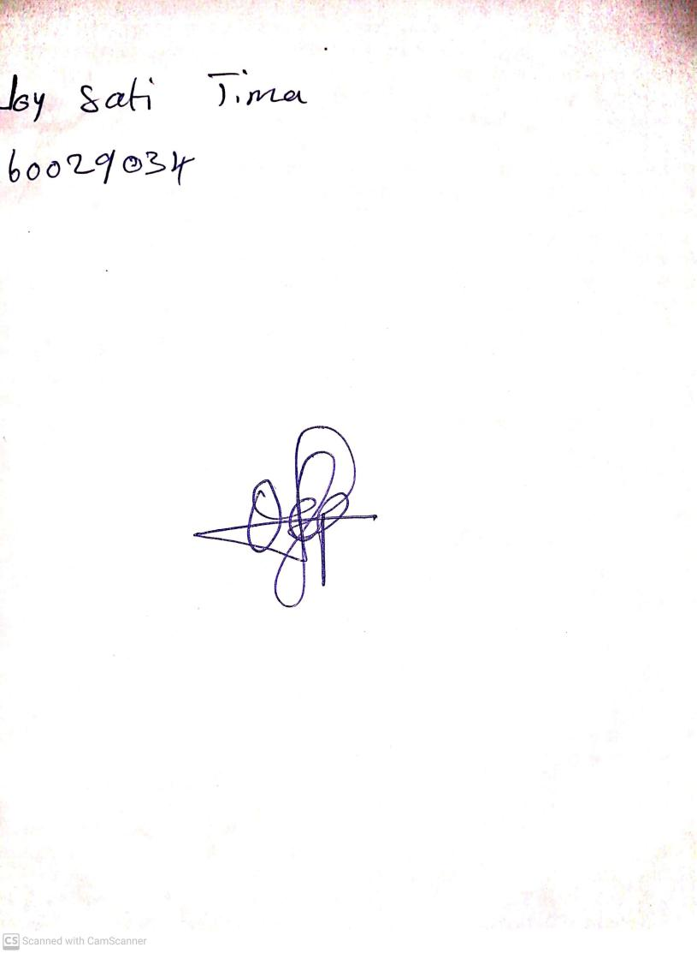

15th August, 2023

Perpetual Ojoma Ocheja

Stream Head Nursery