**EMERALD ROYAL INTERNATIONAL SCHOOL**

**MPAPE, ABUJA.**

**LESSON PLAN AND NOTE FOR WEEK 6 PERIOD 1 ENDING 09/06/2023**

TERM: THIRD

WEEK: 6TH

DATE: 5/06/2023

CLASS: NURSERY 2

SUBJECT: LETTER WORK

TOPIC: WORDS STUDY: PARTS OF MY BODY

SUB-TOPIC: SPELLING OF THE UPPER PARTS OF THE BODY(HEAD)

PERIOD: 1ST

TIME: 09: 30 - 10:10am

DURATION: 40 MINUTES.

NUMBER IN CLASS: 17

AVERAGE AGE: 5 YEARS.

SEX: MIXED.

SPECIFIC OBJECTIVES: BY THE END OF THE LESSON,THE PUPILS SHOULD BE

ABLE TO:

1. IDENTIFY THE VARIOUS PARTS OF THE BODY THAT

MAKES UP THE HEAD.

2. SPELL AND PRONOUNCE THE PARTS THAT MAKES

UP THE HEAD.

RATIONALE: FOR PUPILS TO LEAN SPELLINGS ON PARTS OF THE

BODY.

PREVIOU KNOWLEDGE: PUPILS HAVE BEEN IDENTIFYING THIER BODY PARTS

INSTRUCTIONAL MATERIALS: A CHART OF PARTS OF THE BODY

REFERENCE MATERIALS: THE NEW MASTERING ENGLISH FOR NURSERY

SCHOOLS BOOK 3 BY J. M OMOGBAI

**LESSON DEVELOPMENT**

|  |  |  |  |
| --- | --- | --- | --- |
| STAGES/STEPS | TEACHER’S ACTIVITIES | PUPILS’ ACTIVITIES | LEARNING POINTS |
| INTRODUCTION | Teacher introduces the lesson by singing nursery rhyme as;  My head, my shoulders, my knees, my toes ...... | Pupil listen attentively to the teacher and sing the rhyme along with her. | To prepare pupils minds for the lesson ahead. |
| PRESENTATION  STEP 1 | Teacher presents the lesson by asking pupils to point at their head, and then tell them the parts that makes up the head and asks them to repeat after her. | Pupils point at their head and repeat after her. | For proper understanding . |
| STEP 2 | Teacher writes the parts of the body that makes up the head on the board, spell and pronounce and also asks pupils to repeat after her. | Pupils pay attention to the teacher and repeat after her. | For better understanding of the lesson. |
| BOARD SUMMARY | Teacher writes the whole not of lesson on the board for pupils to copy. That is;  PARTS OF MY BODY  The head is the upper part of the human body.  Parts of the head are:  1. Hair  2. Cheek  3. Nose  4. Mouth  5. Ear  6. Jaw  7. Eye | Pupils copy the note into their exercise books. | For onward study. |
| EVALUATION | Teacher evaluates the lesson by asking pupils to all stand and then spell and pronounce the parts that makes up the head on the board one after another. Such as;  Hair  Cheek  Nose  Mouth  Ear  Jaw  Eye. | Pupils listen to the teacher and answer the questions asked by the her. | To assess pupils reading skills. |
| CONCLUTION | Teacher concludes the lesson by marking pupils books. | Pupils submit their books for marking. | For endorsement. |
| ASSIGNMENT | Spell and pronounce the following words  1. Mouth  2. Cheek  3. Jaw  4. Nose  5. Eye  6. Ear  7. Hair | Pupils do their assignment at home. | To encourage learning at home. |

**LESSON PLAN AND NOTE FOR WEEK 5 PERIOD 2 ENDING 09/06/2023**

TERM: THIRD

WEEK: 6TH

DATE: 08/05/2023

CLASS: NURSERY 2

SUBJECT: LETTER WORK

TOPIC: WORDS STUDY: PARTS OF MY BODY

SUB-TOPIC: SPELLING OF THE MIDDLE PART OF THE BODY

(TRUNK)

PERIOD: 2ND PERIOD

TIME: 09: 30 - 10:10am

DURATION: 40 MINUTES.

NUMBER IN CLASS: 17

AVERAGE AGE: 5 YEARS.

SEX: MIXED.

SPECIFIC OBJECTIVES: BY THE END OF THE LESSON,THE PUPILS SHOULD BE

ABLE TO:

1. MENTION THE MIDDLE PARTS OF THE BODY

2. SPELL AND PRONOUNCE THE MIDDLE PARTS OF THE

BODY.

RATIONALE: FOR PUPILS TO KNOW THE SPELLING OF THIER BODY

PARTS

PREVIOU KNOWLEDGE: PUPILS HAVE LEARNT ABOUT THE PARTS THAT MADE UP

HEAD.

INSTRUCTIONAL MATERIALS: A CHART OF PARTS OF THE BODY

REFERENCE MATERIALS: THE NEW MASTERING ENGLISH FOR NURSERY SCHOOLS BOOK 3 BY J. M OMOGBAI .

**LESSON DEVELOPMENT**

|  |  |  |  |
| --- | --- | --- | --- |
| STAGES/STEPS | TEACHER’S ACTIVITIES | PUPILS’ ACTIVITIES | LEARNING POINTS |
| INTRODUCTION | Teacher introduces the lesson by asking pupils to mention the parts of the body that made up the head. | Pupil listen attentively to the teacher and mention. | To prepare pupils minds for the lesson ahead. |
| PRESENTATION  STEP 1 | Teacher mentions the middle parts of the body to pupils and asks them to repeat after her. | Pupils listen attentively to the teacher and repeat after her. | For proper understanding . |
| STEP 2 | Teacher writes the parts that made up the middle part of the body on the board, spell and pronounce and then asks Pupils to repeat after her. | Pupils pay attention to the teacher and repeat after her. | For better understanding of the lesson. |
| BOARD SUMMARY | Teacher writes the whole not of lesson on the board for pupils to copy.ie,  The middle parts of the body is made up of :  1. Neck  2. Shoulders  3. Chest  4. Elbow  5. Arm  6. Hand  7. Fingers  8. Stomach  9. Breast  10. Nail | Pupils copy the note into their exercise books. | For onward study. |
| EVALUATION | Teacher evaluates the lesson by asking pupils to go to the board one after the other and then   1. spell the words 2. pronounce the words one after another. | Pupils listen to the teacher and read the note on the board one after another. | To assess pupils reading skills. |
| CONCLUTION | Teacher concludes the lesson by marking pupils books. | Pupils submit their books for marking. | For endorsement. |
| ASSIGNMENT | Spell and pronounce the following parts of the body:  1. Fingers  2. Stomach  3. Nail  4. Shoulders  5. Breast  6. Hand  7. Arm  8. Elbow  9. Neck  10. Chest | Pupils do their assignment at home. | To encourage learning at home. |

**LESSON PLAN AND NOTE FOR WEEK 3 PERIOD 5 ENDING 09/06/2023**

TERM: THIRD

WEEK: 6TH

DATE: 09/05/2023

CLASS: NURSERY 2

SUBJECT: LETTER WORK

TOPIC: WORDS STUDY: PARTS OF MY BODY

SUB-TOPIC: SPELLING OF THE LOWER PARTS OF THE BODY

PERIOD: 3RD PERIOD

TIME: 09: 30 - 10:10am

DURATION: 40 MINUTES.

NUMBER IN CLASS: 17

AVERAGE AGE: 5 YEARS.

SEX: MIXED.

SPECIFIC OBJECTIVES: BY THE END OF THE LESSON,THE PUPILS SHOULD BE

ABLE TO:

1. MENTION THE LOWER PARTS OF THE BODY.

2. SPELL AND PRONOUNCE THE LOWER PARTS OF THE

BODY.

RATIONALE: FOR PUPILS TO KNOW HOW TO SPELL THIER BODY

PARTS.

PREVIOU KNOWLEDGE: PUPILS HAVE LEARNT ABOUT THE UPPER AND MIDDLE

PARTS OF THE BODY.

INSTRUCTIONAL MATERIALS: A CHART OF PARTS OF THE BODY

REFERENCE MATERIALS: THE NEW MASTERING ENGLISH FOR NURSERY

SCHOOLS BOOK 3 BY J. M OMOGBAI

**LESSON DEVELOPMENT**

|  |  |  |  |
| --- | --- | --- | --- |
| STAGES/STEPS | TEACHER’S ACTIVITIES | PUPILS’ ACTIVITIES | LEARNING POINTS |
| INTRODUCTION | Teacher reviews the previous lesson. | Pupil listen attentively to the teacher. | To prepare pupils minds for the lesson ahead. |
| PRESENTATION  STEP 1 | Teacher mention the parts that made up the lower part of the body to pupils and asks them to repeat after her. | Pupils listen attentively to the teacher and repeat after her. | For proper understanding . |
| STEP 2 | Teacher writes the parts that made up the lower part of the body on the board, spell and pronounce and also asks pupils to repeat after her. | Pupils pay attention to the teacher and repeat after her. | For better understanding of the lesson. |
| BOARD SUMMARY | Teacher writes the whole not of lesson on the board for pupils to copy.ie,  The lower parts of the body are:  1. Thigh (leg)  2. Calf (leg)  3. Heel  4. Foot  5. Toe  6. Knee  7. Ankle. | Pupils copy the note into their exercise books. | For onward study. |
| EVALUATION | Teacher evaluates the lesson by asking pupils to   1. spell the parts of the body 2. pronounce the parts of the body on the board one after the other. | Pupils listen to the teacher and read the note on the board one after another. | To assess pupils reading skills. |
| CONCLUTION | Teacher concludes the lesson by marking pupils books. | Pupils submit their books for marking. | For endorsement. |
| ASSIGNMENT | Spell and write 10 parts of the body that you know. | Pupils do their assignment at home. | To encourage learning at home. |

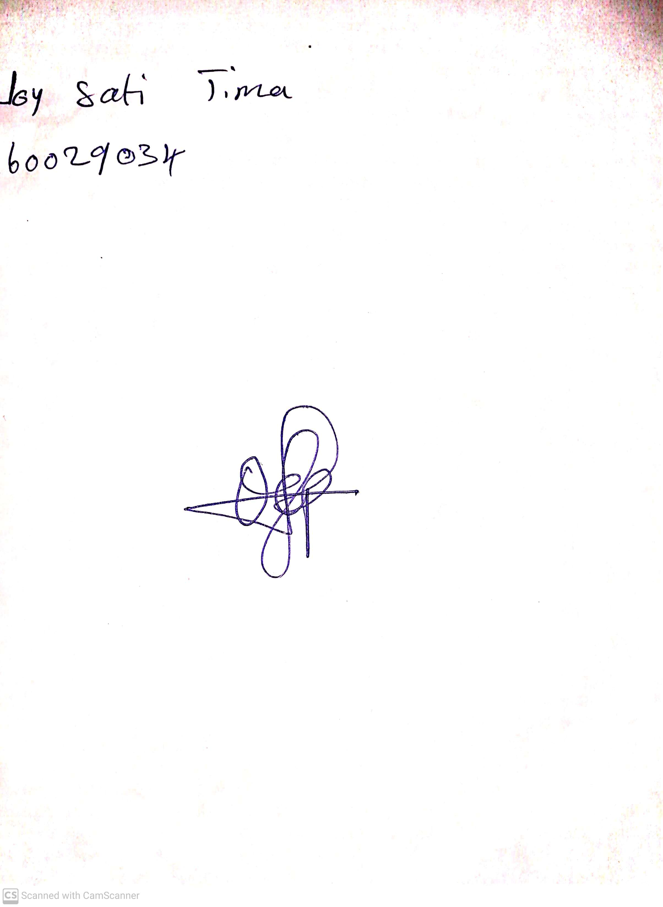

28th May, 2023

Perpetual Ojoma

Stream Head Nursery