**EMERALD ROYAL INTERNATIONAL SCHOOL**

**MPAPE, ABUJA.**

**LESSON PLAN AND NOTE FOR WEEK 7 PERIOD 1 ENDING 16/06/2023**

TERM: THIRD

WEEK: 7TH

DATE: 12/06/2023

CLASS: NURSERY 2

SUBJECT: LETTER WORK

TOPIC: VOWEL DIGRAPHS 5

SUB-TOPIC: WORDS WITH VOWEL DIGRAPHS “IE” AND “IGH”

PERIOD: 1ST PERIOD

TIME: 09: 30 - 10:10am

DURATION: 40 MINUTES.

NUMBER IN CLASS: 17

AVERAGE AGE: 5 YEARS.

SEX: MIXED.

SPECIFIC OBJECTIVES: BY THE END OF THE LESSON,THE PUPILS SHOULD BE

ABLE TO:

1. MENTION WORDS WITH VOWEL DIGRAPHS “IE”

AND "IGH"

2. PRONOUNCE WORDS WITH VOWEL DIGRAPHS

"IE" AND "IGH"

RATIONALE: FOR PUPILS TO KNOW WORDS ON VOWEL DIGRAPHS

"IE" AND "IGH"

PREVIOU KNOWLEDGE: PUPILS HAVE LEARNT ABOUT WORDS ON VOWEL

DIGRAPHS“OY” “AW” “OW” AND “OU”

INSTRUCTIONAL MATERIALS: A CHART OF WORDS ON VOWEL DIGRAPHS "IE" AND

"IGH"

REFERENCE MATERIALS: GOOGLE.COM .

**LESSON DEVELOPMENT**

|  |  |  |  |
| --- | --- | --- | --- |
| STAGES/STEPS | TEACHER’S ACTIVITIES | PUPILS’ ACTIVITIES | LEARNING POINTS |
| INTRODUCTION | Teacher reviews the previous lesson on vowel digraphs to pupils. | Pupil listen attentively to the teacher. | To prepare pupils minds for the lesson ahead. |
| PRESENTATION  STEP 1 | Teacher mentions words on vowel digraphs “ie” “igh” to pupils and asks them to repeat after her. | Pupils listen attentively to the teacher and repeat after her. | For proper understanding . |
| STEP 2 | Teacher writes the words on vowel digraph “ie” and “igh” on the board, spell and pronounce and also asks pupils to identify and repeat after her. | Pupils pay attention to the teacher and repeat after her. | For better understanding of the lesson. |
| BOARD SUMMARY | Teacher writes the whole not of lesson on the board for pupils to copy.ie,  VOWEL DIGRAPH “IE”  Examples of “ie” words are:  “ie” as in pie  “ie” as in tie  “ie” as in die  “ie” as in lie  "ie” as in cried  “ie” as in tried  “ie” as in tied  “ie” as in fried  “ie” as in dried  “ie” as in flies  “ie” as in fries etc  VOWEL DIGRAPHS “IGH” WORDS ARE:  “igh” as in light  “igh” as in fight  “igh” as in sight  “igh” as in bright  “igh” as in right  “igh” as in night  “igh” as in fright  “igh” as in tight  “igh” as in might  “igh” as in high  " igh" as in sigh  "igh" as in knight  " igh" as in delight  " igh" as in tonight  " igh" as in lightening etc. | Pupils copy the note into their exercise books. | For onward study. |
| EVALUATION | Teacher evaluates the lesson by asking pupils to go to the board one after the other and then   1. spell the words 2. pronounce the words. | Pupils listen to the teacher and read the note on the board one after another. | To assess pupils reading skills. |
| CONCLUTION | Teacher concludes the lesson by marking pupils books. | Pupils submit their books for marking. | For endorsement. |
| ASSIGNMENT | Spell and pronounce the following vowel digraphs words.   |  |  | | --- | --- | | "ie" words | "igh" words | | Pie | Light | | Tie | Fight | | Die | Sight | | Lie | Bright | | Cried | Right | | Tried | Night | | Fried | Fright | | Tied | Tight | | Dried | Might | | Flies | High | | Fries | Sigh | | Pupils do their assignment at home. | To encourage learning at home. |

**LESSON PLAN AND NOTE FOR WEEK 7 PERIOD 2 ENDING 16/06/2023**

TERM: THIRD

WEEK: 7TH

DATE: 15/06/2023

CLASS: NURSERY 2

SUBJECT: LETTER WORK

TOPIC: VOWEL DIGRAPHS 5

SUB-TOPIC: WORDS WITH VOWEL DIGRAPHS “Y”

PERIOD: 2ND PERIOD

TIME: 08: 50 - 09:30am

DURATION: 40 MINUTES.

NUMBER IN CLASS: 17

AVERAGE AGE: 5 YEARS.

SEX: MIXED.

SPECIFIC OBJECTIVES: BY THE END OF THE LESSON,THE PUPILS SHOULD BE

ABLE TO:

1. MENTION WORDS ON VOWEL DIGRAPHS “Y”

2. SPELL AND PRONOUNCE WORDS ON VOWEL

DIGRAPHS "Y"

RATIONALE: FOR PUPILS TO KNOW WORDS ON VOWEL DIGRAPH

"Y"

PREVIOU KNOWLEDGE: PUPILS HAVE LEARNT ABOUT WORDS ON VOWEL

DIGRAPHS“IE” AND “IGH” IN PREVIOUS LESSON

INSTRUCTIONAL MATERIALS: CHART OF WORDS ON VOWEL DIGRAPHS "Y"

REFERENCE MATERIALS: GOOGLE.COM .

**LESSON DEVELOPMENT**

|  |  |  |  |
| --- | --- | --- | --- |
| STAGES/STEPS | TEACHER’S ACTIVITIES | PUPILS’ ACTIVITIES | LEARNING POINTS |
| INTRODUCTION | Teacher reviews the previous lesson on vowel digraphs "ie" and "igh" to pupils. | Pupil listen attentively to the teacher. | To prepare pupils minds for the lesson ahead. |
| PRESENTATION  STEP 1 | Teacher mentions words on vowel digraphs “y” to pupils and asks them to repeat after her. | Pupils listen attentively to the teacher and repeat after her. | For proper understanding . |
| STEP 2 | Teacher writes the words on vowel digraph “y” on the board, spell and pronounce and also asks pupils to identify and repeat after her. | Pupils pay attention to the teacher and repeat after her. | For better understanding of the lesson. |
| BOARD SUMMARY | Teacher writes the whole not of lesson on the board for pupils to copy.ie,  VOWEL DIGRAPH “Y” WORDS ARE:  “y” as in my  “y” as in cry  “y” as in by  “y” as in why  “y” as in sly  “y” as in fry  “y” as in dry  “y” as in fly  “y” as in shy  “y” as in cyclone  "y" as in cycle  "y" as in tycoon  "y" as in deny  "y" as in reply  " y" as in July  " y" as in apply  " y" as in rely  " y" as in comply etc. | Pupils copy the note into their exercise books. | For onward study. |
| EVALUATION | Teacher evaluates the lesson by asking pupils to all stand and then 1.spell words on vowel digraph "y"   1. pronounce the words on vowel digraph "y" on the board one after another. | Pupils listen to the teacher and read the note on the board one after another. | To assess pupils reading skills. |
| CONCLUTION | Teacher concludes the lesson by marking pupils books. | Pupils submit their books for marking. | For endorsement. |
| ASSIGNMENT | Spell and pronounce the following words.  1. Fry  2. Fly  3. July  4. Deny  5. Apply  6. Comply  7. Why  8. By  9. My  10. Shy | Pupils do their assignment at home. | To encourage learning at home. |

**LESSON PLAN AND NOTE FOR WEEK 7 PERIOD 3 ENDING 16/06/2023**

TERM: THIRD

WEEK: 7TH

DATE: 16/06/2023

CLASS: NURSERY 2

SUBJECT: LETTER WORK

TOPIC: VOWEL DIGRAPHS 5

SUB-TOPIC: WORDS ON VOWEL DIGRAPHS “EW”

PERIOD: 3RD PERIOD

TIME: 09: 30 - 10:10am

DURATION: 40 MINUTES.

NUMBER IN CLASS: 17

AVERAGE AGE: 5 YEARS.

SEX: MIXED.

SPECIFIC OBJECTIVES: BY THE END OF THE LESSON,THE PUPILS SHOULD BE ABLE TO:

1. MENTION WORDS ON VOWEL DIGRAPHS “EW”

2. PRONOUNCE WORDS ON VOWEL DIGRAPHS "EW"

RATIONALE: FOR PUPILS TO KNOW WORDS ON VOWEL DIGRAPHS

" EW"

PREVIOU KNOWLEDGE: PUPILS HAVE LEARNT ABOUT WORDS ON VOWEL

DIGRAPHS “Y” IN PREVIOUS LESSON.

INSTRUCTIONAL MATERIALS: CHART OF WORDS ON VOWEL DIGRAPHS "EW"

REFERENCE MATERIALS: GOOGLE.COM .

**LESSON DEVELOPMENT**

|  |  |  |  |
| --- | --- | --- | --- |
| STAGES/STEPS | TEACHER’S ACTIVITIES | PUPILS’ ACTIVITIES | LEARNING POINTS |
| INTRODUCTION | Teacher reviews the previous lesson on vowel digraphs “y” to pupils. | Pupil listen attentively to the teacher. | To prepare pupils minds for the lesson ahead. |
| PRESENTATION  STEP 1 | Teacher mentions words on vowel digraphs “ew” to pupils and asks them to repeat after her. | Pupils listen attentively to the teacher and repeat after her. | For proper understanding . |
| STEP 2 | Teacher writes the words on vowel digraph “ew” on the board, spell and pronounce and also asks pupils to identify and repeat after her. | Pupils pay attention to the teacher and repeat after her. | For better understanding of the lesson. |
| BOARD SUMMARY | Teacher writes the whole not of lesson on the board for pupils to copy.ie,  VOWEL DIGRAPH “EW” WORDS ARE:  “ew” as in new  “ew” as in few  “ew” as in flew  “ew” as in brew  “ew” as in chew  “ew” as in crew  “ew” as in drew  “ew” as in knew  “ew”as in grew  “ew” as in threw  “ew” as in stew  “ew”as in blew  “ew” as in cashew  “ew” as in Andrew etc. | Pupils copy the note into their exercise books. | For onward study. |
| EVALUATION | Teacher evaluates the lesson by asking pupils to go to the board one after the other and then   1. spell the words on Vowel "ew" 2. pronounce the words on Vowel "ew" on the board one after the other . | Pupils read the note on the board one after another. | To assess pupils reading skills. |
| CONCLUTION | Teacher concludes the lesson by marking pupils books. | Pupils submit their books for marking. | For endorsement. |
| ASSIGNMENT | Fill in the missing words on the worksheet below. | Pupils do their assignment at home. | To encourage learning at home. |

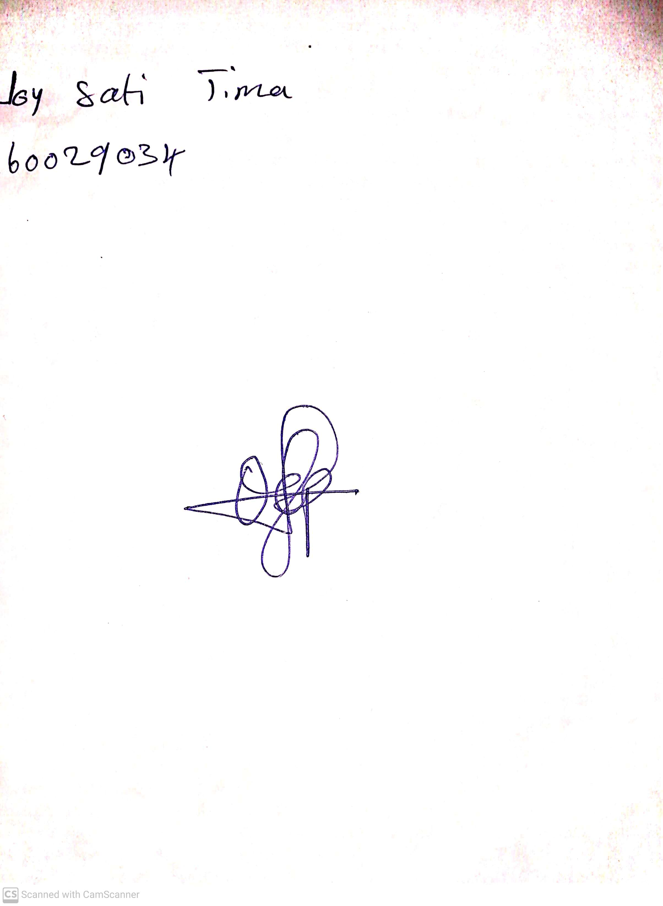

28th May, 2023

Perpetual Ojoma

Stream Head Nursery