EMERALD ROYAL INTERNATIONAL SCHOOL

MPAPE, ABUJA.

LESSON PLAN AND NOTE FOR WEEK 1 ENDING 15TH SEPTEMBER,2023

TERM: First term.

WEEK: First

SUBJECT: Nature study.

TOPIC: Parts of the body.

SUB-TOPIC: Self awareness.

DATE: 11/9/2023

DURATION: 40 minutes

TIME: 08:50-09:30

PERIOD: 3rd

CLASS: Pre-nursery

NUMBER OF PUPILS: 8

AVERAGE AGE: 2 years

SEX: Mixed

SPECIFIC OBJECTIVES: By the end of the lesson, the pupils should be able to:-

I Identify the head and eye.

2. Identify the nose and mouth.

RATIONALE: For Pupils to identify their body parts.

PREVIOUS KNOWLEDGE: Pupils have been walking around with the body parts.

INSTRUCTIONAL MATERIALS: Charts video clips.

REFERENCE: Showers kiddies books Elementary science book nursery 1 by Showers kiddies books.

LESSON DEVELOPMENT

|  |  |  |  |
| --- | --- | --- | --- |
| Stages/steps | Teacher's activities | Pupils' activities | Learning points |
| Introduction | Teacher introduces the lesson by singing a nursery rhyme as:-  Head, shoulder, knees and toes  Knees and toes,.................... | Pupils listen to the teacher and practice the rhyme and sing along with the teacher.. | To arouse the interest of the pupils. |
| Presentation  Step 1 | Teacher touches her head and says  ''My head".  The teacher again touched her eyes and says  "My eyes".  Teacher tells the pupils to touch their head and eyes and say the name. | Pupils watch the teacher s she is touching her head and eyes and say their names. Pupils also repeay after the teacher by touching their head and eyes and calling their names . | For better understanding of the lesson. |
| Step 2 | Teacher again touches her nose and mouth and say their names respectively and asks the pupils to repeat after her. | Pupils also touch their nose and mouth and say their names respectively. | For better understanding of the lesson. |
| Summary | Teacher summarizes the lesson by going over the lesson again for more understanding. | Pupils listen attentively to the teacher as she is going over the lesson. | To ensure better understanding. |
| Evaluation | Teacher asks the Pupils to :-  I. Identify their head and eyes.  II. Identify their nose and mouth. | Pupils answer the teacher's questions correctly. | To ascertain the level of pupils understanding of the lesson. |
| Conclusion | Teacher concludes the lesson by singing nursery rhymes that was sang at the introduction. | Pupils sing along with the teacher. | For onwards learning. |
| Assignment | Teacher tells the pupils to colour the following parts of the body in their text books.  -- nose.  -- mouth  -- head. | Pupils do the assignment at home. | To encourage Learning at home. |

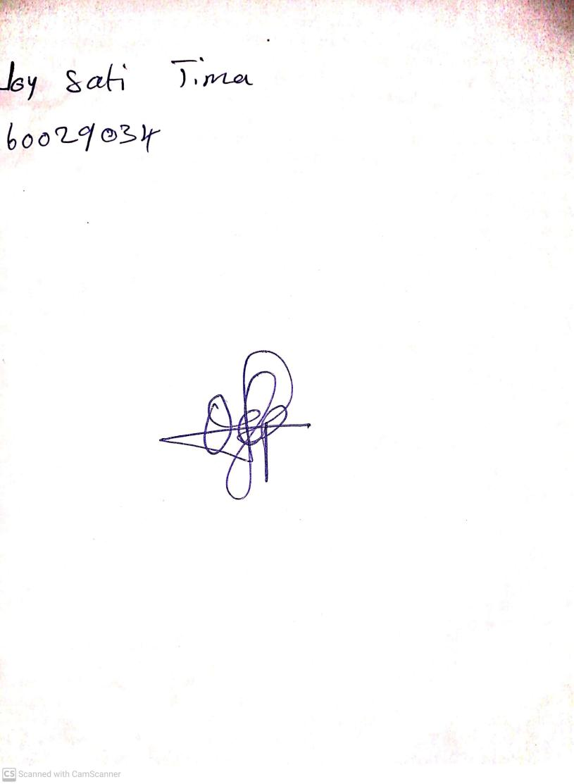

20th August, 2023

Perpetual Ojoma Ocheja

Stream Head Nursery