**EMERALD ROYAL INTERNATIONAL SCHOOL MPAPE, ABUJA.**

**LESSON PLAN AND NOTE 1 FOR WEEK 5 ENDING 24/05/2024**

**TERM: 3rd**

**WEEK: 5th**

**DATE: 20/05/2024**

**CLASS: Nursery 2**

**SUBJECT: Number work**

**TOPIC: Length**

**SUB—TOPIC: Simple meaning of length and examples**

**PERIOD: 1st**

**TIME: 08:50—09:30 am**

**DURATION: 40 minutes**

**NUMBER IN CLASS: 13**

**AVERAGE AGE: 5 years**

**SEX: Mixed**

**LEARNING OBJECTIVES: By the end of the lesson, the Pupils should be able to:**

**1. Explain the meaning of length**

**2. Mention some examples of instrument for measuring length**

**RATIONALE: For Pupils to know measurement**

**PREVIOUS KNOWLEDGE: Pupils have been seeing long and short things in their daily activities.**

**INSTRUCTIONAL MATERIALS: long and short pencils, ruler,books, and crayons.**

**REFERENCE MATERIALS: Mastering Mathematics for Nursery schools book 3 by Henry Z.Idogun**

**LESSON DEVELOPMENT**

|  |  |  |  |
| --- | --- | --- | --- |
| **STAGES/ STEPS** | **TEACHER'S ACTIVITIES** | **PUPILS' ACTIVITIES** | **LEARNING POINT** |
| **Introduction** | **Teacher reviews the previous lesson.** | **Pupils listen attentively to the teacher.** | **To arouse pupils interest for the lesson.** |
| **Presentation step 1** | **Teacher explains the meaning of length to pupils and then asks them to repeat after her.** | **Pupils listen to the teacher and repeat after her.** | **For proper understanding.** |
| **Step 2** | **Teacher mentions the examples of instrument for measuring length to pupils and also asks them to repeat after her.** | **Pupils pay attention to the teacher and repeat after her.** | **To enhance Pupils participation in class.** |
| **Board summary** | **Teacher writes the whole note of lesson on the board for pupils to copy into their books. That is;**  **Length means how long something is. Some things are long. Some things are short.**  **The examples of instrument for measuring lengths are:**  **1.Ruler**  **2. Meter–rule**  **3. Tape rule**  **4. Arms length**  **5.Hand–span**  **6. Strides**  **7. Foot, etc.**  **The use of arms length, Hand–span ,studies and foot for taking measurement are old methods of measuring lengths. These methods have been replaced by the use of ruler and tape–rule.** | **Pupils copy the note into their exercise books.** | **For onward study.** |
| **Evaluation** | **Teacher evaluates the lesson by asking pupils the following questions;**  **1. What is the meaning of length?**  **2. Mention the instrument for measuring lengths.** | **Pupils answer the questions ask by the teacher.** | **To assess pupils level of understanding.** |
| **Conclusion** | **Teacher concludes the lesson by marking pupils books.** | **Pupils submit their books for marking.** | **For endorsement.** |
| **Assignment** | **Answer the following questions:**  **With the help of the objects in your bag,**  **1. What color is the longest pencil ?**  **2. What colour is the shortest pencil?**  **3. Find two things longer than your pencil and draw them in your book.**  **4. Which ruler is the shortest?**  **5. Which ruler is the longest?** | **Pupils do their assignment at home.** | **To encourage learning at home.** |

**LESSON PLAN AND NOTE 2 FOR WEEK 5 ENDING 24/05/2024**

**TERM: 3rd**

**WEEK: 5th**

**DATE: 21/05/2024**

**CLASS: Nursery 2**

**SUBJECT: Number work**

**TOPIC: Length**

**SUB—TOPIC: Measuring lengths using natural units.**

**PERIOD: 2nd**

**TIME: 08:50—09:30 am**

**DURATION: 40 minutes**

**NUMBER IN CLASS: 13**

**AVERAGE AGE: 5 years**

**SEX: Mixed**

**LEARNING OBJECTIVES: By the end of the lesson, the Pupils should be able to:**

**1. Mention the natural units for measuring lengths.**

**2. Measure some things in the classroom with their hand span, foot**

**and pencils.**

**RATIONALE: For Pupils to be able to measure things.**

**PREVIOUS KNOWLEDGE: Pupils have learnt the meaning of length and some examples.**

**INSTRUCTIONAL MATERIALS: Table,hand,pencils and foot.**

**REFERENCE MATERIALS: New General Mathematics for primary schools book 1. By J Aderohunmu etal.**

**LESSON DEVELOPMENT**

|  |  |  |  |
| --- | --- | --- | --- |
| **STAGES/ STEPS** | **TEACHER'S ACTIVITIES** | **PUPILS' ACTIVITIES** | **LEARNING POINT** |
| **Introduction** | **Teacher reviews the previous lesson.** | **Pupils listen attentively to the teacher.** | **To arouse pupils interest for the lesson.** |
| **Presentation step 1** | **Teacher mentions the natural units for measuring lengths to pupils and then asks them to repeat after her.** | **Pupils listen to the teacher and repeat after her.** | **For proper understanding.** |
| **Step 2** | **Teacher guides pupils to measure the length of their classroom with their feet one after the other** | **Pupils measure the length of their classroom with the help of the teacher.** | **To enhance Pupils participation in class.** |
| **Board summary** | **Teacher writes the whole note of lesson on the board for pupils to copy into their books. That is;**  **Natural Units for measuring lengths:**  **1. Feet**  **2. Arms**  **3. Blocks**  **4. Sticks.**  **We use;**  **Feet to measure the length of our classroom.**  **Arm's length to measure the width of our classroom.**  **Pencils to measure the length of the teacher's table.** | **Pupils copy the note into their exercise books.** | **For onward study.** |
| **Evaluation** | **Teacher evaluates the lesson by asking pupils the following question:**  **Mention the natural units for measuring lengths.** | **Pupils answer the question ask by the teacher.** | **To assess Pupils level of understanding.** |
| **Conclusion** | **Teacher concludes the lesson by marking pupils books.** | **Pupils submit their books for marking.** | **For endorsement.** |
| **Assignment** | **1. How many of your hand spans is the length of your dinning table?**  **2. Mrs Vivian walls 14 Strides to visit her friend. How many feet did she walk? One stride is five feet.** | **Pupils do their assignment at home.** | **To encourage learning at home.** |

**LESSON PLAN AND NOTE 3 FOR WEEK 5 ENDING 24/05/2024**

**TERM: 3rd**

**WEEK: 5th**

**DATE: 24/05/2024**

**CLASS: Nursery 2**

**SUBJECT: Number work**

**TOPIC: Place value of numbers**

**SUB—TOPIC: Comparing and Ordering of length**

**PERIOD: 3rd**

**TIME: 08: 10–80 :50am**

**DURATION: 40 minutes**

**NUMBER IN CLASS: 13**

**AVERAGE AGE: 5 years**

**SEX: Mixed**

**LEARNING OBJECTIVES: By the end of the lesson, the Pupils should be able to:**

**1. Identify objects**

**2. Mention objects that are short, shorter,and shortest.**

**RATIONALE: For Pupils to know length of objects.**

**PREVIOUS KNOWLEDGE: Pupils have been seeing things of different length.**

**INSTRUCTIONAL MATERIALS: keys, pencils and bottles.**

**REFERENCE MATERIALS: The New Mastering Mathematics for Nursery schools book 3 by Henry Z.Idogun**

**LESSON DEVELOPMENT**

|  |  |  |  |
| --- | --- | --- | --- |
| **STAGES/ STEPS** | **TEACHER'S ACTIVITIES** | **PUPILS' ACTIVITIES** | **LEARNING POINT** |
| **Introduction** | **Teacher introduces the lesson by showing Pupils her last three fingers and then asks which amongst this there fingers is the shortest?** | **Pupils listen attentively to the teacher and answer the question.** | **To arouse pupils interest for the lesson.** |
| **Presentation step 1** | **Teacher draws some objects on the board and then identify them according to their length and then asks Pupils to repeat after her.** | **Pupils listen to the teacher and repeat after her.** | **For proper understanding.** |
| **Step 2** | **Teacher guides pupils to mention the object that is short, shorter, shortest.**  **That is;** | **Pupils take turns to identify the objects on the board.** | **To enhance Pupils participation in class.** |
| **Board summary** | **Teacher summarizes the lesson by going through the lesson over again..** | **Pupils listen attentively to the teacher..** | **To create platform for slow learners.** |
| **Evaluation** | **Teacher evaluates the lesson by asking pupils the following questions;** | **Pupils answer the questions ask by the teacher.** | **To assess Pupils level of understanding.** |
| **Conclusion** | **Teacher concludes the lesson by marking pupils books.** | **Pupils submit their books for marking.** | **For endorsement.** |
| **Assignment** | **Answer the following questions.**  **1.**  **2.** | **Pupils do their assignment at home.** | **To encourage learning at home.** |

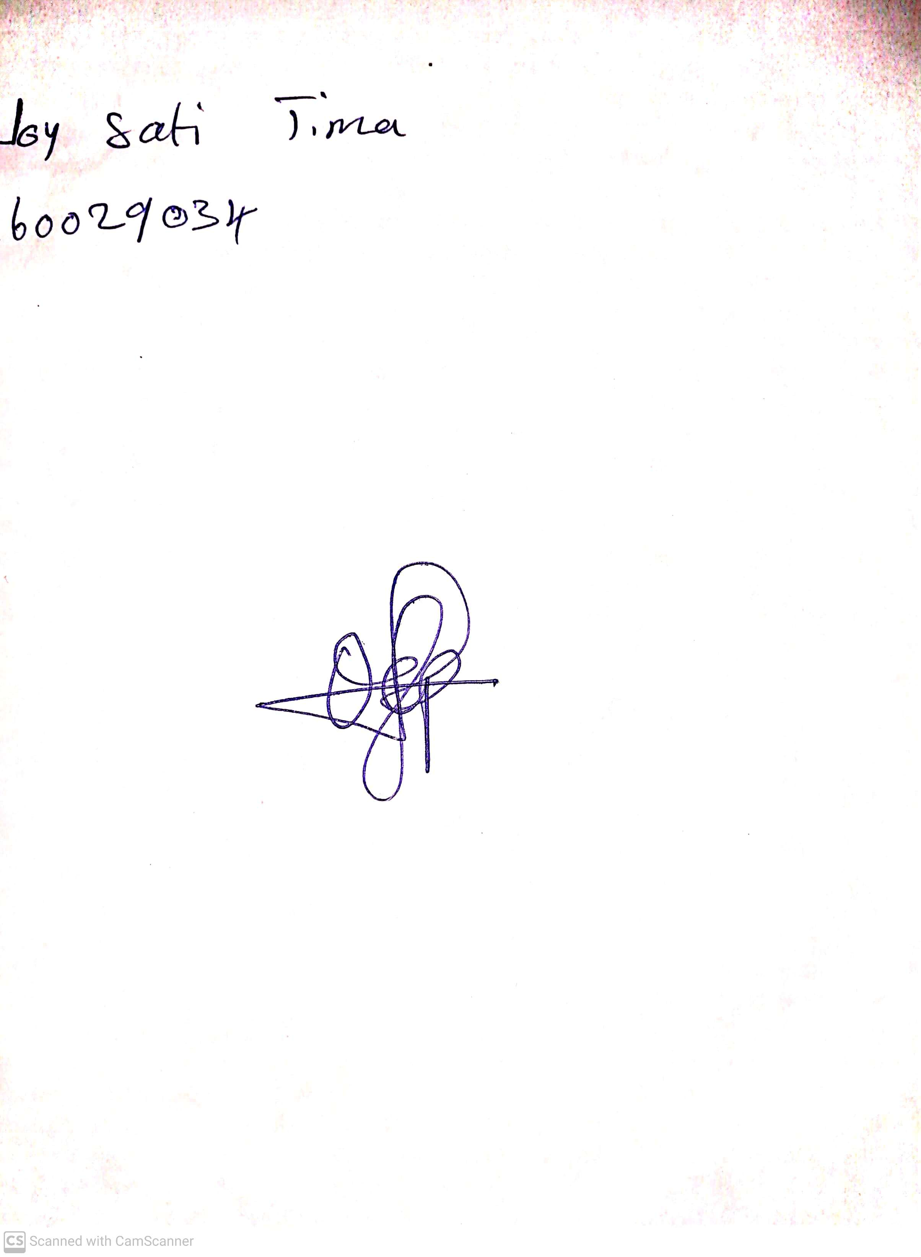

**17th May, 2024**

**Perpetual Ojoma Ocheja**

**Stream Head Nursery**