**EMERALD ROYAL INTERNATIONAL SCHOOL MPAPE, ABUJA.**

**LESSON PLAN AND NOTE FOR WEEK 7 ENDING 07/06/2024**

**TERM: 3rd**

**WEEK: 7th**

**DATE: 03/06/2024**

**CLASS: Nursery 2**

**SUBJECT: Social norms**

**TOPIC: Living with people with HIV/ AIDS.**

**SUB—TOPIC: Meaning of HIV/AIDS.**

**PERIOD: 2nd period after long break**

**TIME: 11:20—12: 00pm**

**DURATION: 40 minutes**

**NUMBER IN CLASS: 13**

**AVERAGE AGE: 5 years**

**SEX: Mixed**

**LEARNING OBJECTIVES: By the end of the lesson, the Pupils should be able to:**

**1. Explain the meaning of HIV**

**2. Define AIDS.**

**3. State the ways HIV/AIDS can be contacted.**

**RATIONALE: For pupils to know the meaning of HIV/AIDS virus**

**PREVIOUS KNOWLEDGE: Pupils have learnt about orphaned and vulnerable children.**

**INSTRUCTIONAL MATERIALS: Razor blade, needle and syringes.**

**REFERENCE MATERIALS: Stage 3 Social habit for nursery classes.**

**LESSON DEVELOPMENT**

|  |  |  |  |
| --- | --- | --- | --- |
| **Steps** | **Teacher's activities** | **Pupils' activities** | **Learning point** |
| **Introduction** | **Teacher reviews the previous lesson.** | **Pupils pay attention to the teacher.** | **To prepare pupils minds for the lesson ahead.** |
| **Presentation step 1** | **Teacher explains the meaning of HIV to pupils and then asks them to repeat after her.** | **Pupils pay attention to the teacher and repeat after her.** | **For proper understanding.** |
| **Step 2** | **Teacher defines the word AIDS to pupils and also asks them to repeat after her.** | **Pupils listen to the teacher and repeat after her.** | **For better understanding.** |
| **Step 3** | **Teacher States the various ways in which one can contact HIV/AIDS to pupils and also asks them to repeat after her.** | **Pupils listen attentively to the teacher and also repeat after her.** | **To enhance Pupils listening and speaking ability.** |
| **Board summary** | **Teacher summarizes the lesson by writing the whole note of lesson on the board for pupils to copy into their books. That is;**  **LIVING WITH PEOPLE WITH HIV AIDS.**  **Meaning of HIV**  **HIV means( human immune deficiency virus) is a virus that attacks the body's immune system. If HIV is not treated, it can lead to AIDS (acquired immunodeficiency syndrome).**  **There is currently no effective cure. Once people get HIV they have it for life.**  **AIDS is the late stage of HIV infection that occurs when the body's immune system is badly damaged because of the virus.**  **Ways it can be contacted**  **1. Sharing needles**  **2. Sharing syringes**  **3. Sharing razor blade**  **4. Through blood transfusion.**  **5. Through breast milk etc.** | **Pupils copy the note into their books.** | **For onward study.** |
| **Evaluation** | **Teacher evaluates the lesson by asking pupils the following questions:**  **1. What is the full meaning of HIV?**  **2. If HIV is not treated, it can lead to ____**  **3. What is the full meaning of AIDS?**  **4. Mention the ways by which HIV/ AIDS can contacted.** | **Pupils answer the questions asked by the teacher.** | **To assess pupils level of understanding.** |
| **Conclusion** | **Teacher concludes the lesson by marking pupils books.** | **Pupils submit their books for marking..** | **For endorsement.** |
| **Assignment** | **Answer the following question:**  **Mention ten (10) ways of preventing HIV/ AIDS.** | **Pupils do their assignment at home.** | **To encourage learning at home.** |

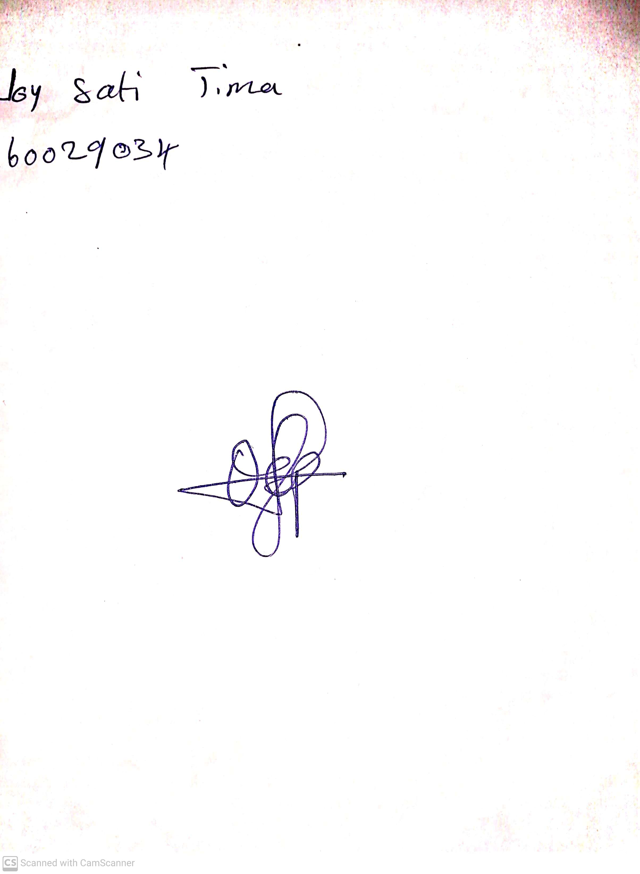

**31st May, 2024**

**Perpetual Ojoma Ocheja**

**Stream Head Nursery**