**EMERALD ROYAL INTERNATIONAL SCHOOL MPAPE, ABUJA.**

**LESSON PLAN AND NOTE FOR WEEK 1 ENDING 26/04/2024**

**TERM: 3rd**

**WEEK: 1**

**DATE: 22/04/2024**

**CLASS: Nursery 2**

**SUBJECT: Social norms**

**TOPIC: Revision of 2nd term work ( my country 1)**

**SUB—TOPIC: Recitation of National Anthem and National pledge.**

**PERIOD: 2nd period after long break**

**TIME: 11:20—12: 00pm**

**DURATION: 40 minutes**

**NUMBER IN CLASS: 13**

**AVERAGE AGE: 5 years**

**SEX: Mixed**

**LEARNING OBJECTIVES: By the end of the lesson, the Pupils should be able to:**

**1. Sing National Anthem**

**2. Recite National pledge**

**RATIONALE: For Pupils to be able to recite National Anthem and pledge.**

**PREVIOUS KNOWLEDGE: Pupils have learnt States and Capitals in previous lesson.**

**INSTRUCTIONAL MATERIALS: Map of Nigeria.**

**REFERENCE MATERIALS: Emerald Royal International school Calendar 1st edition 2020**

**Almanac.**

**LESSON DEVELOPMENT**

|  |  |  |  |
| --- | --- | --- | --- |
| **Steps** | **Teacher's activities** | **Pupils' activities** | **Learning point** |
| **Introduction** | **Teacher introduces the lesson by asking pupils to recite the 36 States and Capitals in Nigeria.** | **Pupils recites the 36 States and capitals in Nigeria.** | **To prepare pupils minds for the lesson proper.** |
| **Presentation step 1** | **Teacher sings the National Anthem and asks pupils to repeat after her.** | **Pupils sing the National Anthem after the teacher.** | **For proper understanding.** |
| **Step 2** | **Teacher recites the National pledge and also asks pupils to repeat after her.** | **Pupils pay attention to the teacher and repeat the National pledge after her.** | **For better understanding.** |
| **Board summary** | **Teacher writes the whole note of lesson on the board for pupils to copy. That is;**  **NATIONAL ANTHEM**  **Arise, O compatriots Niger's call obey**  **To serve our fatherland with love and strength and faith**  **The labour of our heroes past shall never be in vain**  **To serve with heart and might one nation bound in freedom, peace and unity.**  **NATIONAL PLEDGE**  **I pledge to Nigeria my country to be faithful, loyal and honest**  **To serve Nigeria with all my strength**  **To defend her unity, and uphold her honour and glory**  **So help me God.** | **Pupils copy the note into their exercise books.** | **For onward study.** |
| **Evaluation** | **Teacher evaluates the lesson by asking pupils to all stand and recite the National Anthem and National pledge.** | **Pupils all stand and recite the National Anthem and National pledge.** | **To assess Pupils level of understanding.** |
| **Conclusion** | **Teacher concludes the lesson by marking pupils books.** | **Pupils submit their books for marking.** | **To make corrections where necessary.** |
| **Assignment** | **Recite and write the school Anthem.** | **Pupils do their assignment at home.** | **To encourage learning at home.** |

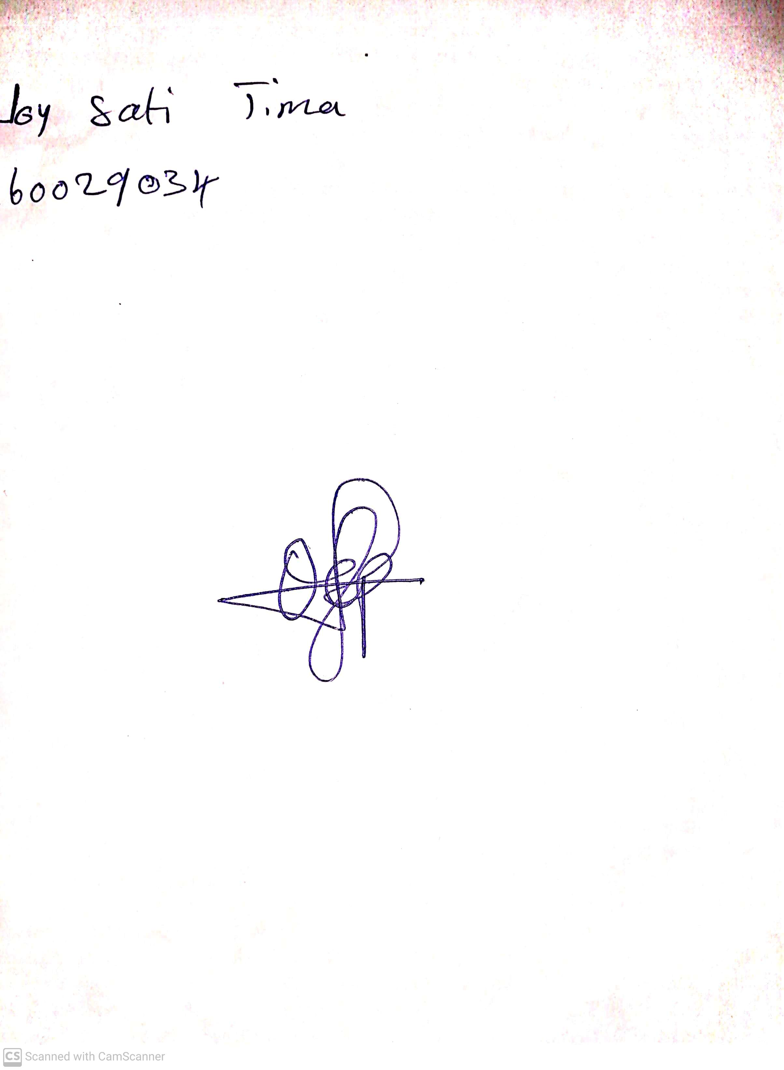

**19th April, 2024**

**Perpetual Ojoma Ocheja**

**Stream Head Nursery**