**LESSON PLAN AND NOTE 1 FOR WEEK 2 ENDING 22/09/2023**

**Term 1st  term**

**Week 2nd week**

**Date 18th September,2023**

**Class Nursery one**

**Subject Letter work**

**Topic Coping letter Aa - Bb.**

**Sub-topic Trace letter Aa.**

**Period 2nd period**

**Time 8:50 am**

**Duration 35 minutes**

**No in class 15**

**Average Age 3 years**

**Sex Mixed**

**Specific Objectives: By the end of the lesson the pupils should be able to;**

1. **Trace letter Aa.**
2. **Identify letter Aa.**

**Rationale: To make sure the pupils trace and identify letter Aa.**

**Previous knowledge: The pupils can write letters Ss - Zz.**

**Instructional Resources: Chart, board, marker, exercise books, pencils.**

**Reference Materials: Online Research,chart,board.**

**LESSON PRESENTATION**

|  |  |  |  |
| --- | --- | --- | --- |
| **Steps** | **Teacher’s Activities** | **Pupils’ Activities** | **Learning points** |
| **Introduction** | **The teacher introduces the topic (Coping letters Aa - Bb) to the pupils.** | **The pupils listen attentively to the teacher.** | **To arouse the interest of the pupils.** |
| **Step 1** | **The teacher guides the pupils to trace letter Aa using their notebooks.**  **dotted letter Aa** | **The pupils trace letter Aa inside their notebook.** | **For proper understanding.** |
| **Step 2** | **The teacher leads the pupils to identify letter Aa**  **Aa Aa**  **Aa Aa** | **The pupils identify the letter Aa after the teacher.** | **For better understanding.** |
| **Summary** | **The teacher summarizes the lesson by writing capital and small letter Aa.** | **The pupils can identify capital and small letter Aa.** | **For onward study.** |
| **Evaluation** | 1. **What letter is this Aa?** 2. **Trace the letter below?**     **dotted letter Aa** | **The pupils answer the question correctly.** | **To ascertain the pupils’ understanding.** |
| **Conclusion** | **The teacher summarizes, reacts & corrects the pupils.** | **The pupils answer to the teacher’s questions.** | **To consolidate the lesson.** |
| **Assignment** | 1. **What letter is this Aa?** 2. **Trace capital and small letter Aa?**   **dotted letter Aa** | **The pupils copy and do their homework at home.** | **To encourage learning while at home.** |

**LESSON PLAN AND NOTE 2 FOR WEEK 2 ENDING 22/09/2023**

**Term 1st  term**

**Week 2nd week**

**Date 19th September,2023**

**Class Nursery one**

**Subject Letter work**

**Topic Coping letter Aa - Bb.**

**Sub-topic Trace letter Bb.**

**Period 2nd period**

**Time 8:50 am**

**Duration 35 minutes**

**No in class 15**

**Average Age 3 years**

**Sex Mixed**

**Specific Objectives: By the end of the lesson the pupils should be able to;**

1. **Trace letter Bb.**
2. **Identify letter Bb.**

**Rationale: To make sure the pupils trace and identify letter Bb.**

**Previous knowledge: The pupils can trace and identify letter Aa.**

**Instructional Resources: Chart, board, marker, exercise books, pencils.**

**Reference Materials: Online Research,chart,board.**

**LESSON PRESENTATION**

|  |  |  |  |
| --- | --- | --- | --- |
| **Steps** | **Teacher’s Activities** | **Pupils’ Activities** | **Learning points** |
| **Introduction** | **The teacher introduces the topic (Coping letters Aa - Bb) to the pupils.** | **The pupils listen attentively to the teacher.** | **To arouse the interest of the pupils.** |
| **Step 1** | **The teacher guides the pupils to trace letter Bb using their notebooks.**  **dotted letter Bb** | **The pupils trace letter Bb inside their notebook.** | **For proper understanding.** |
| **Step 2** | **The teacher leads the pupils to identify letter Bb**  **Bb Bb**  **Bb Bb** | **The pupils identify the letter Bb after the teacher.** | **For better understanding.** |
| **Summary** | **The teacher summarizes the lesson by writing capital and small letter Bb.** | **The pupils can identify capital and small letter Bb.** | **For onward study.** |
| **Evaluation** | 1. **What letter is this Bb?** 2. **Trace the letter below?**   **dotted letter Bb** | **The pupils answer the question correctly.** | **To ascertain the pupils’ understanding.** |
| **Conclusion** | **The teacher summarizes, reacts & corrects the pupils.** | **The pupils answer to the teacher’s questions.** | **To consolidate the lesson.** |
| **Assignment** | 1. **Identify the letter below?**   **Bb**   1. **Trace capital and small letter Bb?**   **dotted letter Bb** | **The pupils copy and do their homework at home.** | **To encourage learning while at home.** |

**LESSON PLAN AND NOTE 3 FOR WEEK 2 ENDING 22/09/2023**

**Term 1st  term**

**Week 2nd week**

**Date 21st September,2023**

**Class Nursery one**

**Subject Letter work**

**Topic Coping letter Aa - Bb.**

**Sub-topic Write letter Aa - Bb.**

**Period 2nd period**

**Time 8:50 am**

**Duration 35 minutes**

**No in class 15**

**Average Age 3 years**

**Sex Mixed**

**Specific Objectives: By the end of the lesson the pupils should be able to;**

1. **Underline only letter Aa.**
2. **Underline only letter Bb.**
3. **Write letter Aa and Bb.**

**Rationale: To make sure the pupils write letter Aa and Bb.**

**Previous knowledge: The pupils can trace letter Bb.**

**Instructional Resources: Chart, board, marker, exercise books, pencils.**

**Reference Materials: Online Research,chart,board.**

**LESSON PRESENTATION**

|  |  |  |  |
| --- | --- | --- | --- |
| **Steps** | **Teacher’s Activities** | **Pupils’ Activities** | **Learning points** |
| **Introduction** | **The teacher introduces the topic (Coping letters Aa - Bb) to the pupils.** | **The pupils listen attentively to the teacher.** | **To arouse the interest of the pupils.** |
| **Step 1** | **The teacher guides the pupils to underline only letter Aa using their notebooks.**  **Dd Ee Gg**  **Aa Ff Hh Aa**  **Ii Pp Aa Bb Nn Aa Mm Ll** | **The pupils underline only letter Aa inside their notebook.**  **Dd Ee Gg**  **Aa Ff Hh Aa**  **Ii Pp Aa Bb Nn Aa Mm Ll** | **For proper understanding.** |
| **Step 2** | **The teacher guides the pupils to underline only letter Bb using their notebooks**  **Bb Ee Bb**  **Aa Bb Hh Aa**  **Bb Pp Aa Bb Nn Bb Mm Bb** | **The pupils underline only letter Bb inside their notebook**  **Bb Ee Bb**  **Aa Bb Hh Aa**  **Bb Pp Aa Bb Nn Bb Mm Bb** | **For better understanding.** |
| **Step 3** | **The teacher guides the pupils to write letter Aa - Bb inside their notebook**   |  |  | | --- | --- | | **Aa** | **Aa** | |  |  | | **Bb** | **Bb** | |  |  | | **The pupils write the capital and small letter Aa - Bb inside their notebook with the help of their teachers.** | **For further understanding.** |
| **Summary** | **The teacher summarizes the lesson by writing capital and small letter Aa and Bb on the board.** | **The pupils can identify capital and small letter Aa and Bb.** | **For onward study.** |
| **Evaluation** | 1. **Underline only capital and small letter Bb?**   **Bb Ee Bb**  **Aa Bb Hh Aa**  **Bb Pp Aa Bb Nn Bb Mm Bb**   1. **Underline only capital and small letter Aa**   **Dd Ee Gg**  **Aa Ff Hh Aa**  **Ii Pp Aa Bb Nn**  **Aa Mm Ll**  **Write letter Aa - Bb below?**   |  |  | | --- | --- | | **Aa** | **Aa** | |  |  | | **Bb** | **Bb** | |  |  | | **The pupils answer the question correctly.** | **To ascertain the pupils’ understanding.** |
| **Conclusion** | **The teacher summarizes, reacts & corrects the pupils.** | **The pupils answer to the teacher’s questions.** | **To consolidate the lesson.** |
| **Assignment** | 1. **Underline only capital and small letter Bb?**   **Bb Ee Bb**  **Aa Bb Hh Aa**  **Bb Pp Aa Bb Nn Bb Mm Bb**   1. **Underline only capital and small letter Aa**   **Dd Ee Gg**  **Aa Ff Hh Aa**  **Ii Pp Aa Bb Nn**  **Aa Mm Ll**   1. **Write the capital and small letters below?**  |  |  | | --- | --- | | **Aa** | **Aa** | |  |  | | **Bb** | **Bb** | |  |  | | **The pupils copy and do their homework at home.** | **To encourage learning while at home.** |

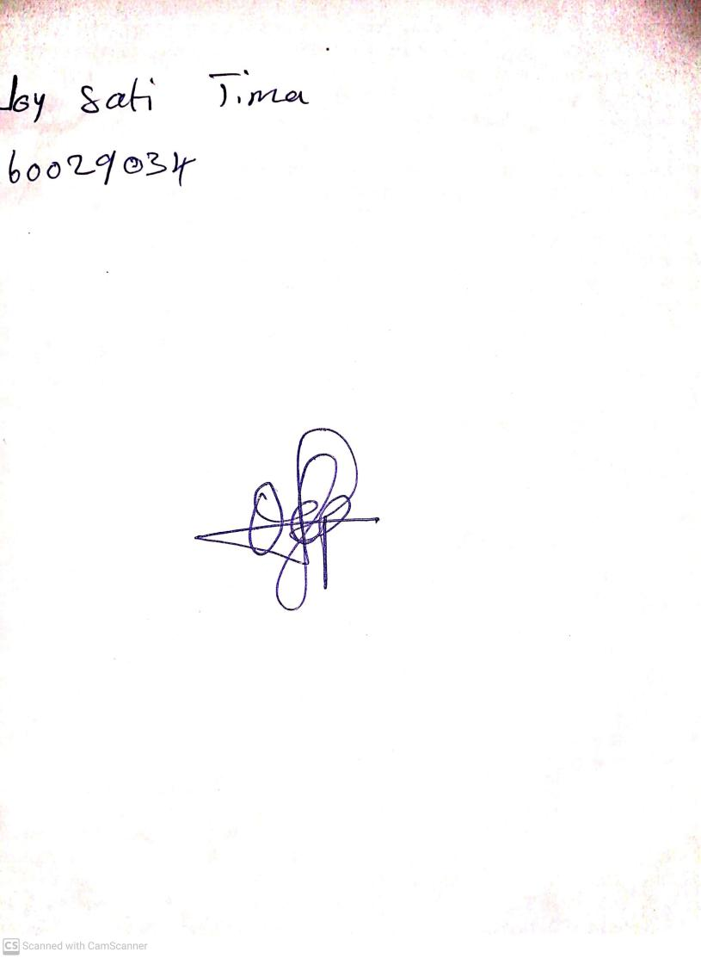

15th August, 2023

Perpetual Ojoma Ocheja

Stream Head Nursery