EMERALD ROYAL INTERNATIONAL SCHOOL

MPAPE, ABUJA.

LESSON NOTE/PLAN 1 FOR WEEK 3 ENDING 26th JANUARY,2024.

SUBJECT: Letter work

TOPIC: Identification of letter g and it's sound.

SUB-TOPIC: Identifying and circling letter g.

DATE: 23/01/2024

DURATION: 40 minutes

TIME: 11:20-12:00

PERIOD: 5th

CLASS: Pre-nursery

NUMBER OF PUPILS: 17.

AVERAGE AGE: 2 years

SEX: Mixed

SPECIFIC OBJECTIVES:By the end of the lesson , the pupils should be able to:-

1. Say the sound for letter"g'.

2. Identify the letter that makes the sound /g/.

RATIONALE: For pupils to know the sounds of the alphabet.

PREVIOUS KNOWLEDGE: Pupils have practised to say the sound for letter g in their previous lesson.

INSTRUCTIONAL MATERIALS: Flash cards and picture book.

REFERENCE: Mastering English for nursery Schools book 1 by J.M.Omogbai.

LESSON DEVELOPMENT

|  |  |  |  |
| --- | --- | --- | --- |
| Stages/steps | Teacher's activities | Pupils' activities | Learning points |
| Introduction | Teacher introduces the lesson by singing the alphabetic song for letter “g” for the pupils. | Pupils repeat the sound for letter g after the teacher. | To arouse the interest of the pupils. |
| Presentation  Step 1 | Teacher sings a Phonics song for letter g for the pupils. | Pupils repeat phonics song after the teacher ie  The water gurgles down the drain, the water gurgles down the drain ,the water gurgles down the drain with the /g / /g / / g/ /g / /g/ | To make Pupils familiar with the sound for letter "g". |
| Step 2 | Teacher prepares the pupils books and guides them to identify letter “g” amongst other letters and circles them. | Pupils identify and circle letter “g” in their exercise books. | To give pupils better knowledge of the letter that sounds /g/. |
| Summary | Teacher summarizes the lesson by telling the pupils the sound for letter g. | Pupils say the sound for letter g after the teacher. | To ensure proper understanding of the lesson. |
| Evaluation | Teacher calls out the pupils one after another to-:   1. say the sound for letter g. 2. Identify the letter that makes the sound /g/. | Pupils answer the teacher’s questions. | To ascertain the pupils level of pupils understanding of the lesson . |
| Conclusion | Teacher concludes the lesson by singing the Phonics song for letter g again for the pupils. | Pupils sing the song for letter g after the teacher. | To consolidate the lesson. |
| Assignment | Identify and circle the letter that makes the /g/ sound. | Pupils identify and circle the letter that makes the /g/ sound.  e f ( g)  f (g) e. | To encourage learning at home. |

LESSON NOTE/PLAN 2 FOR WEEK 3 ENDING 26th JANUARY,2024.

SUBJECT: Letter work

TOPIC: Identification of letter g and it's sound.

SUB-TOPIC: Things that begins with letter "g".

DATE: 24/01/2024

DURATION: 40 minutes

TIME: 11:20-12:00

PERIOD: 5th

CLASS: Pre-nursery

NUMBER OF PUPILS: 17.

AVERAGE AGE: 2 years

SEX: Mixed

SPECIFIC OBJECTIVES:By the end of the lesson , the pupils should be able to:-

1. Say the sound for letter"g'.

2. Mention the things that begins with letter "g " sound.

RATIONALE: For pupils to know the sounds of the alphabet.

PREVIOUS KNOWLEDGE: Pupils have practised to say the sound for letter g in their previous lesson.

INSTRUCTIONAL MATERIALS: Flash cards and picture book.

REFERENCE: Mastering English for nursery Schools book 1 by J.M.Omogbai.

LESSON DEVELOPMENT

|  |  |  |  |
| --- | --- | --- | --- |
| Stages/steps | Teacher's activities | Pupils' activities | Learning points |
| Introduction | Teacher introduces the lesson by reminding the pupils the sound for letter "g". | Pupils repeat the sound for letter g after the teacher. | To arouse the interest of the pupils. |
| Presentation  Step 1 | Teacher sings a Phonics song for letter g for the pupils. | Pupils repeat phonics song after the teacher ie  The g sounds /g/  The g sounds /g/  Every letter makes a sound the g says /g/. | To make Pupils familiar with the sound for letter "g". |
| Step 2 | Teacher relates the sound for letter g to objects for pupils and asks the pupils to repeat after the teacher. | Pupils repeat after the teacher to say things that begins with letter g. Examples  /g/ /g/ as in goat.  /g//g/ as in gun. | To ensure the pupils are able to relate letter sounds with the objects. |
| Summary | Teacher summarizes the lesson by telling the pupils the sound for letter g. | Pupils say the sound for letter g after the teacher. | To ensure proper understanding of the lesson. |
| Evaluation | Teacher calls out the pupils one after another to -:   1. say the sound for letter g. 2. Mention the things that begins with letter “g”. | Pupils answer the teacher's questions. | To ascertain the pupils level of pupils understanding of the lesson . |
| Conclusion | Teacher concludes the lesson by singing the Phonics song for letter g again for the pupils. | Pupils sing the song for letter g after the teacher. | To consolidate the lesson. |
| Assignment | Identify and circle the letter that makes the /g/ sound. | Pupils identify and circle the letter that makes the /g/ sound.  e f ( g)  f (g) e. | To encourage learning at home. |

LESSON NOTE/PLAN 3 FOR WEEK 3 ENDING 26th JANUARY,2024.

SUBJECT: Letter work

TOPIC: Identification of letter g and it's sound.

SUB-TOPIC: Tracing letter g

DATE: 26/1/2024

DURATION: 40 minutes

TIME: 08:50 -09:30

PERIOD: 2nd

CLASS: Pre-nursery

NUMBER OF PUPILS: 17

AVERAGE AGE: 2 years

SEX: Mixed

SPECIFIC OBJECTIVES: By the end of the lesson, the pupils should be able to:-

1. Identify letter "g" and associate it's sound in names of words or objects.

2. Trace letter " g".

RATIONALE: For pupils to know letters and their sound also for them to recognize the sounds in names, words and objects.

PREVIOUS KNOWLEDGE: Pupils have been practising the sounds for letter a,b,c,d,e,f and g in previous lesson.

LEARNING MATERIALS: Flash cards and Pupils books.

REFERENCE: Mastering English for nursery Schools book 1 by J.M.Omogbai.

LESSON DEVELOPMENT

|  |  |  |  |
| --- | --- | --- | --- |
| Stages/steps | Teacher's activities | Pupils' activities | Learning points |
| Introduction | Teacher introduces the lesson by going over the sounds for letter a,b,c,d,e,f and g for the pupils to remember. | Pupils repeat after the teacher to say the sounds for letter a, b, c, d, e, f and g. | To remind Pupils of the letter sounds learnt in previous lesson. |
| Presentation  Step 1 | Teacher shows the pupils letter "g" on a flash cards and asks them to point at it and say it's sound repeatedly. Also relates the sound for letter "g" to the beginning sounds of words or objects using a picture book. | Pupils point at letter "g" on the flash cards and say it's sound after the teacher. Pupils also repeat after him/her to say the following repeatedly.  /g//g/ as in gum  /g//g/ as in go  /g//g/ as in goat | To ensure Pupils can say the sound for letter g |
| Step 2 | Teacher prepares the pupils books for them to identify and trace letter g. | Pupils identify and trace letter g | For better understanding. |
| Summary | Teacher summarizes the lesson by singing phonics song on letter g for the pupils. | Pupils sing phonics song along with the teacher. | To enhance Pupils understanding of the lesson. |
| Evaluation | Teacher's evaluates the lesson by asking the pupils to point at letter g on the chart. | Pupils answer the teacher's question by touching the letter g on the chart. | To ascertain the level of pupils understanding of the lesson. |
| Conclusion | Teacher ends the lesson by playing a video clips of the alphabets. | Pupils sit down on the mat and watch the video and recite the letters along side with the television. | To improve Pupils knowledge of the alphabet and enhance their attention span. |
| Assignment | Practice the sound of these letters and match them correctly  d f  e g  f e  g d | Pupils practice and match the letters . | To ensure learning takes place at home. |

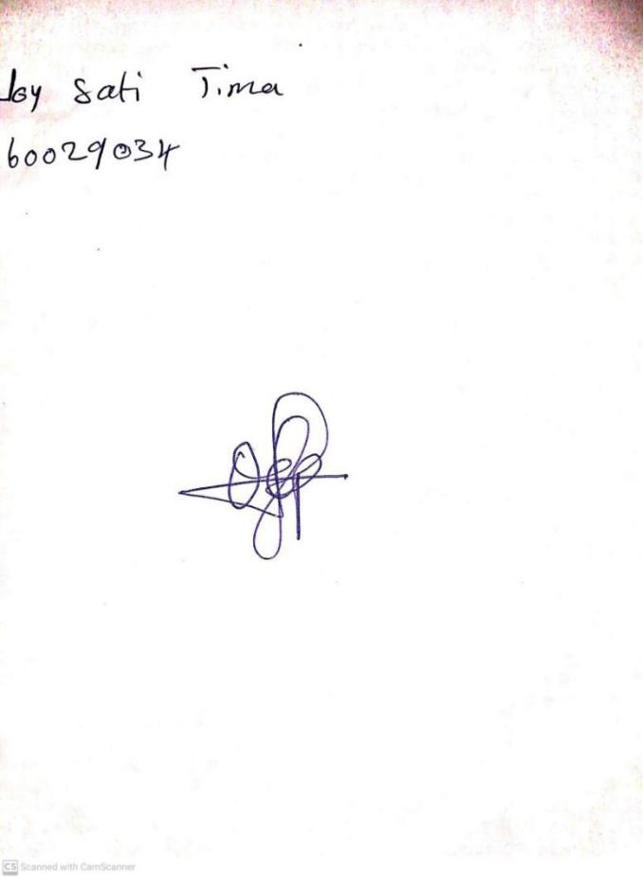

**19TH JANUARY, 2024**

**Perpetual Ojoma Ocheja**

**Stream Head Nursery**