EMERALD ROYAL INTERNATIONAL SCHOOL

MPAPE, ABUJA.

LESSON NOTE 1 FOR WEEK 8 ENDING 1ST MARCH, 2024.

SUBJECT: Letter work

TOPIC: Identification of letter k and it’s sound.

SUB-TOPIC: Recognition and colouring of letter k.

DATE: 27/2/2024 .

DURATION: 40 minutes.

TIME: 0850-- 09:30

PERIOD: 2nd

CLASS: Pre-nursery

NUMBER OF PUPILS: 17

AVERAGE AGE: 2 YEARS

SEX: Mixed.

SPECIFIC OBJECTIVES: By the end of the lesson, the pupils should be able to:-

1. Point at letter k amongst other letter.

2 colour and identify letter k.

INSTRUCTIONAL MATERIALS: Flash cards board and pupils books.

RATIONALE: For pupils to know letters and their sounds.

PREVIOUS KNOWLEDGE: Pupils have been reciting letters a-z through rhyme .

REFERENCE:Mastering English for nursery schools book 1 by J.M.Omogbai.

LESSON DEVELOPMENT

|  |  |  |  |
| --- | --- | --- | --- |
| STAGES/STEPS | TEACHER’S ACTIVITIES | PUPILS’ ACTIVITIES | LEARNING POINTS |
| INTRODUCTION | Teacher introduces the lesson by going over the previous lesson. | Pupils pay attention and participate in the lesson . | To get the pupils attention for the main lesson. |
| PRESENTATION  STEP 1 | Teacher write letters randomly on the board and asks the pupils to circle and identify letter k. | Pupils pay attention to the teacher. Pupils also identify and circle letter k    a (k) b u  d g (k) (k) | For better understanding of the lesson . |
| STEP2 | Teacher prepares the pupils books for them to colour letter k”. | Pupils colour and identify letter k  k | To improve pupils eye-hand coordination. |
| SUMMARY | Teacher summarizes the lesson by showing the pupils letter k on the flash card and asks them to repeat after her. | Pupils point at letter k on the flash card and repeat after the teacher. | For more understanding of the lesson. |
| EVALUATION | Teacher asks the pupils to:-  --- Identify letter k randomly on the board.  --- sound letter k. | Pupils answer the teacher’s questions. | To ascertain the level of pupils understanding of the lesson. |
| CONCLUSION | Teacher marks the pupils books and make corrections where necessary. | Pupils submit their books for marking and corrections . | For onwards study. |
| ASSIGNMENT | Teacher asks the pupils to colour letter k in their textbooks letter k. | Pupils do their Home work at home. | To ensure learning takes place at home. |

LESSON NOTE 2 FOR WEEK 8 ENDING 1ST MARCH, 2024.

SUBJECT: Letter work

TOPIC: Reviewing letter k and it’s sound.

SUB-TOPIC: Recognition and tracing of letter k.

DATE: 28/2/2024 .

DURATION: 40 minutes.

TIME: 11:20--12:00.

PERIOD: 6th

CLASS: Pre-nursery

NUMBER OF PUPILS: 17

AVERAGE AGE: 2 YEARS

SEX: Mixed.

SPECIFIC OBJECTIVES: By the end of the lesson, the pupils should be able to:-

1. Identify letter k and it’s sound.

2 Tracing letter k

INSTRUCTIONAL MATERIALS: Flash cards board and pupils books.

RATIONALE: For pupils to know letters and their sounds.

PREVIOUS KNOWLEDGE: Pupils have been reciting letters a-z through rhyme .

REFERENCE:Mastering English for nursery schools book 1 by J.M.Omogbai.

LESSON DEVELOPMENT

|  |  |  |  |
| --- | --- | --- | --- |
| STAGES/STEPS | TEACHER’S ACTIVITIES | PUPILS’ ACTIVITIES | LEARNING POINTS |
| INTRODUCTION | Teacher introduces the lesson by singing the jolly phonics song for letter k | Pupils sing song along with the teacher . | To get the pupils attention for the main lesson. |
| PRESENTATION  STEP 1 | Teacher write letter k boldly on the board and asks the pupils to point at it and say “letter k repeatedly “. | Pupils point at letter k on the board and say letter k repeatedly. | For better understanding of the lesson . |
| STEP2 | Teacher prepares the pupils books for them to trace letter k”. | Pupils trace letter k | To improve pupils eye-hand coordination. |
| SUMMARY | Teacher summarizes the lesson by showing the pupils letter k on the flash card and also sing the phonics song for the letter.. | Pupils point at letter k on the flash card and practice it sound through the phonics song . | For more understanding of the lesson. |
| EVALUATION | Teacher asks the pupils to:-  --- Identify letter k on the board.  --- sound letter k. | Pupils answer the teacher’s questions. | To ascertain the level of pupils understanding of the lesson. |
| CONCLUSION | Teacher marks the pupils books and make corrections where necessary. | Pupils submit their books for marking and corrections . | For onwards study. |
| ASSIGNMENT | Teacher asks the pupils to trace letter k in their textbooks letter k. page 35 | Pupils do their Home work at home. | To ensure learning takes place at home. |

LESSON NOTE 3 FOR WEEK 8 ENDING 1ST MARCH, 2024.

SUBJECT: Letter work

TOPIC: Reviewing letter k and it’s sound.

SUB-TOPIC: Recognition and sounding of letter k.

DATE: 1/3/2024 .

DURATION: 40 minutes.

TIME: 08:50--09:30.

PERIOD: 2nd

CLASS: Pre-nursery

NUMBER OF PUPILS: 17

AVERAGE AGE: 2 YEARS

SEX: Mixed.

SPECIFIC OBJECTIVES: By the end of the lesson, the pupils should be able to:-

1. Sing the jolly phonics song for letter k.
2. Identify letter k on a flash card.

RATIONALE: For pupils to know letters and their sounds.

PREVIOUS KNOWLEDGE: Pupils have been practicing sounds of the alphabets.

REFERENCE:Mastering English for nursery schools book 1 by J.M.Omogbai.

LESSON DEVELOPMENT

|  |  |  |  |
| --- | --- | --- | --- |
| STAGES/STEPS | TEACHER’S ACTIVITIES | PUPILS’ ACTIVITIES | LEARNING POINTS |
| INTRODUCTION | Teacher introduces the lesson by singing the A,B,C,D’S song for the pupils. | sing song along with the teacher . | To get the pupils attention for the main lesson. |
| PRESENTATION  STEP 1 | Teacher sing the jolly phonics song for letter k and does action for the pupils . | Pupils sing along with the teacher. That is  The k says /k/  The k says /k/  Every letter makes a sound the k says /k/. | For better understanding of the lesson . |
| STEP2 | Teacher shows the pupils letter k on a flash card and asks them to say “letter k”. | Pupils point at letter k and say the sound for letter k. | For better under standing of the letter that sounds /k/. |
| SUMMARY | Teacher calls out the pupils to point at letter k on a flash card and makes it’s sound. | Pupils point at letter k and make it sound. | For more understanding of the lesson. |
|  |  |  |  |
| CONCLUSION | Teacher marks the pupils books and make corrections where necessary. | Pupils submit their books for marking and corrections . | For onwards study. |
| ASSIGNMENT | Colour letter k and practice it’s sound  k | Pupils do their Home work at home. | To ensure learning takes place at home. |

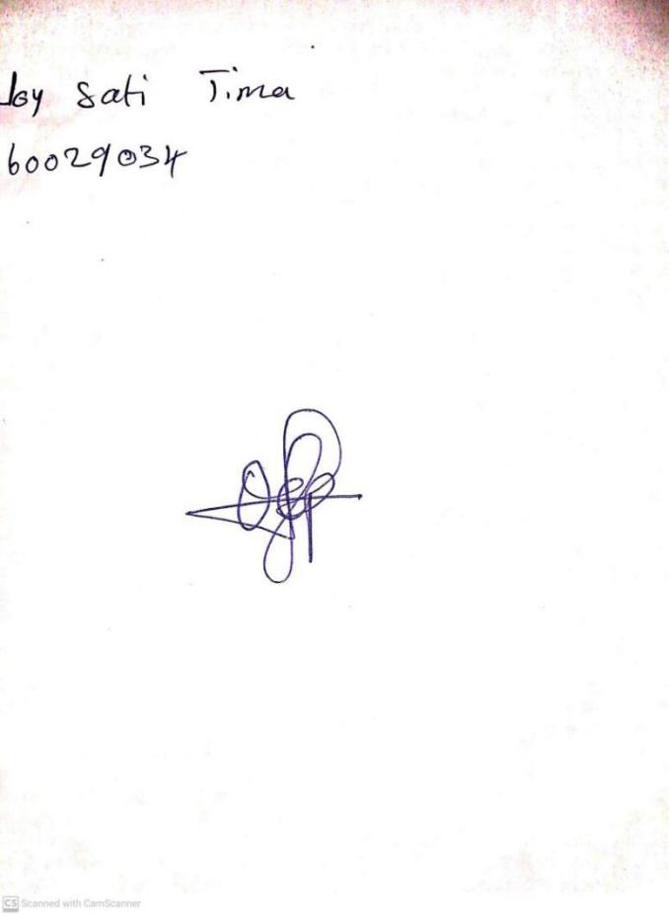

**23RD FEBRUARY, 2024**

**Perpetual Ojoma Ocheja**

**Stream Head Nursery**