**EMERALD ROYAL INTERNATIONAL SCHOOL**

**MPAPE, ABUJA.**

**LESSON PLAN AND NOTE FOR WEEK 6 ENDING 18/10/2024**

**TERM: 1st**

**WEEK: 6th**

**DATE: 14/10/2024**

**CLASS: Nursery 2**

**SUBJECT: Nature studies**

**TOPIC: Living things**

**SUB—TOPIC: Meaning, examples and characteristics of living things.**

**PERIOD: 4th**

**TIME: 10:40—11:20am**

**DURATION: 40 minutes**

**NUMBER IN CLASS: 14**

**AVERAGE AGE: 5 years**

**SEX: Mixed**

**LEARNING OBJECTIVES: By the end of the lesson, the pupils should be able to:**

**1. Define living things.**

**2. Mention the examples of living things**

**3. State the characteristics of living things.**

**RATIONALE: For pupils to know what living things means.**

**PREVIOUS KNOWLEDGE: Pupils have been seeing plants, animals and human beings without knowing there are living things.**

**INSTRUCTIONAL MATERIALS: A plant, pictures f animals, trees and humans in pupils text books.**

**REFERENCE MATERIALS: Basic science and technology for Nursery schools book 3 by OPEMIPO DADA.**

**LESSON DEVELOPMENT**

|  |  |  |  |
| --- | --- | --- | --- |
| **Steps** | **Teacher's activities** | **Pupils' activities** | **Learning point** |
| **Introduction** | **Teacher introduces the lesson by reviewing the previous lesson.** | **Pupils pay attention to the teacher.** | **To prepare pupils minds for the lesson ahead.** |
| **Presentation step 1** | **Teacher defines living things to pupils and then asks them to repeat after her.** | **Pupils listen to the teacher and repeat after her.** | **To improve pupils listening and speaking ability.** |
| **Step 2** | **Teacher mentions the examples of living things to pupils and also asks them to repeat after her.** | **Pupils pay attention to the teacher and repeat her.** | **To enhance pupils participation in the class.** |
| **Step 3** | **Teacher states the characteristics of living things to pupils and also asks pupils to repeat after her.** | **Pupils listen attentively to the teacher and repeat after her.** | **To improve pupils speaking ability.** |
| **Board summary** | **Teacher writes the whole note of lesson on the board for pupils to copy into their books. That is;**  **Living things:**  **Living things are those things that have life in them.**  **Examples of living things:**   1. **Human beings** 2. **Animals** 3. **Plants** 4. **Insects**   **Characteristics of living things:**  **Characteristics of living things are MR NIGER D which means;**  **M — Movement**  **R — Reproduction**  **N — Nutrition**  **I — Irritability**  **G — Growth**  **E — Excretion**  **R — Respiration**  **D — Death** | **Pupils copy the note into their exercise books.** | **For onward study.** |
| **Evaluation** | **Teacher evaluates the lesson by asking pupils the following questions;**   1. **Define living things.** 2. **Mention the examples of living things.** 3. **States the characteristics of living things.** | **Pupils answer the questions asked by the teacher.** | **To assess pupils level of understanding.** |
| **Conclusion** | **Teacher concludes the lesson by marking pupils books.** | **Pupils submit their books for marking.** | **For endorsement.** |
| **Assignment** | 1. **What are non living things?** 2. **Mention 5 examples of non living things in the classroom.** 3. **State 5 examples of non living things at home.** | **Pupils do their assignment at home.** | **To encourage learning at home.** |

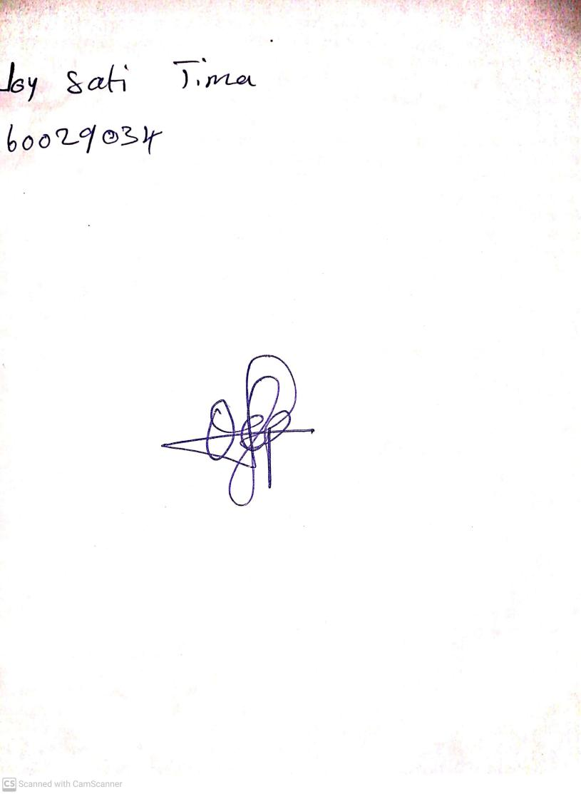

**11th October, 2024**

**Perpetual Ojoma Ocheja**

**Stream Head Nursery**