**LESSON PLAN AND NOTE 1 FOR WEEK 1 ENDING 13/09/2024**

**Term 1st term**

**Week 1st week**

**Date 10th September,2024**

**Class Nursery One**

**Subject Number Work**

**Topic Counting numbers 1-20.**

**Sub-topic Count numbers 1-10**

**Period 2nd period**

**Time 8:50 am**

**Duration 35 minutes**

**No in class 15**

**Average Age 3 years**

**Sex Mixed**

**Specific Objectives: By the end of the lesson ,the pupils should be able to:**

1. **Count numbers 1-10.**
2. **Identify numbers 1-10.**
3. **Write numbers 1-10.**

**Rationale: To make sure the pupils count numbers 1-20.**

**Previous Knowledge: The pupils knows addition/subtraction of numbers.**

**Instructional Resources: Chart, board, marker, etc.**

**Reference Material: The new mastering mathematics.**

**LESSON PRESENTATION**

|  |  |  |  |
| --- | --- | --- | --- |
| **Steps** | **Teacher’s Activities** | **Pupils’ Activities** | **Learning Points** |
| **Introduction** | **The teacher introduces the topic (counting numbers 1-20) to the pupils by rhyming it.** | **The pupils with the teacher rhyme the numbers 1-20.** | **To arouse the pupils’ interest.** |
| **Step 1** | **The teacher assists the pupils to count numbers 1-10**  **1 2 3 4 5**  **6 7 8 9 10** | **The pupils counts numbers 1-10 with their teacher.** | **For proper understanding.** |
| **Step 2** | **The teacher leads the pupils to identify numbers 1-10**  **1 5 7 8**  **2 4 6 9** | **The pupils participate with the teacher in identifying numbers 1-10.**  **1 5 7 8**  **2 4 6 9** | **For better understanding.** |
| **Step 3** | **The teacher guides the pupils to write numbers 1-10 inside their notebooks.** | **The pupils write numbers 1-10 as the teacher guides them.** | **For further understanding** |
| **Summary** | **The teacher summarizes the lesson by counting numbers 1-10** | **The pupils have master and count numbers 1-10.** | **For onward study.** |
| **Evaluation** | 1. **Identify numbers 1-10.** 2. **Count numbers 1 - 10.** 3. **Write numbers 1-10 below?** | **The pupils answers the question correctly.** | **To ascertain the pupils’ understanding.** |
| **Conclusion** | **The teacher summarizes, reacts and corrects the lesson.** | **The pupils answers to the teacher’s questions** | **To consolidate the lesson** |
| **Assignment** | 1. **Count numbers 1-10** 2. **Identify numbers 1-10** 3. **Copy and write the following numbers below**  |  |  | | --- | --- | | **1** | **2** | |  |  | | **3** | **4** | |  |  | | **5** | **6** | |  |  | | **7** | **8** | |  |  | | **9** | **10** | |  |  | | **The pupils copy and do their homework at home.** | **To encourage learning while at home.** |

**LESSON PLAN AND NOTE 2 FOR WEEK 1 ENDING 13/09/2024**

**Term 1st term**

**Week 1st week**

**Date 11th September,2024**

**Class Nursery One**

**Subject Number Work**

**Topic Counting numbers 1-20..**

**Sub-topic Count numbers 11-20**

**Period 2nd period**

**Time 8:50 am**

**Duration 35 minutes**

**No in class 15**

**Average Age 3 years**

**Sex Mixed**

**Specific Objectives: By the end of the lesson ,the pupils should be able to:**

1. **Count numbers 11-20.**
2. **Identify numbers 11-20.**
3. **Write numbers 11-20.**

**Rationale: To make sure the pupils count numbers 1-20.**

**Previous Knowledge: The pupils knows how to count numbers 1-10.**

**Instructional Resources: Chart, board, marker, etc.**

**Reference Material: The new mastering mathematics.**

**LESSON PRESENTATION**

|  |  |  |  |
| --- | --- | --- | --- |
| **Steps** | **Teacher’s Activities** | **Pupils’ Activities** | **Learning Points** |
| **Introduction** | **The teacher introduces the topic (counting numbers 1-20) to the pupils by rhyming it.** | **The pupils with the teacher rhyme the numbers 1-20.** | **To arouse the pupils’ interest.** |
| **Step 1** | **The teacher assists the pupils to count numbers 11-20**  **11 12 13 14 15**  **16 17 18 19 20** | **The pupils counts numbers 11-20 with their teacher.** | **For proper understanding.** |
| **Step 2** | **The teacher leads the pupils to identify numbers 11-20**  **11 15 17 18**  **12 14 16 19**  **13** | **The pupils participate with the teacher in identifying numbers 11-20.**  **11 15 17 18**  **12 14 16 19**  **13** | **For better understanding.** |
| **Step 3** | **The teacher guides the pupils to write numbers 11-20 inside their notebooks.** | **The pupils write numbers 11-20 as the teacher guides them.** | **For further understanding** |
| **Summary** | **The teacher summarizes the lesson by counting numbers 11-20** | **The pupils have master and count numbers 11-20.** | **For onward study.** |
| **Evaluation** | 1. **Identify numbers 11-20.**      1. **Count numbers 11-20**   **11 12 13 14 15**  **16 17 18 19 20**   1. **Write the following numbers below**  |  |  | | --- | --- | | **11** | **12** | |  |  | | **13** | **14** | |  |  | | **15** | **16** | |  |  | | **17** | **18** | |  |  | | **19** | **20** | |  |  | | **The pupils answers the question correctly.** | **To ascertain the pupils’ understanding.** |
| **Conclusion** | **The teacher summarizes, reacts and corrects the lesson.** | **The pupils answers to the teacher’s questions** | **To consolidate the lesson** |
| **Assignment** | 1. **Identify numbers 11-20**   **11 15 17 18**  **12 14 16 19**  **13**   1. **Count numbers 11-20**   **11 12 13 14 15**  **16 17 18 19 20**   1. **Write the following numbers below**  |  |  | | --- | --- | | **11** | **12** | |  |  | | **13** | **14** | |  |  | | **15** | **16** | |  |  | | **17** | **18** | |  |  | | **19** | **20** | |  |  | | **The pupils copy and do their homework at home.** | **To encourage learning while at home.** |

**LESSON PLAN AND NOTE 3 FOR WEEK 1 ENDING 13/09/2024**

**Term 1st term**

**Week 1st week**

**Date 12th September,2024**

**Class Nursery One**

**Subject Number Work**

**Topic Counting numbers 1-20..**

**Sub-topic Matching numbers 1-10**

**Period 4th period**

**Time 10:40 am**

**Duration 35 minutes**

**No in class 15**

**Average Age 3 years**

**Sex Mixed**

**Specific Objectives: By the end of the lesson ,the pupils should be able to:**

1. **Match numbers 1-10.**
2. **Fill in the numbers 11-20.**

**Rationale: To make sure the pupils match numbers 1-20.**

**Previous Knowledge: The pupils knows numbers 11-20.**

**Instructional Resources: Chart, board, marker, etc.**

**Reference Material: The new mastering mathematics.**

**LESSON PRESENTATION**

|  |  |  |  |
| --- | --- | --- | --- |
| **Steps** | **Teacher’s Activities** | **Pupils’ Activities** | **Learning Points** |
| **Introduction** | **The teacher introduces the topic (counting numbers 1-20) to the pupils by rhyming it.** | **The pupils with the teacher rhyme the numbers 1-20.** | **To arouse the pupils’ interest.** |
| **Step 1** | **The teacher assists the pupils to match numbers 1-10**  **1 10**  **2 9**  **3 8**  **4 7**  **5 6**  **6 5**  **7 4**  **8 3**  **9 2**  **10 1** | **The pupils match numbers 1-10 with their teacher.**  **1 10**  **2 9**  **3 8**  **4 7**  **5 6**  **6 5**  **7 4**  **8 3**  **9 2**  **10 1** | **For proper understanding.** |
| **Step 2** | **The teacher leads the pupils to fill in the missing numbers 11-20**  **11 ____ 13 ______ 15**  **____ 17 ____ 19 ____** | **The pupils participate with the teacher in filling in the missing numbers 11-20.**  **11 12 13 14 15**  **16 17 18 19 20** | **For better understanding.** |
| **Summary** | **The teacher summarizes the lesson by counting numbers 11-20.** | **The pupils have master and count numbers 11-20.** | **For onward study.** |
| **Evaluation** | 1. **Count numbers 1-20.** 2. **Match the following numbers below**   **1 10**  **2 9**  **3 8**  **4 7**  **5 6**  **6 5**  **7 4**  **8 3**  **9 2**  **10 1**   1. **Fill in the missing numbers below**   **1 ____ 3 ______ 5**  **____ 7 ____ 9 ____** | **The pupils answers the question correctly.** | **To ascertain the pupils’ understanding.** |
| **Conclusion** | **The teacher summarizes, reacts and corrects the lesson.** | **The pupils answers to the teacher’s questions** | **To consolidate the lesson** |
| **Assignment** | 1. **Fill in the missing numbers below**   **1 ____ 3 ____ 5 ____**  **7 ____ 8 ____ 10**   1. **Count numbers 1-20.** 2. **Match the following numbers below**   **1 10**  **2 9**  **3 8**  **4 7**  **5 6**  **6 5**  **7 4**  **8 3**  **9 2**  **10 1** | **The pupils copy and do their homework at home.** | **To encourage learning while at home.** |

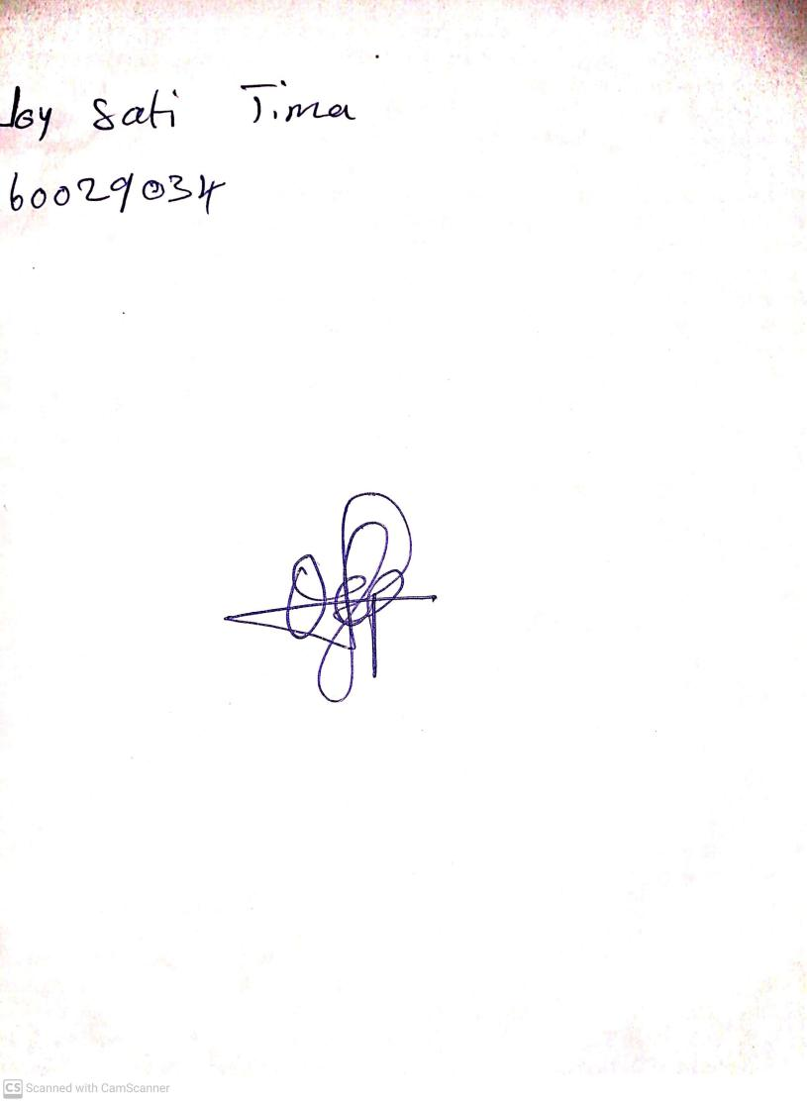

13th September, 2024

Perpetual Ojoma Ocheja

Stream Head Nursery