EMERALD ROYAL INTERNATIONAL SCHOOL MPAPE, ABUJA

LESSON PLAN AND NOTE FOR WEEK 11 PERIOD 1 ENDING 24/11/2023

TERM: FIRST

WEEK: 11TH

DATE: 2O/11/2023

CLASS: NURSERY 2

SUBJECT: LETTER WORK

TOPIC: FOUR LETTER WORDS.

SUB-TOPIC: MEANING AND EXAMPLES OF FOUR LETTER WORDS.

PERIOD: 3RD

TIME: 09: 30-10: 10 am

DURATION: 40 MINUTES

NUMBER IN CLASS: 16

AVERAGE AGE: 4

SEX: MIXED

SPECIFIC OBJECTIVES: BY THE END OF THE LESSON, THE PUPILS SHOULD BE ABLE

TO:

1. EXPLAIN THE MEANING OF FOUR LETTER WORDS.
2. MENTION SOME EXAMPLES OF FOUR LETTER WORDS.

RATIONALE: FOR PUPILS TO BE ABLE TO KNOW THE MEANING AND EXAMPLES OF FOUR LETTER WORDS.

PREVIOUS KNOWLEDGE: PUPILS HAVE LEARNT THREE LETTERS RHYMING WORDS IN PREVIOUS LESSON.

INSTRUCTIONAL MATERIALS: A CHART OF FOUR LETTEER WORDS.

REFERENCE MATERIALS: THE NEW MASTERING ENGLISH FOR NURSERY SCHOOLS BOOK 2 BY J.M OMOGBAI

TOP STAR MY CHOICE OF ENGLISH LANGUAGE STAGE 3 BY

J.F OMOTAYO.

LESSON DEVELOPMENT

|  |  |  |  |
| --- | --- | --- | --- |
| STAGES/STEPS | TEACHER’S ACTIVITIES | PUPILS’ ACTIVITIES | LEARNING POINT |
| INTODUCTION | Teacher introduces the lesson by reviewing the previous lesson. | Pupils listen attentively to the teacher. | To arouse pupils interest for the lesson ahead. |
| PRESENTATION  STEP 1 | Teacher explains the meaning of four letter words to pupils and then asks them to repeat after her. | Pupils pay attention to the teacher and repeat after her. | For proper understanding. |
| STEP 2 | Teacher mention the examples of four letter words to pupils and also asks them to repeat after her. | Pupils listen very attentively to the teacher and repeat after her. | For better understanding of the lesson. |
| BOARD SUMMARY | Teacher summarizes the lesson by writing the whole note of lesson on the board for pupils to copy into their books. That is;  Four letter words  Four letter words are meaningful words that has only four letters of the alphabets.  Examples of four letters words are;   1. Book 2. Food 3. Wool 4. Wood 5. Leaf 6. Crab 7. Look 8. Comb 9. Desk 10. Moon etc. | Pupils copy the note on the board into their exercise books. | For onward study. |
| EVALUATION | Teacher evaluates the lesson by asking the following questions:   1. Explain the meaning of four letter words. 2. Mention the examples of four letter words. | Pupils answer the questions asked by the teacher. | To asses pupils level of understanding of the lesson. |
| CONCLUSION | Teacher concludes the lesson by marking pupils books. | Pupils submit their books for marking. | For endorsement. |
| ASSIGNMENT | Answer the following questions;   1. What are four letter words? 2. Mention 10 examples of four letter words. | Pupils do their assignment at home. | To encourage learning at home.s |

LESSON PLAN AND NOTE FOR WEEK 11 PERIOD 2 ENDING 24/11/2023

TERM: FIRST

WEEK: 11TH

DATE: 23/11/2023

CLASS: NURSERY 2

SUBJECT: LETTER WORK

TOPIC: FOUR LETTER WORDS

SUB-TOPIC: FOUR PHONICS LETTER SOUNDS

PERIOD: 2ND

TIME: 08: 50-09: 30 am

DURATION: 40 MINUTES

NUMBER IN CLASS: 16

AVERAGE AGE: 4

SEX: MIXED

SPECIFIC OBJECTIVES: BY THE END OF THE LESSON, THE PUPILS SHOULD BE ABLE

TO:

1. IDENTIFY THE FIVE VOWEL LETTERS AMONGST OTHERS.
2. SOUND AND PRONOUNCE THE FOUR PHONICS LETTER

SOUNDS ON “a”, “e” ,AND “I”.

RATIONALE: FOR PUPILS TO KNOW HOW TO SOUND AND PRONOUNCE FOUR PHONICS LETTER SOUNDS .

PREVIOUS KNOWLEDGE: PUPILS HAVE LEARNT THE MEANING AND EXAMPLES OF FOUR LETTER WORDS IN PREVIOUS LESSON.

INSTRUCTIONAL MATERIALS: A CHART OF FOUR PHONICS LETTER WORDS.

REFERENCE MATERIALS: THE NEW MASTERING ENGLISH FOR NURSERY SCHOOLS BOOK 2 BY J. M OMOGBAI

TOP STAR MY CHOICE OF ENGLISH LANGUAGE STAGE 3 BY

1. F OMOTAYO.

LESSON DEVELOPMENT

|  |  |  |  |
| --- | --- | --- | --- |
| STAGES/STEPS | TEACHER’S ACTIVITIES | PUPILS’ ACTIVITIES | LEARNING POINT |
| INTODUCTION | Teacher introduces the lesson by reviewing the previous lesson. | Pupils listen attentively to the teacher. | To arouse pupils interest for the lesson ahead. |
| PRESENTATION  STEP 1 | Teacher writes the 26 letters of the alphabets on the board for pupils to identify the five vowel letters amongst others. That is;  a b c d e f g h i j k l m n o p q r s t u v w x y z. | Pupils pay attention to the teacher and identify the five vowel letters on the board. As;  a b c d e f g h i j k l m n o p q r s t u v w x y z. | For proper understanding. |
| STEP 2 | Teacher sounds and pronounce the four phonics letter sounds with “a”, “e”,and “I” on the board , and then asks pupils to repeat after her. | Pupils listen very attentively to the teacher and repeat after her. | For better understanding of the lesson. |
| BOARD SUMMARY | Teacher summarizes the lesson by writing the whole note of lesson on the board for pupils to copy into their books. That is:  Four letter words on “a”, “e”, and “I” are:   |  |  |  | | --- | --- | --- | | “a” as in | “e” as in | “i” as in | | hand | heip | milk | | sand | rent | sing | | bank | rest | ring | | band | next | pink | | crab | desk | swim | | clap | send | clip | | camp | sent | slip | | damp | went | grip | | fast | vest | king | | flag | pest | wing | | brag | best | gift | | gang | belt | trip | | bang | bend | list | | land | melt | limp | | lamb etc. | held etc. | mist etc. | | Pupils copy the note into their exercise books .. | For onward study. |
| EVALUATION | Teacher evaluates the lesson by asking the following questions one after the other;   1. Mention the five vowel letters. 2. Sound and pronounce four letter words with vowel “a”. 3. spell and pronounce four letter words with vowel “e”. 4. identify and pronounce four letter words with vowel “I”. | Pupils answer the questions asked by the teacher. | To asses pupils level of understanding of the lesson. |
| CONCLUSION | Teacher concludes the lesson by marking pupils books. | Pupils submit their books for marking. | For endorsement. |
| ASSIGNMENT | Fill in the missing vowel to complete the words   1. B--nk 2. C--mp 3. P--st 4. F--st 5. L--st 6. Cl--p 7. Cr--b 8. R--nt 9. G--ft 10. M--lk | Pupils do their assignment at home. | To encourage learning at home.s |

LESSON PLAN AND NOTE FOR WEEK 11 PERIOD 3 ENDING 24/11/2023

TERM: FIRST

WEEK: 11TH

DATE: 24/11/2023

CLASS: NURSERY 2

SUBJECT: LETTER WORK

TOPIC: FOUR LETTER WORDS .

SUB-TOPIC: FOUR LETTER WORDS WITH VOWEL “o” AND “u”.

PERIOD: 3RD

TIME: 09: 30-10: 10 am

DURATION: 40 MINUTES

NUMBER IN CLASS: 16

AVERAGE AGE: 4

SEX: MIXED

SPECIFIC OBJECTIVES: BY THE END OF THE LESSON, THE PUPILS SHOULD BE ABLE

TO:

1. IDENTIFY FOUR LETTER WORDS WITH VOWEL “o” AND “u”
2. SPELL AND PRONOUNCE FOUR LETTER WORDS WITH

VOWEL “o” AND “u”.

RATIONALE: FOR PUPILS TO BE ABLE TO SPELL AND PRONOUNCE FOUR LETTER WORDS WITH VOWEL “o” AND “ u”.

PREVIOUS KNOWLEDGE: PUPILS HAVE LEARNT FOUR LETTER WORDS WITH VOWEL “a”, “e”, AND “I” IN PREVIOUS LESSON.

INSTRUCTIONAL MATERIALS: A CHART OF FOUR LETTER WORDS WITH VOWEL “0” AND “u” .

REFERENCE MATERIALS: THE NEW MASTERING ENGLISH FOR NURSERY SCHOOLS BOOK 2 BY J.M OMOGBAI.

TOP STAR MY CHOICE OF ENGLISH LANGUAGE STAGE 3 BY J.M OMOTAYO.

LESSON DEVELOPMENT

|  |  |  |  |
| --- | --- | --- | --- |
| STAGES/STEPS | TEACHER’S ACTIVITIES | PUPILS’ ACTIVITIES | LEARNING POINT |
| INTODUCTION | Teacher introduces the lesson by reviewing the previous lesson. | Pupils listen attentively to the teacher. | To arouse pupils interest for the lesson ahead. |
| PRESENTATION  STEP 1 | Teacher writes four letter words with vowel “o” and “u” on the board, identify and then asks pupils to repeat after her. | Pupils pay attention to the teacher and repeat after her. | For proper understanding. |
| STEP 2 | Teacher spells and pronounce four letter words with vowel “o” and “u” to pupils and also asks them to repeat after her. | Pupils listen very attentively to the teacher and repeat after her. | For better understanding of the lesson. |
| BOARD SUMMARY | Teacher summarizes the lesson by writing the whole note of lesson on the board for pupils to copy into their books. That is;  Four letter words with vowel “o” and “u” are:   |  |  | | --- | --- | | “o” as in | “u” as in | | cost | drug | | crop | drum | | drop | dump | | frog | bump | | song | jump | | long | pump | | pond | dust | | soft | rust | | from | bust | | stop | plug | | spot | hunt | | gong | hung | | golf | lung | | fond | just | | lost | sulk | | piot | must | | blot | plum | | flop | lump | | trot | hump | | Romp etc. | Snub etc. | | Pupils copy the note on the board into their exercise books. | For onward study. |
| EVALUATION | Teacher evaluates the lesson by asking the following questions:   1. Identify four letter words with vowel “o” and “u”. 2. Spell and pronounce four letter words with vowel “o” and “u”. | Pupils answer the questions asked by the teacher. | To asses pupils level of understanding of the lesson. |
| CONCLUSION | Teacher concludes the lesson by marking pupils books. | Pupils submit their books for marking. | For endorsement. |
| ASSIGNMENT | Spell and pronounce the following four (4) letter words:   1. Tank 2. Lamp 3. List 4. Stop 5. Ring 6. From 7. Frog 8. Flag 9. Bank 10. Food | Pupils do their assignment at home. | To encourage learning at home.s |

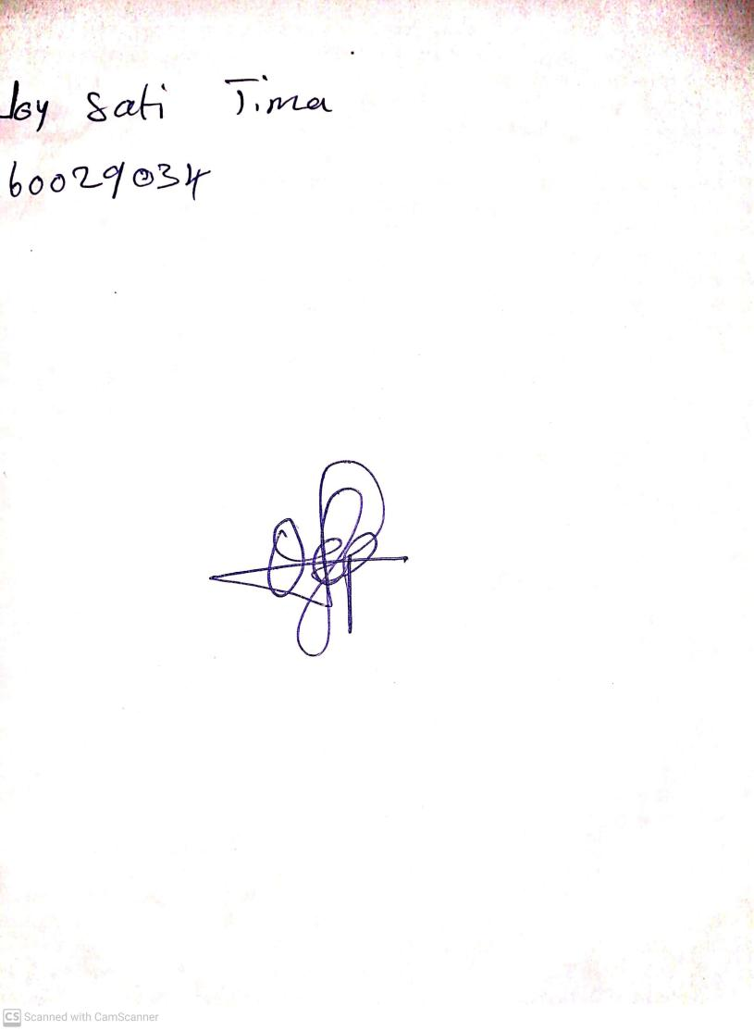

9TH November, 2023

Perpetual Ojoma Ocheja

Stream Head Nursery