**EMERALD ROYAL INTERNATIONAL SCHOOL**

**MPAPE, ABUJA.**

**LESSON PLAN AND NOTE FOR WEEK 10 ENDING 17TH NOVEMBER,2023**

TERM : First term.

WEEK : 10

SUBJECT: Social Norms

TOPIC: It is not good to fight.

SUB-TOPIC: Reasons for not fighting.

DATE: 15/9/2023

DURATION: 40 minutes

TIME: 10:40-11:20

PERIOD: 5th

CLASS: pre-nursery

NUMBER OF PUPILS: 10

AVERAGE AGE: 2

SEX: Mixed

SPECIFIC OBJECTIVES: By the end of the lesson, the pupils should be able to:-

1. Mention the reasons why it is not good to fight.

2. Say how they feel when they fight.

RATIONALE: For pupils to have value for human Life.

PREVIOUS KNOWLEDGE: Pupils have seen where people are fighting.

INSTRUCTIONAL MATERIALS: picture book.

REFERENCE: Smart start Civic education for nursery Schools book 1 by T.Y. Alabi and A. M. Solu.

LESSON DEVELOPMENT

|  |  |  |  |
| --- | --- | --- | --- |
| Stages/steps | Teacher's activities | Pupils' activities | Learning points |
| Introduction | Teacher introduces the lesson by singing nursery rhymes for the pupils. | Pupils sing along the nursery rhymes with the teacher. | To arouse the interest of the pupils. |
| Presentation  Step 1 | Teacher shows the pupils the picture of people that are fighting and what happens to them during the fight. Teacher again asks the pupils base on what they have seen in the picture book the reasons why it is not good to fight. | Pupils watch the pictures of those that are fighting and what happens to them. Pupils answer the teacher the reasons why it is not good to fight are :-   1. You may injure someone. 2. The person may mistakenly hit his or her head on a stone. 3. It may lead to death. | To improve better understanding. |
| Step 2 | Teacher asks the pupils if they accidentally engage in a fight how do they feel. | Pupils answer the teacher's question as:-   1. Sad. 2. Very bad. 3. Very angry. | For better understanding of the lesson. |
| Summary | Teacher summarizes the lesson by going over the topic for more understanding. | Pupils pay attention to the teacher's explanation. | To ensure better understanding of the lesson. |
| Evaluation | Teacher asks the pupils these questions:-   1. Mention the reasons why it is not good to fight? 2. How do you feel when you fight? | Pupils respond to the teacher's question correctly. | To assess pupils level of understanding of the lesson. |
| Conclusion | Teacher ends the lesson by correcting the pupils who were not able to answer the questions. | Pupils take the corrections given to them by the teacher. | For onwards learning. |

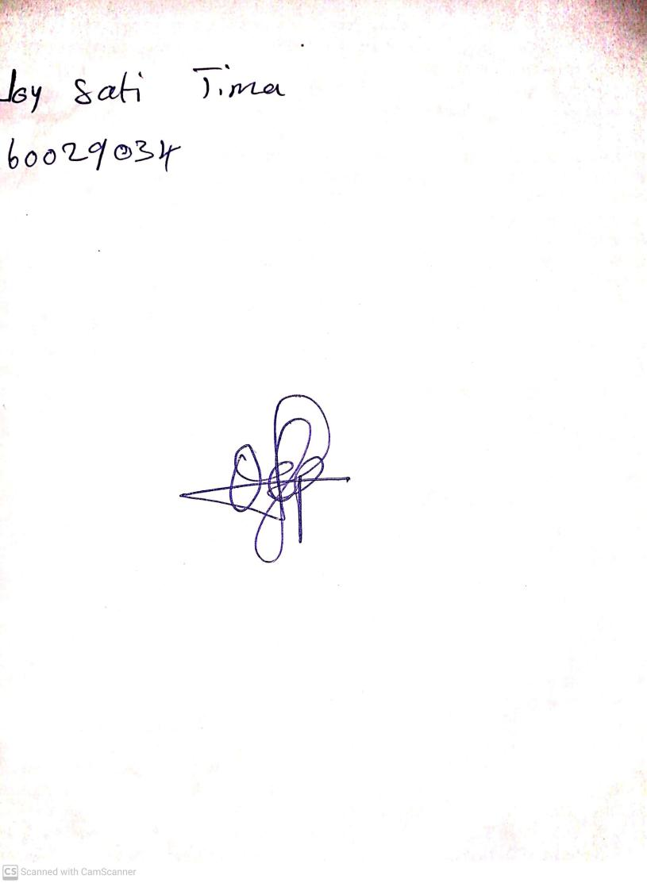

25th August, 2023

Perpetual Ojoma Ocheja

Stream Head Nursery