**LESSON PLAN AND NOTE 1 FOR WEEK 8 ENDING 01/3/2024**

**Term 2nd term**

**Week 8th week**

**Date 26th February,2024**

**Class Nursery One**

**Subject Number Work**

**Topic Counting numbers 1-110**

**Sub-topic Counting numbers 100-105**

**Period 2nd period**

**Time 9:05 am**

**Duration 35 minutes**

**No in class 15**

**Average Age 3 years**

**Sex Mixed**

**Specific Objectives: By the end of the lesson ,the pupils should be able to:**

1. **Count numbers 100-105**
2. **Identify numbers 100-105**
3. **Write numbers 100-105**

**Rationale:To ensure the pupils know how to Count, identify and write numbers 100-105**

**Previous Knowledge: The pupils have colour and match numbers 95-100**

**Instructional Resources: Chart, board, marker, etc.**

**Reference Materia The new mastering mathematics by Henry Z. Idogun.**

**LESSON PRESENTATION**

|  |  |  |  |
| --- | --- | --- | --- |
| **Steps** | **Teacher’s Activities** | **Pupils’ Activities** | **Learning Points** |
| **Introduction** | **The teacher introduces the topic (counting numbers 1-110) by rhyming.** | **The pupils together with the teacher rhyme the numbers 1-110.** | **To arouse the pupils’ interest.** |
| **Step 1** | **The teacher assists the pupils to count numbers 100-105.**  **100 101 102**  **103 104 105** | **The pupils count the numbers 100-105 with their teacher.** | **For proper understanding** |
| **Step 2** | **The teacher leads the pupils to identify numbers 100, 101, 102, 103, 104, 105.** | **The pupils identify numbers 100, 101, 102, 103, 104, 105.** | **For better understanding** |
| **Step 3** | **The teacher guides the pupils to write numbers 100-105 inside their notebooks.** | **The pupils write numbers 100-105 as the teacher guides them.** | **For further understanding** |
| **Summary** | **The teacher summarizes the lesson by counting numbers 100-105.** | **The pupils have master and count numbers 100-105.** | **For onward study.** |
| **Evaluation** | **Question:**  **Count numbers: 100-105 fluently.** | **The pupils answer the question correctly.** | **To ascertain the pupils’ understanding.** |
| **Conclusion** | **The teacher summarizes, reacts and corrects the pupils.** | **The pupils gives answers to the teacher's question.** | **To consolidate the lesson.** |
| **Assignment** | **Write the following numbers below**   |  |  | | --- | --- | | **100** | **101** | |  |  | | **102** | **103** | |  |  | | **104** | **105** | |  |  | | **The pupils copy and do their homework at home.** | **To encourage learning while at home.** |

**LESSON PLAN AND NOTE 2 FOR WEEK 8 ENDING 01/3/2024**

**Term 2nd term**

**Week 8th  week**

**Date 28th February,2024**

**Class Nursery One**

**Subject Number Work**

**Topic Counting numbers 1-110**

**Sub-topic Counting numbers 105-110.**

**Period 2nd period**

**Time 9:32 am**

**Duration 35 minutes**

**No in class 15**

**Average Age 3 years**

**Sex Mixed**

**Specific Objectives: By the end of the lesson ,the pupils should be able to:**

1. **Count numbers 105-110**
2. **Identify numbers 105-110**
3. **Write numbers 105-110**

**Rationale:To ensure the pupils know how to Count, identify and write numbers 105-110**

**Previous Knowledge: The pupils have count, identify & write numbers 105-110.**

**Instructional Resources: Chart, board, marker, etc.**

**Reference Material: The new mastering mathematics by Henry Z. Idogun**

**LESSON PRESENTATION**

|  |  |  |  |
| --- | --- | --- | --- |
| **Steps** | **Teacher’s Activities** | **Pupils’ Activities** | **Learning Points** |
| **Introduction** | **The teacher introduces the topic (counting numbers 1-110) by rhyming.** | **The pupils together with the teacher rhyme the numbers 1-110** | **To arouse the pupils’ interest.** |
| **Step 1** | **The teacher assists the pupils to count numbers 105-110.**  **105 106 107**  **108 109 110** | **The pupils count the numbers 105-110 with their teacher.** | **For proper understanding.** |
| **Step 2** | **The teacher leads the pupils to identify numbers 105, 106, 107, 108, 109, 110.** | **The pupils identify numbers 105, 106, 107 108, 109, 110.** | **For better understanding.** |
| **Step 3** | **The teacher guides the pupils to write numbers 105-110 inside their notebooks.** | **The pupils write numbers 105-110 as the teacher guides them** | **For further understanding.** |
| **Summary** | **The teacher summarizes the lesson by counting numbers 105-110.** | **The pupils have master and count numbers 105-110.** | **For onward study.** |
| **Evaluation** | **Question:**  **Count numbers: 105-110 fluently.** | **The pupils answer the question correctly** | **To ascertain the pupils’ understanding.** |
| **Conclusion** | **The teacher summarizes, reacts and corrects the pupil.** | **The pupils gives answers to the teacher's question.** | **To consolidate the lesson.** |
| **Assignment** | **Write the following numbers below**   |  |  | | --- | --- | | **105** | **106** | |  |  | | **107** | **108** | |  |  | | **109** | **110** | |  |  | | **The pupils copy and do their homework at home.** | **To encourage learning while at home.** |

**LESSON PLAN AND NOTE 3 FOR WEEK 8 ENDING 01/3/2024**

**Term 2nd term**

**Week 8th  week**

**Date 1st March,2024**

**Class Nursery One**

**Subject Number Work**

**Topic Counting numbers 1-110**

**Sub-topic Colouring and matching numbers 100-110**

**Period 2nd period**

**Time 9:50 am**

**Duration 35 minutes**

**No in class 15**

**Average Age 3 years**

**Sex Mixed**

**Specific Objectives: By the end of the lesson ,the pupils should be able to:**

1. **Colour numbers 100-105**
2. **Match numbers 105-110**

**Rationale: To make sure the pupils colour & match numbers 100-110**

**Previous Knowledge: The pupils have count, identify & write numbers 105-110**

**Instructional Resources: Crayons, exercise books, pencils.**

**Reference Material: Exercise books, the new mastering mathematics by Henry Z. Idogun**

**LESSON PRESENTATION**

|  |  |  |  |
| --- | --- | --- | --- |
| **Steps** | **Teacher’s Activities** | **Pupils’ Activities** | **Learning Points** |
| **Introduction** | **The teacher introduces the topic (counting numbers 1-110) by rhyming.** | **The pupils together with the teacher rhyme the numbers 1-110** | **To arouse the pupils’ interest.** |
| **Step 1** | **The teacher draws numbers 100-105 inside their notebooks for the pupils to identify and colour** | **The pupils participate to identify and colour numbers 100-105.** | **For proper understanding.** |
| **Step 2** | **The teacher write down numbers 105-110 for the pupils to match inside their notebooks.**  **105 109**  **106 110**  **107 108**  **108 105**  **109 106**  **110 107** | **The pupils match the numbers 105-110.**  **105 109**  **106 110**  **107 108**  **108 105**  **109 106**  **110 107** | **For better understanding.** |
| **Summary** | **The teacher summarizes the lesson by counting numbers 105-110.** | **The pupils have master and count numbers 105-110.** | **For onward study.** |
| **Evaluation** | **Question:**  **Count numbers: 100-110** | **The pupils answer the question correctly.** | **To ascertain the pupils’ understanding.** |
| **Conclusion** | **The teacher summarizes, reacts and corrects the pupils.** | **The pupils gives answers to the teacher's question** | **To consolidate the lesson.** |
| **Assignment** | **Match the following numbers**  **100 106**  **105 109**  **108 100**  **106 105**  **103 110**  **100 107**    **107 103** | **The pupils copy and do their homework at home.** | **To encourage learning while at home.** |

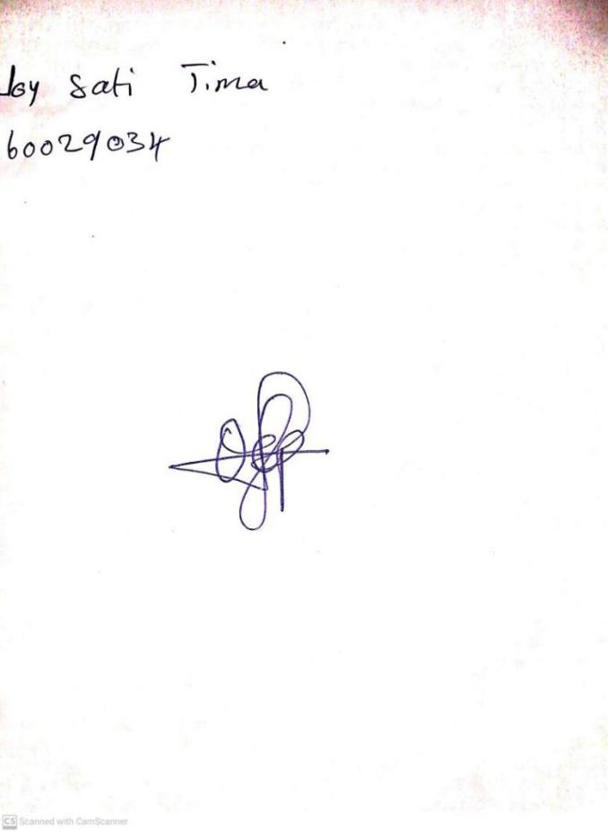

23RD February, 2024

Perpetual Ojoma Ocheja

Stream Head Nursery

**N.B THE EVALUATION SHOULD TALLY WITH THE LEARNING OBJECTIVES**

|  |  |
| --- | --- |
| **Evaluation** | **Question:**  **Count numbers: 105-110** |

**Specific Objectives: By the end of the lesson ,the pupils should be able to:**

1. **Count numbers 105-110**
2. **Identify numbers 105-110**
3. **Write numbers 105-110**

KINDLY DO SAME FOR THE OTHER NOTES