**EMERALD ROYAL INT’L SCHOOL**

**LESSON PLAN/NOTE FOR WEEK 2 ENDING: 27th JANUARY 2023**

|  |  |
| --- | --- |
| **Term** | 2nd |
| **Week** | 3 |
| **Class** | SS2 |
| **Date** | 25/01/2023 |
| **Subject** | Data Processing |
| **Topic** | Internet (Practical) |
| **Sub-Topic** | Copying from the internet |
| **Period** | 5th |
| **Time** | 11:10 – 11:50 |
| **Duration** | 40minutes |
| **Number in class** | 5 |
| **Average age** | 15years |
| **Sex** | Mixed |
| **Specific Objectives** | By the end of the lesson, students should be able to:   1. Copy from the internet 2. Explain why some documents cannot be copied from the internet |
| **Rationale** | To enable students understand the process of copying documents from a webpage. |
| **Previous knowledge** | Students have been taught internet in their previous lesson |
| **Instructional material** | Computer set, with internet facility |
| **Reference** | Data Processing for Senior Secondary Education (SS1 – 3) by Hiit Plc |

|  |  |  |  |
| --- | --- | --- | --- |
| **STEPS** | **TEACHER’S ACTIVITIES** | **STUDENTS ACTIVITIES** | **LEARNING POINTS** |
| Introduction | The teacher introduces the lesson by asking the students to state the shortcut for copy, cut and paste. | Students participate in the class discussion. | To arouse the students interest for the lesson. |
| Step I | The teacher sets up the computer system and demonstrates to the students how to copy from the internet.  {P R A C T I C A L S} | Students demonstrate on the computer system. | To create a platform for the slow learners. |
| Step II | *The teacher explains reasons why some documents cannot be copied.*  The following are the reasons why some documents cannot be copied from the internet.   1. It is encrypted 2. To avoid plagiarism 3. Some sites block text using JavaScript on their web properties.     {P R A C T I C A L S} | Students pay attention and demonstrate as the teacher does | To ensure proper understanding of the lesson |
| Summary | The teacher summarizes the lesson by highlighting the major points to note when copying from the internet | Students asks questions. | For clarification |
| Evaluation | The teacher asks the students this question.   1. Explain why some documents cannot be copied from a webpage | Students answer the question orally | To ascertain the students level of understanding of the lesson |
| Conclusion | The teacher corrects the students via demonstration on the computer set | Students take note of the correction(s) made. | For proper understanding of the lesson |
| Assignment | Give other reasons why some text are not allowed to be copied from the internet | Students copy the assignment in their exercise books | To encourage studying at a home. |

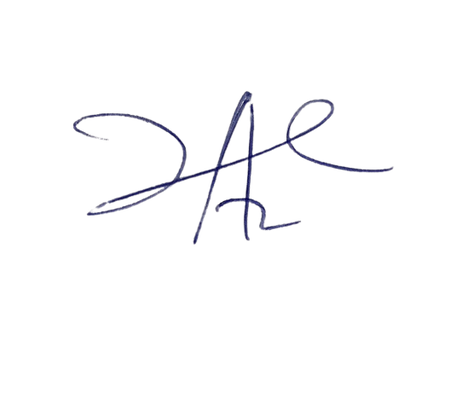

**22/2/2023**

**Head Instructor**