**EMERALD ROYAL INTERNATIONAL SCHOOL**

**MPAPE, ABUJA.**

**LESSON PLAN AND NOTE FOR WEEK 1 ENDING 12/01/2024**

**Term: 2nd**

**Week: 1**

**Date: 08/01/2024**

**Class: Nursery 2**

**Subject: Nature studies**

**Topic: Food**

**Sub–topic: Table manners**

**Period: 4th**

**Time: 10:40–11:20 am**

**Duration: 40 minutes**

**Number in class: 13**

**Average age: 5 years**

**Sex: Mixed**

**Specific objectives: By the end of the lesson, the pupils should be able to:**

1. **State the meaning of table manners**
2. **Mention the examples of table manners**

**Rationale: For pupils to know how to maintain good table manners in school and at home**

**Previous knowledge:pupils have been guided on how to maintain good table manners in school.**

**Instructional materials: spoon,knife and food.**

**Reference materials: pre–vocational studies for primary schools Home economics 1 by Olabisi Are etal**

**Lesson Development**

|  |  |  |  |
| --- | --- | --- | --- |
| **Steps** | **Teacher’s activities** | **Pupils activities** | **Learning point** |
| **Introduction** | **Teacher introduces the lesson by singing rhymes** | **Pupils sing the rhymes along with the teacher** | **To prepare pupils minds for the lesson ahead** |
| **Step 1** | **Teacher presents the lesson by explaining the meaning of table manners to pupils and then ask them to repeat after her.** | **Pupils listen to the teacher and repeat after her.** | **For proper understanding.** |
| **Step 2** | **Teacher mention the examples of table manners to pupils and also ask them to repeat after her.** | **Pupils pay attention to the teacher and repeat after her.** | **For better understanding.** |
| **Board summary** | **Teacher summarizes the lesson by writing the whole note of lesson on the board for pupils to copy into their books.Is:**  **Table manners : are the things we should do while eating. Examples :**  **1.wash your hands with soap and clean water before and after eating.**  **2. Take only small quantity of your food into tour mouth at a time.**  **3.Chew the food in your mouth properly before swallowing.**  **4. Do not talk when there is food in your mouth.etc** | **Pupils copy the note into their exercise books.** | **For onward study.** |
| **Evaluation** | **Teacher evaluates the lesson by asking pupils the following questions**   1. **What is table manners?** 2. **Mention the examples of table manners.** | **Pupils answer the questions ask by the teacher.** | **To assess pupils level of understanding.** |
| **Conclusion** | **Teacher concludes the lesson by marking pupils books.** | **Pupils submit their books for marking.** | **For endorsement** |
| **Assignment** | 1. **What are living things?** 2. **Define non–living things.** 3. **Mention the characteristics of living things.** | **Pupils do their assignment at home.** | **To encourage learning at home.** |

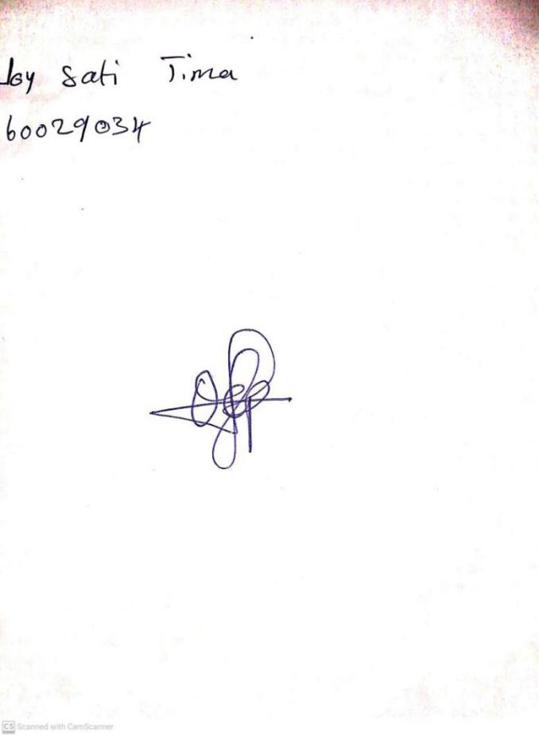

**5th January, 2024**

**Perpetual Ojoma Ocheja**

**Stream Head Nursery**