**EMERALD ROYAL INTERNATIONAL SCHOOL, MPAPE ABUJA**

**LESSON PLAN AND NOTE FOR WEEK 3 ENDING 19TH MAY, 2023**

**TERM: THIRD**

**WEEK**: **3**

**DATE** : **15TH - 19TH MAY, 2023.**

**SUBJECT:** **BIOLOGY**

**CLASS : SS 2**

**TOPIC : NERVOUS CORDINATION**

**SUB - TOPIC: 1**. **definition nervous coordination.**

1. **Systems involve in coordination.**
2. **Nervous system in mammals.**

**PERIOD : 7th**

**TIME : 12: 30 - 1:00**

**DURATION : 40 minutes**

**AVERAGE AGE : 15 years**

**SEX:** **mixed**

**LEARNING OBJECTIVES:** by the end of the lesson,the students, should be able to;

1. Define nervous coordination.
2. State the system involve in coordination.
3. Explain nervous system in mammals.

**RATIONALE:** the students should understand nervous coordination.

**PREVIOUS KNOWLEDGE:** The students have been taught functions and care of the skin.

**INSTRUCTIONAL MATERIALS:** chart showing nervous coordination and the brain.

**Reference Material:** Essential Biology foe Senior Secondary School by M.C. Michael.

**LESSON DEVELOPMENT**

|  |  |  |  |
| --- | --- | --- | --- |
| **STAGES** | **TEACHER’S ACTIVITIES** | **STUDENTS’**  **ACTIVITIES** | **LEARNING POINT** |
| **INTRODUCTION** | The teacher introduces the lesson by reviewing the previous lesson. | The students were active. | To arouse the students interest. |
| **PRESENTATION**  **STEP 1** | The teacher defines nervous coordination. | The students pay attention. | To keep them focus. |
| **STEP 2** | The teacher asks the students to state the system involved in coordination. | The students state the system involved in coordination. | To encourage critical thinking. |
| **STEP 3** | The teacher explains nervous coordination in mammals. | The students were active. | To keep them focus. |
| **BOARD SUMMARY** | **NERVOUS COORDINATION**  Nervous coordination is defined as the process by which different parts of an organism works together for proper effectiveness. All metabolic processes in the body of an organism do not function individually but are all closely linked and dependent on each other for effective functioning. The two communication system that bring this coordination are;   1. The endocrine system (hormones) 2. The nervous system.   The hypothalamus of the brain is is the important link between the two system.  **NERVOUS CORDINATION IN MAMMALS.**  The nervous system of mammals is made up of two part;   1. The central nervous system ( CNS) which consist of the brain and the spinal cord.    Your brain and spinal cord make up your CNS. Your brain uses your nerves to send messages to the rest of your body. Each nerve has a protective outer layer called myelin. Myelin insulates the nerve and helps the messages get through.   1. The peripheral nervous system (PNS) which consist of the rest of the nervous tissues found throughout the body. It consist of the somatic system and the autonomic nervous system.   Autonomic nervous system is further divided into parasympathetic and sympathetic  Your peripheral nervous system consists of many nerves that branch out from your CNS all over your body. This system relays information from your brain and spinal cord to your organs, arms, legs, fingers and toes. Your peripheral nervous system contains your:   * ****Somatic nervous system****, which guides your voluntary movements. * ****Autonomic nervous system,****which controls the activities you do without thinking about them. | The students ask questions for further clarification. | To create room for slow learners. |
| **Evaluation** | The teacher evaluates the students with the following questions:   1. Define nervous coordination. 2. Explain nervous coordination in mammals. 3. State the two parts of the nervous system. | The students attempt the questions. | To ascertain their level of understanding. |
| **Conclusion** | The teacher concludes by coping the note on the board. She checks and marks the note. | The students copy the note on the board. | For future use. |
| **Assignment** | With the aid of a chart explain nervous system. | The students did and submit their assignment for marking and correction. | To encourage the students to study at home. |

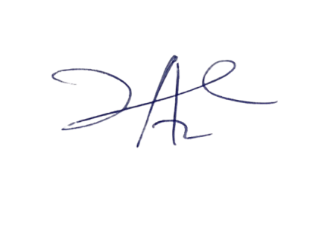

22/5/2023

Principal Head Instuctor