**LESSON PLAN AND NOTE 1 FOR WEEK 9 ENDING 10/11/2023**

**Term 1st  term**

**Week 9th week**

**Date 6th November,2023**

**Class Nursery one**

**Subject Letter work**

**Topic Tracing letter Qq - Uu.**

**Sub-topic Trace letter Qq, Rr.**

**Period 2nd period**

**Time 8:50 am**

**Duration 35 minutes**

**No in class 15**

**Average Age 3 years**

**Sex Mixed**

**Specific Objectives: By the end of the lesson the pupils should be able to;**

1. **Sound letter Qq, Rr.**
2. **Identify letter Qq, Rr.**
3. **Trace letter Qq, Rr.**

**Rationale: To make sure the pupils sound trace and identify letter Qq, Uu.**

**Previous knowledge: The pupils can trace letter Kk-Pp.**

**Instructional Resources: Chart, board, marker, exercise books, pencils.**

**Reference Materials: Online Research,chart,board.**

**LESSON PRESENTATION**

|  |  |  |  |
| --- | --- | --- | --- |
| **Steps** | **Teacher’s Activities** | **Pupils’ Activities** | **Learning points** |
| **Introduction** | **The teacher introduces the topic (Tracing of letters Qq - Uu) to the pupils by rhyming it.** | **The pupils listen attentively to the teacher.** | **To arouse the interest of the pupils.** |
| **Step 1** | **The teacher assists the pupils to sound letters Qq, Rr**  **Q q**  **R r** | **The pupils individually sound the letters Qq, Rr.** | **For proper understanding.** |
| **Step 2** | **The teacher leads the pupils to identify letter Qq, Rr .**  **Qq Rr** | **The pupils identify the letter Qq, Rr after the teacher.** | **For better understanding.** |
| **Step 3** | **The teacher guides the pupils in tracing letters Qq, Rr inside their notebooks**  **untraced letter Qq**  **untraced letter Rr** | **The pupils trace the letters Qq, Rr as the teacher guides them.** | **For further understanding.** |
| **Summary** | **The teacher summarizes the lesson by sounding capital and small letter Qq, Rr.** | **The pupils can sound capital and small letter Qq, Rr.** | **For onward study.** |
| **Evaluation** | **The teacher asks the pupils to:**   1. **Sound the letters below?**     **Qq Rr**   1. **Identify these letters below?**   **Qq Rr**     1. **Trace the letters Qq, Rr below?**   **untraced letter Qq**  **untraced letter Rr** | **The pupils answer the question correctly.** | **To ascertain the pupils’ understanding.** |
| **Conclusion** | **The teacher summarizes, reacts & corrects the pupils.** | **The pupils answer to the teacher’s questions.** | **To consolidate the lesson.** |
| **Assignment** | **Sound the letters below?**    **Qq Rr**  **Identify these letters below?**  **Qq Rr**  **Trace capital and small letter Qq, Rr?**  **untraced letter Qq**  **untraced letter Rr** | **The pupils copy and do their homework at home.** | **To encourage learning while at home.** |

**LESSON PLAN AND NOTE 2 FOR WEEK 9 ENDING 10/11/2023**

**Term 1st  term**

**Week 9th week**

**Date 8th November,2023**

**Class Nursery one**

**Subject Letter work**

**Topic Tracing letter Qq - Uu.**

**Sub-topic Trace letter Ss-Tt.**

**Period 4th period**

**Time 10:40 am**

**Duration 35 minutes**

**No in class 15**

**Average Age 3 years**

**Sex Mixed**

**Specific Objectives: By the end of the lesson the pupils should be able to;**

1. **Sound letter Ss-Tt.**
2. **Identify letter Ss-Tt.**
3. **Trace letter Ss-Tt.**

**Rationale: To make sure the pupils trace and identify letter Ss-Tt.**

**Previous knowledge: The pupils can trace and identify letter Qq, Rr.**

**Instructional Resources: Chart, board, marker, exercise books, pencils.**

**Reference Materials: Online Research,chart,board.**

**LESSON PRESENTATION**

|  |  |  |  |
| --- | --- | --- | --- |
| **Steps** | **Teacher’s Activities** | **Pupils’ Activities** | **Learning points** |
| **Introduction** | **The teacher introduces the topic (Tracing letter Qq-Uu) to the pupils by rhyming them.** | **The pupils listen attentively to the teacher.** | **To arouse the interest of the pupils.** |
| **Step 1** | **The teacher assists the pupils to sound letter Ss-Tt.**  **Ss Tt** | **The pupils individually sound the letters Ss-Tt.** | **For proper understanding.** |
| **Step 2** | **The teacher leads the pupils to identify letter Ss-Tt.**    **Ss Tt** | **The pupils identify the letter Ss-Tt after the teacher.** | **For better understanding.** |
| **Step 3** | **The teacher guides the pupils in tracing letters Ss-Tt**  **untraced letter Ss**  **untraced letter Tt** | **The pupils trace the letters Ss-Tt as the teacher guides them.** | **For further understanding.** |
| **Summary** | **The teacher summarizes the lesson by sounding letters Ss-Tt to the pupils.** | **The pupils can sound letters Ss-Tt.** | **For onward study.** |
| **Evaluation** | **The teacher asks the pupils to:**   1. **Sound the letters below?**   **Ss Tt**   1. **Identify these letters below?**   **Ss Tt**   1. **Trace the letters below?**   **untraced letter Ss**  **untraced letter Tt** | **The pupils answer the question correctly.** | **To ascertain the pupils’ understanding.** |
| **Conclusion** | **The teacher summarizes, reacts & corrects the pupils.** | **The pupils answer to the teacher’s questions.** | **To consolidate the lesson.** |
| **Assignment** | **Sound the letters below?**  **Ss Tt**  **Identify these letters below?**  **Ss Tt**  **Trace capital and small letter Ss-Tt ?**  **untraced letter Ss**  **untraced letter Tt** | **The pupils copy and do their homework at home.** | **To encourage learning while at home.** |

**LESSON PLAN AND NOTE 3 FOR WEEK 9 ENDING 10/11/2023**

**Term 1st  term**

**Week 9th week**

**Date 10th  November,2023**

**Class Nursery one**

**Subject Letter work**

**Topic Tracing letter Qq - Uu.**

**Sub-topic Trace letter Uu.**

**Period 2nd period**

**Time 8:50 am**

**Duration 35 minutes**

**No in class 15**

**Average Age 3 years**

**Sex Mixed**

**Specific Objectives: By the end of the lesson the pupils should be able to;**

1. **Sound letter Uu.**
2. **Identify letter Uu.**
3. **Trace letter Uu.**

**Rationale: To make sure the pupils trace and identify letter Uu.**

**Previous knowledge: The pupils can trace and identify letter Ss, Tt.**

**Instructional Resources: Chart, board, marker, exercise books, pencils.**

**Reference Materials: Online Research,chart,board.**

**LESSON PRESENTATION**

|  |  |  |  |
| --- | --- | --- | --- |
| **Steps** | **Teacher’s Activities** | **Pupils’ Activities** | **Learning points** |
| **Introduction** | **The teacher introduces the topic (Tracing letter Qq-Uu) to the pupils by rhyming them.** | **The pupils listen attentively to the teacher.** | **To arouse the interest of the pupils.** |
| **Step 1** | **The teacher assists the pupils to sound letter Uu.**  **U u** | **The pupils individually sound the letters Uu.** | **For proper understanding.** |
| **Step 2** | **The teacher leads the pupils to identify letter Uu.**    **U u** | **The pupils identify the letter Uu after the teacher.** | **For better understanding.** |
| **Step 3** | **The teacher guides the pupils in tracing letters Uu.**  **untraced letter Uu** | **The pupils trace the letters Uu as the teacher guides them.** | **For further understanding.** |
| **Summary** | **The teacher summarizes the lesson by sounding letters Uu to the pupils.** | **The pupils can sound letters Uu.** | **For onward study.** |
| **Evaluation** | **The teacher asks the pupils to :**   1. **Sound the letters below?**   **U u**   1. **Identify these letters below?**   **U u**   1. **Trace the letters below?**   **untraced letter Uu** | **The pupils answer the question correctly.** | **To ascertain the pupils’ understanding.** |
| **Conclusion** | **The teacher summarizes, reacts & corrects the pupils.** | **The pupils answer to the teacher’s questions.** | **To consolidate the lesson.** |
| **Assignment** | **Sound the letters below?**  **U u**  **Identify these letters below?**  **U u**  **Trace capital and small letter Uu?**  **untraced letter Uu** | **The pupils copy and do their homework at home.** | **To encourage learning while at home.** |

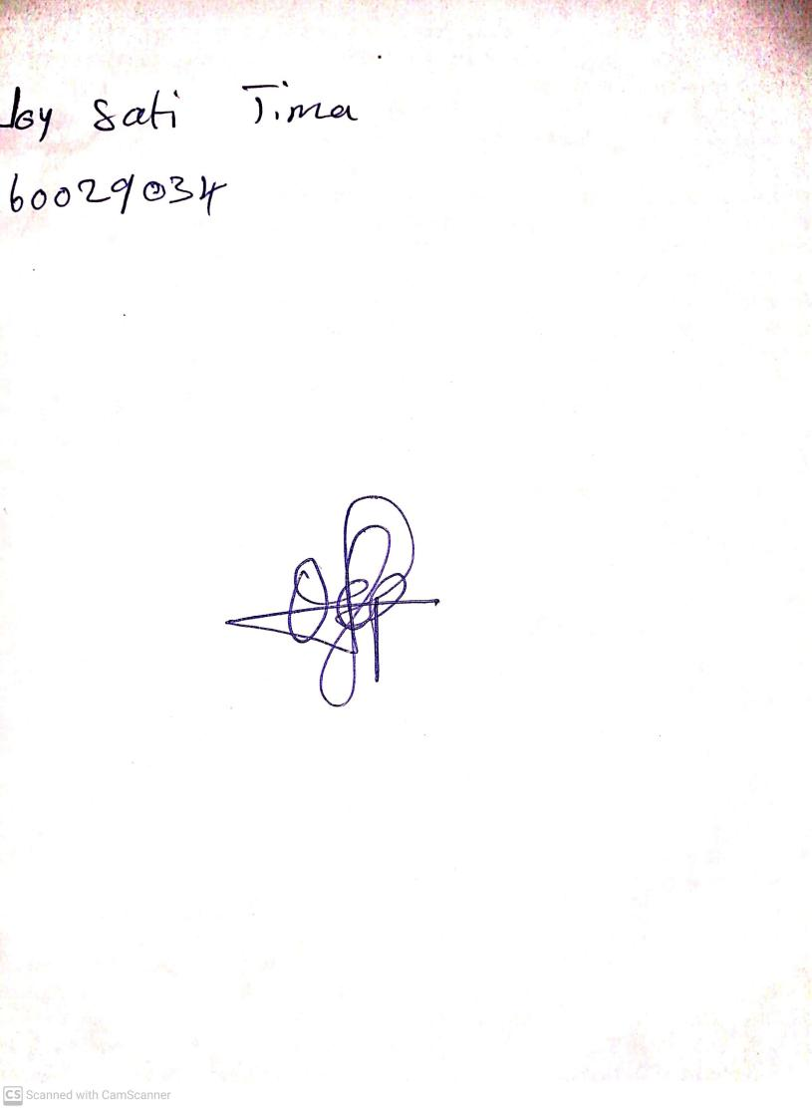

3RD NOVEMBER, 2023

Perpetual Ojoma Ocheja

Stream Head Nursery